**Competency Based Learning Materials (CBLM’s)**

**NTVQ Level 2**

**Certificate in Web design**

**(New qualification code)**

**Module: Develop Cascading Style Sheet (CSSs)**

This module comprises elements 1-6 from the Unit of Competency ITWEB30017A1 in the NVQ Level 2

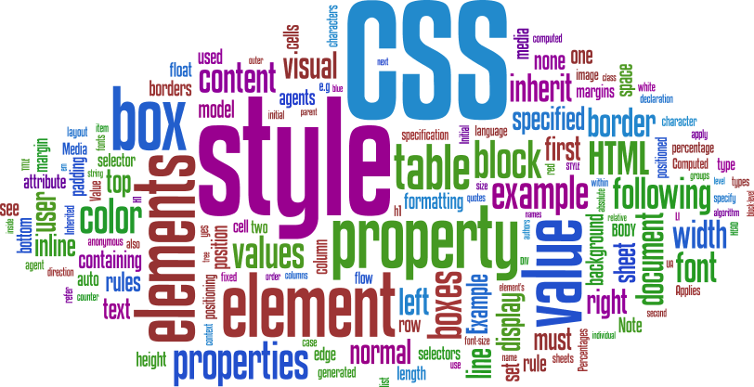

Version: 02.0 – Pilot Program

Last update: Oct 15 2011

**ILO TEVET Reform Project**

|  |
| --- |
| Table of Contents |

Table of Contents 2

How to use this learning guide 11

Learning Activities 12

Comments are used 13

**CSS Example** 14

**Styles Solved a Big Problem** 15

**CSS Saves a Lot of Work!** 15

CSS Id and Class 17

CSS Background 20

text formatting 26

CSS Font 31

How many states of link? 36

CSS Links 36

CSS Lists 38

When CSS box model is used? 49

CSS Box Model 49

CSS Border 51

CSS Margin 56

CSS Padding 58

CSS Grouping and Nesting Selectors 60

CSS Dimension 61

What is display properties? 62

CSS Display and Visibility 62

CSS Horizontal Align 73

CSS Pseudo-classes 77

CSS Pseudo-elements 80

CSS Navigation Bars 84

CSS Image Opacity / Transparency 89

CSS Image Sprites 91

CSS Media Types 94

CSS Attribute Selectors 95

Style HTML Elements With Specific Attributes 95

Attribute Selector 96

Example 96

Attribute and Value Selector 96

96

Attribute and Value Selector - Multiple Values 97

Styling Forms 98

Presenting web pages to users 117

|  |
| --- |
| **About this module** – **Develop Cascading Style Sheet (CSSs)** |

**Learning Outcomes**

**At the end of this training you should be able to:**

1. Define Purpose and Accessibility

2. Define styles

3. Produce CSS

4. Attach CSS to mark-up language documents

5. Edit CSS

6. Validate CSS

**Performance criteria**

1.1 The purpose of the mark-up language document is identified.

1.2 The platform where the CSS will be used is identified.

1.3 Accessibility options are identified and defined for the different visually or physically impaired persons.

2.1 Appropriate styles that are to be controlled by the CSS are identified.

2.2 The styles are defined and documented in accordance with established design principles or business guidelines

3.1 CSS is produced using the determined styles

4.1 CSS is attached to the mark-up language document

4.2 CSS styles are applied to the mark-up language document

5.1 CSS is edited and changes are confirmed in attached document

6.1 CSS is validated according to established design principles or business guidelines.

**Content** This learning package includes the following:

1. Define Purpose and Accessibility

2. Define styles

3. Produce CSS

4. Attach CSS to mark-up language documents

5. Edit CSS

6. Validate CSS

**Pre-requisites** To complete this learning module you will need to have completed unit ITSS1006A1, ITSS1007A1, ITSS1008A1, ITWEB1010A1, ITWEB1011A ITWEB2014A1, and ITWEB2016A1 which covers:

* Operate a personal computer and use industry standard office applications software.
* Type Document Bangla and English(Intermediate level)
* Send and retrieve information using email, web browsers
* Create and edit web content using HTML
* Use Image Editing Tool e.g. Photoshop (Basic level)
* Convert, slice and use templates.
* Using Web animation(Basic Level)

|  |
| --- |
| How to use this learning guide |

C:\Users\Flora-User\AppData\Local\Microsoft\Windows\Temporary Internet Files\Content.IE5\DVD5STNU\MC900442022[1].wmf

This Learning Guide will lead you through a series of learning activities. These activities may be completed as part of structured classroom activities or you may be required you to work at your own pace. These activities will ask you to complete associated learning and practice activities in order to gain the knowledge and skills you need to achieve the learning outcomes as stated.

Refer to the **Learning Activity table on** pg 5 to know the sequence of learning tasks. This page will serve as your road map towards the achievement of competence.

**Information sheets**. These will give you an understanding of the work you are learning about, and explain why things are done the way they are. Once you have finished reading the Information sheets complete the questions in the **Self Check Sheets.**

**Self-checks** follow the Information Sheets in the learning guide. Completing the **Self-checks** will help you know how you are progressing. To know how you fared with the self checks, review the answer keys.

Complete all activities as directed in the **Job Sheets** (**and/ or** **Activity sheets)**. This is where you will apply your new knowledge while developing new skills.

When working though this module always be aware of safety requirements (as highlighted in this material). Should you require some assistance and clarification consult your trainer or facilitator.

When you have completed all the tasks required in this learning guide, an assessment event will be scheduled to assess if you have achieved competency in the specified learning outcomes and are ready for the next task or module

A review of competency is provided on the last page to help remind if all the required assessment criteria have been met. This record is for your own information only and not an official record of competency.

Good luck and enjoy your learning

|  |
| --- |
| Learning Activities |

In order to achieve the objectives stated in this learning guide, you must perform the learning steps below. Beside each step are the resources or special instructions you will use to accomplish the corresponding activity.

|  |  |
| --- | --- |
| **Learning Steps** | **Resources specific instructions** |
| 1 Student will ask the instructor about the materials to be used. | 1 Instructor will provide the learning materials in *(insert details of the module to be completed)* |
| 2 Read the **Information sheet/s** | 2 Information Sheet/s (insert the title of the information sheets) |
| 3. Complete the **Self Checks & Check answer sheets.** | 3. Self Check/s *(insert the title of the self check sheets and answer sheets)* |
| 4. Read the **Job Task sheet** and **Specification Sheet** | 4. Job Task Sheet and Specification Sheet *(Insert the title of the job)* |
| 5. Complete Activities ( if applicable) | 5. Activity Sheet/s *(Insert the title of the activity)* |
| 6. Perform the **Job Task** | 6. Job Task sheet/s and Specification Sheet/s *(Insert the title of the Job Sheet and Specification Sheet)* |

**Note**: If you have multiple Information sheets and Job Sheets repeat the above Learning Steps 2 to 6 for each job

|  |
| --- |
| **Information Sheet No 1: Define the purpose, accessibility and styles of CSS and create a webpage using CSS and HTML.** |

**What is CSS?** 

1. CSS stands for Cascading Style Sheets
2. Styles define how to display HTML elements
3. Styles were added to HTML to solve a problem
4. External Style Sheets can save a lot of work
5. External Style Sheets are stored in CSS files

**What You Should Already Know?**

Before you continue you should have a basic understanding of the following:

1. HTML / XHTML

**CSS Example**

<html>

<head>

<style type="text/css">

Body {background-color: #d0e4fe ;}

h1 {color: orange; text-align: center ;}

p{font-family:"Times New Roman";font-size:20px; text-align: center ;}

</style>

</head>

<body>

<h1>CSS example!</h1>

<p>This is a paragraph.</p>

</body>

</html>

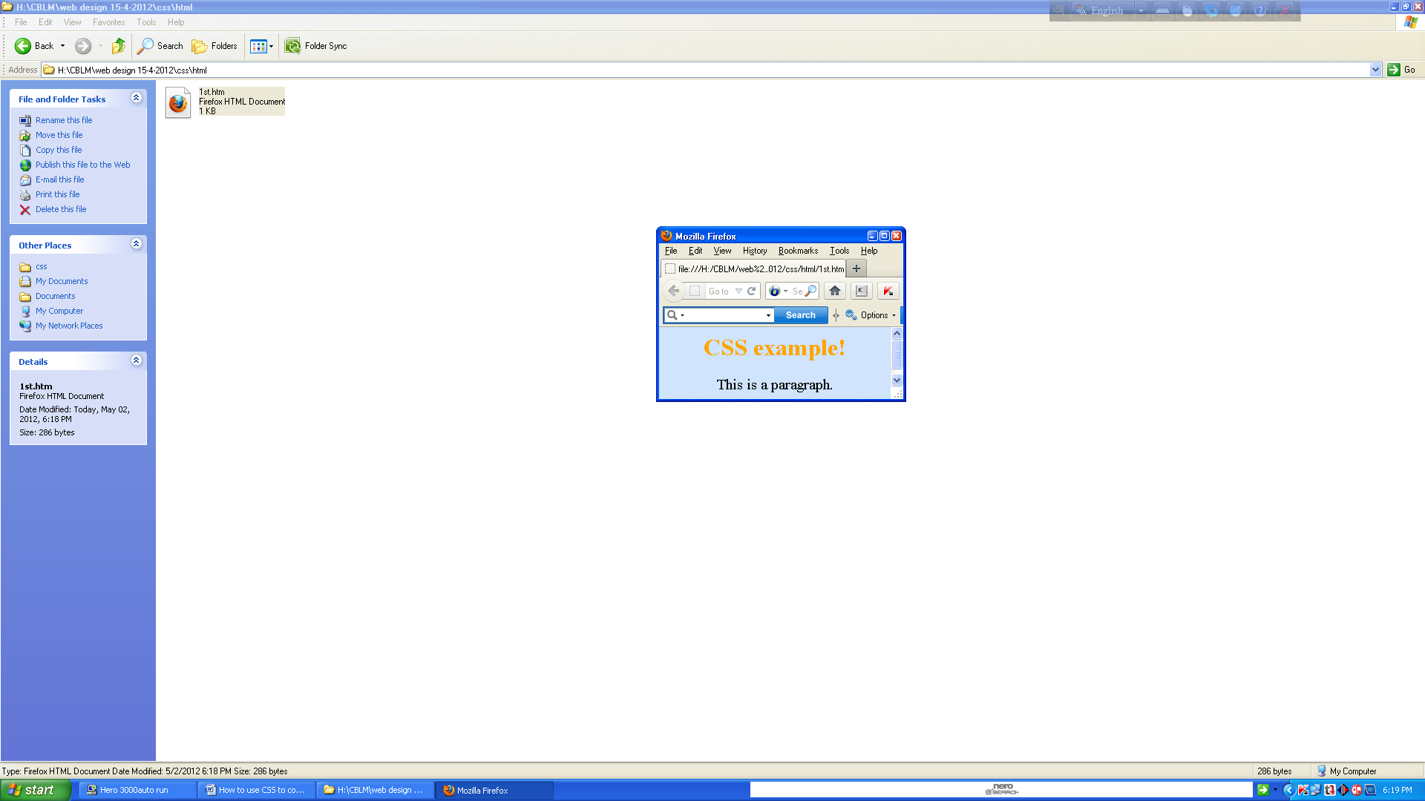

# What is the purpose of the HTML?

HTML stands for Hyper Text Markup Language. It is used to code (program) the basic elements of the web and WebPages. Basically, it is a way to set the basic blocks for other languages (like Javascript and CSS) to manipulate.

CSS is a special purpose style sheet language and it helps in defining the format of presentation for any document that has been written in a markup language like the HTML. Mostly, CSS is used to define the presentation of HTML and XHTML documents. CSS gives great style to your web pages that are written in any markup language.

Now, as you have learnt a bit about CSS, its time to know something about the syntax of CSS that is critical when using CSS. Make sure that you have the pre-requisite knowledge of CSS. In order to work on CSS, you must know some markup languages like HTML or XHTML so that you can add personalized styles on the markup documents. Before you move on towards the syntax of CSS, let’s refresh some basic concepts of CSS.

* CSS is an acronym which means Cascading Style Sheets
* The main purpose of CSS is to define the presentation of HTML elements
* All styles are defined and stored in Style sheets
* After storing styles in a separate style sheet files, these are added into HTML documents.
* Defining the style outside the html document helps in saving lots of work and time
* CSS allows you to define more than one style in one style sheet; known as the cascading of styles

# Ways to Ensure Your Site Is Accessible to the Visually Impaired



According to Prevent Blindness America, 53.2 million Americans aged 45 or older have some form of visual impairment, from mild to severe, and about 18% of those affected are “legally blind.” Despite their visual impairments, many of those people use the Internet every day, just like you and me. Further, as more and more people over the age of 50 become comfortable with technology, Internet usage among this demographic will only increase in coming years.

The web is full of tips on how to design websites for blind users, most of which are geared toward making your website accessible to screen readers. But as you can tell by looking at the numbers above, there is a large middle ground. The vast majority of individuals with visual impairments, even those considered legally blind, don’t need or use screen-reading software. However, the web can still be a difficult and cumbersome place to navigate when one can’t quite see it clearly.

Here are a few tips and techniques for making your site more accessible to these visually impaired users — and why they’re important.

## 1. Make Allowances For Enlarged Text



Often times, simply making text larger is all that a user requires. Consider offering alternate stylesheets with larger font sizes and make sure your layout doesn’t break when text-only zoom is enabled in the browser. Many visually impaired users will want to zoom in on the text without changing the scale of the entire site layout, which can lead to difficulties scrolling and tracking text over long lines.

Depending on your site’s target market, you may also want to consider making the default font a few points larger, and if you’re publishing articles or large quantities of text, it’s a good idea to offer text-only versions, so the user can then manipulate the text however he likes.

## 2. Contrast is Key

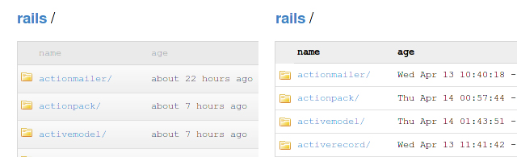

Eye diseases like Retinitis Pigmentosa, Glaucoma, Retinopathy and cataracts (some of the most common eye disorders out there) all lead to a significant decrease in contrast sensitivity — that is, the eye’s ability to differentiate between similar shades and levels of brightness.

But today’s layouts are detailed-oriented, often utilizing subtle gradients and slight shifts in value to create clean, modern, unobtrusive interfaces. For a user with normal eyesight, this makes for a very pleasing visual experience. To a user who struggles with contrast sensitivity, however, it can be a literal headache.

Consider offering a second version of your site with more contrast between elements. Make use of bold text for added readability on low-contrast items and avoid very thin fonts. Also, don’t use any JavaScript or CSS techniques that would prevent users from highlighting elements of the page with their mouse or change the default highlight behavior. Many visually impaired users make use of highlighting as a quick trick to increase contrast and to aid visual focus.

## 3. Be Mindful of Colors for Action Items

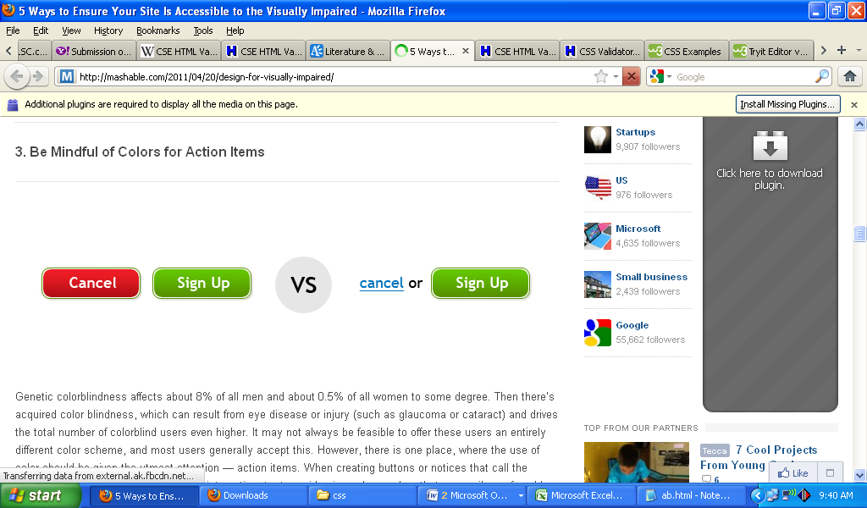

Genetic colorblindness affects about 8% of all men and about 0.5% of all women to some degree. Then there’s acquired color blindness, which can result from eye disease or injury (such as glaucoma or cataract) and drives the total number of colorblind users even higher. It may not always be feasible to offer these users an entirely different color scheme, and most users generally accept this. However, there is one place, where the use of color should be given the utmost attention — action items. When creating buttons or notices that call the user’s attention and require their direct interaction, try to avoid using color combos that are easily confused by colorblind users (red and green, blue and yellow) and make sure these elements contain clear, visible text or iconography that makes their purpose clear.

Placing a red “cancel” button next to a green “submit” button, for example, might cause visual confusion to a user who is red-green colorblind. Similarly, users with the seemingly misnomered “blue-yellow” colorblindness (more common in acquired colorblindness) are less able to differentiate between shades of green and blue.

## 4. Let Desktop Users Browse Your Mobile Site

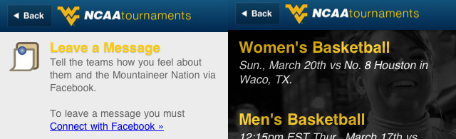

If you offer a mobile version of your web site, don’t restrict it only to mobile devices. Layouts optimized for the mobile web are typically, by nature, more visually accessible than their more grown-up counterparts. Elements are often simplified (and thus easier to scale), more focus is given to text, and there is less overall visual clutter to potentially confuse users who have blurred vision or difficulties with contrast and color. Giving anyone access to the mobile version of your site can be a quick way to increase accessibility without adding a lot to development costs.

Note, though, that while they can be quite useful for sighted persons with vision problems, mobile websites that utilize large amounts of JavaScript and AJAX functionality are not ideal solutions for blind users who need to access the web via screen reading technology.

## 5. Use Keyboard Shortcuts to Aid Navigation



In addition to being useful to persons with screen readers, keyboard shortcuts can make site navigation for the visually impaired user far easier. With the addition of keyboard commands, it’s possible to navigate a site with the use of arrow keys and a few quick keystrokes, eliminating the need to follow a mouse cursor across a screen — and the associated need to keep shifting visual focus. This can go a long way toward reducing eye strain and frustration. Many users with visual impairments surf the web on large monitors (23″ or bigger), which can lead to a lot of head and eye movement, particularly at shorter focal distances. The less time the user has to spend following the cursor (which can easily become lost) around the screen, the better.

**Identify the platform where the CSS will be used:**

CSS platform means where CSS will be run. The most common platforms are IE9+, Firefox, Safari, Chrome AND iPad / iPhone, Blacberry, Android etc.

**Define styles**

CSS defines HOW HTML elements are to be displayed.

Styles are normally saved in external .css files. External style sheets enable you to change the appearance and layout of all the pages in a Web site, just by editing one single file!

## CSS Syntax

A CSS rule has two main parts: a selector, and one or more declarations:

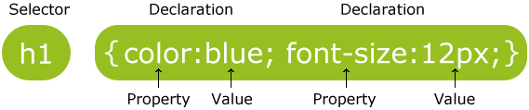

The selector is normally the HTML element you want to style.

Each declaration consists of a property and a value.

The property is the style attribute you want to change. Each property has a value.

## CSS Example

A CSS declaration always ends with a semicolon, and declaration groups are surrounded by curly brackets:

p {color:red;text-align:center;}

To make the CSS more readable, you can put one declaration on each line, like this:

## 

## Example

<html>

<head>

<style type="text/css">

p { color:red;

text-align:center; }

</style>

</head>

<body>

<p>Hello World!</p>

<p>This paragraph is styled with CSS.</p>

</body>

</html>

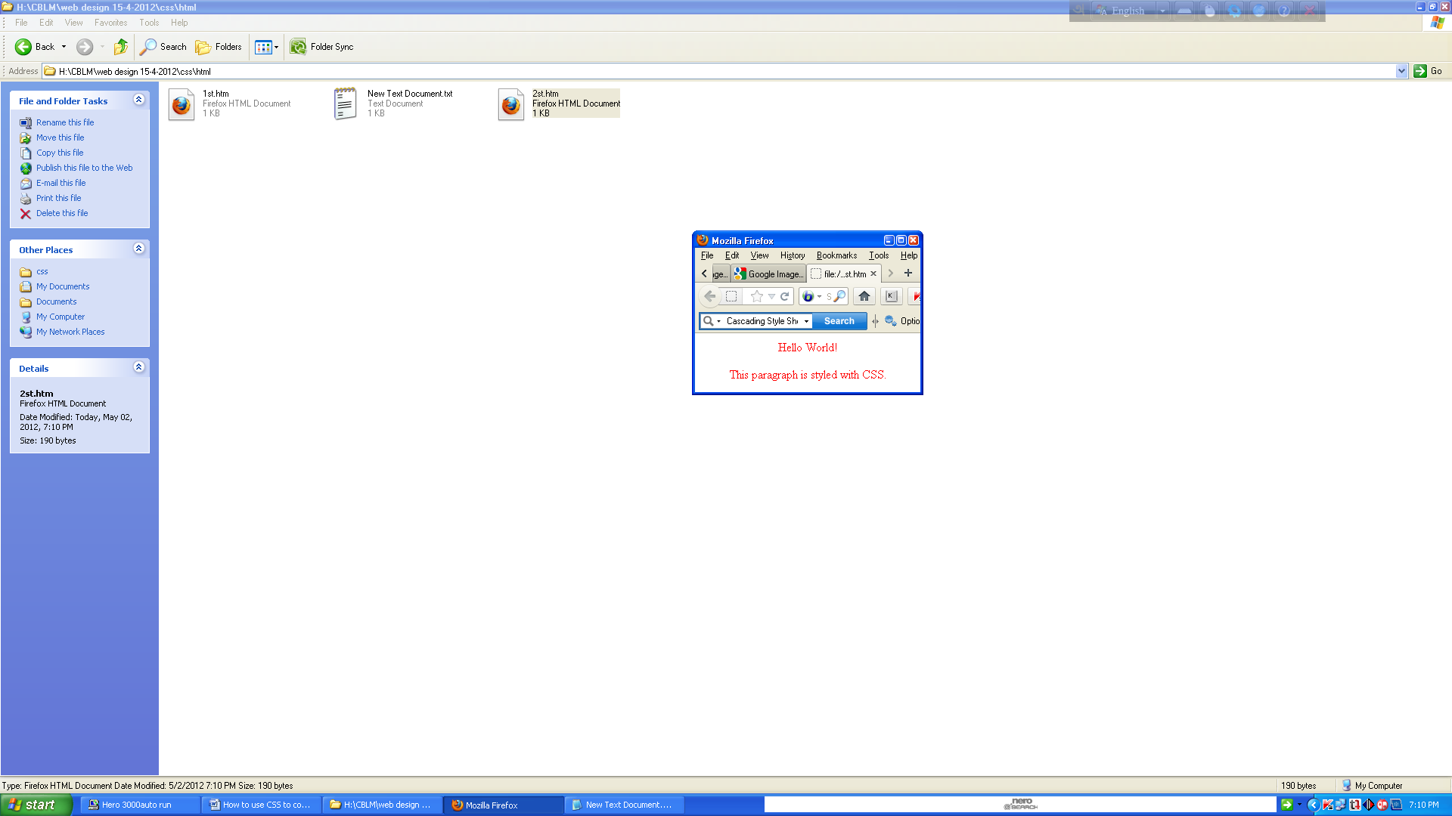

## CSS Comments

Comments are used to explain your code, and may help you when you edit the source code at a later date. Comments are ignored by browsers.

A CSS comment begins with "/*", and ends with "*/", like this:

/*This is a comment*/

# CSS Id and Class

## The id and class Selectors

In addition to setting a style for a HTML element, CSS allows you to specify your own selectors called "id" and "class".

## 

## The id Selector

The id selector is used to specify a style for a single, unique element.

The id selector uses the id attribute of the HTML element, and is defined with a "#".

The style rule below will be applied to the element with id="para1":

## 

## Example

<html>

<head>

<style type="text/css">

#para1 { text-align:center; color:red; }

</style>

</head>

<body>

<p id="para1">Hello World!</p>

<p>This paragraph is not affected by the style.</p>

</body>

</html>

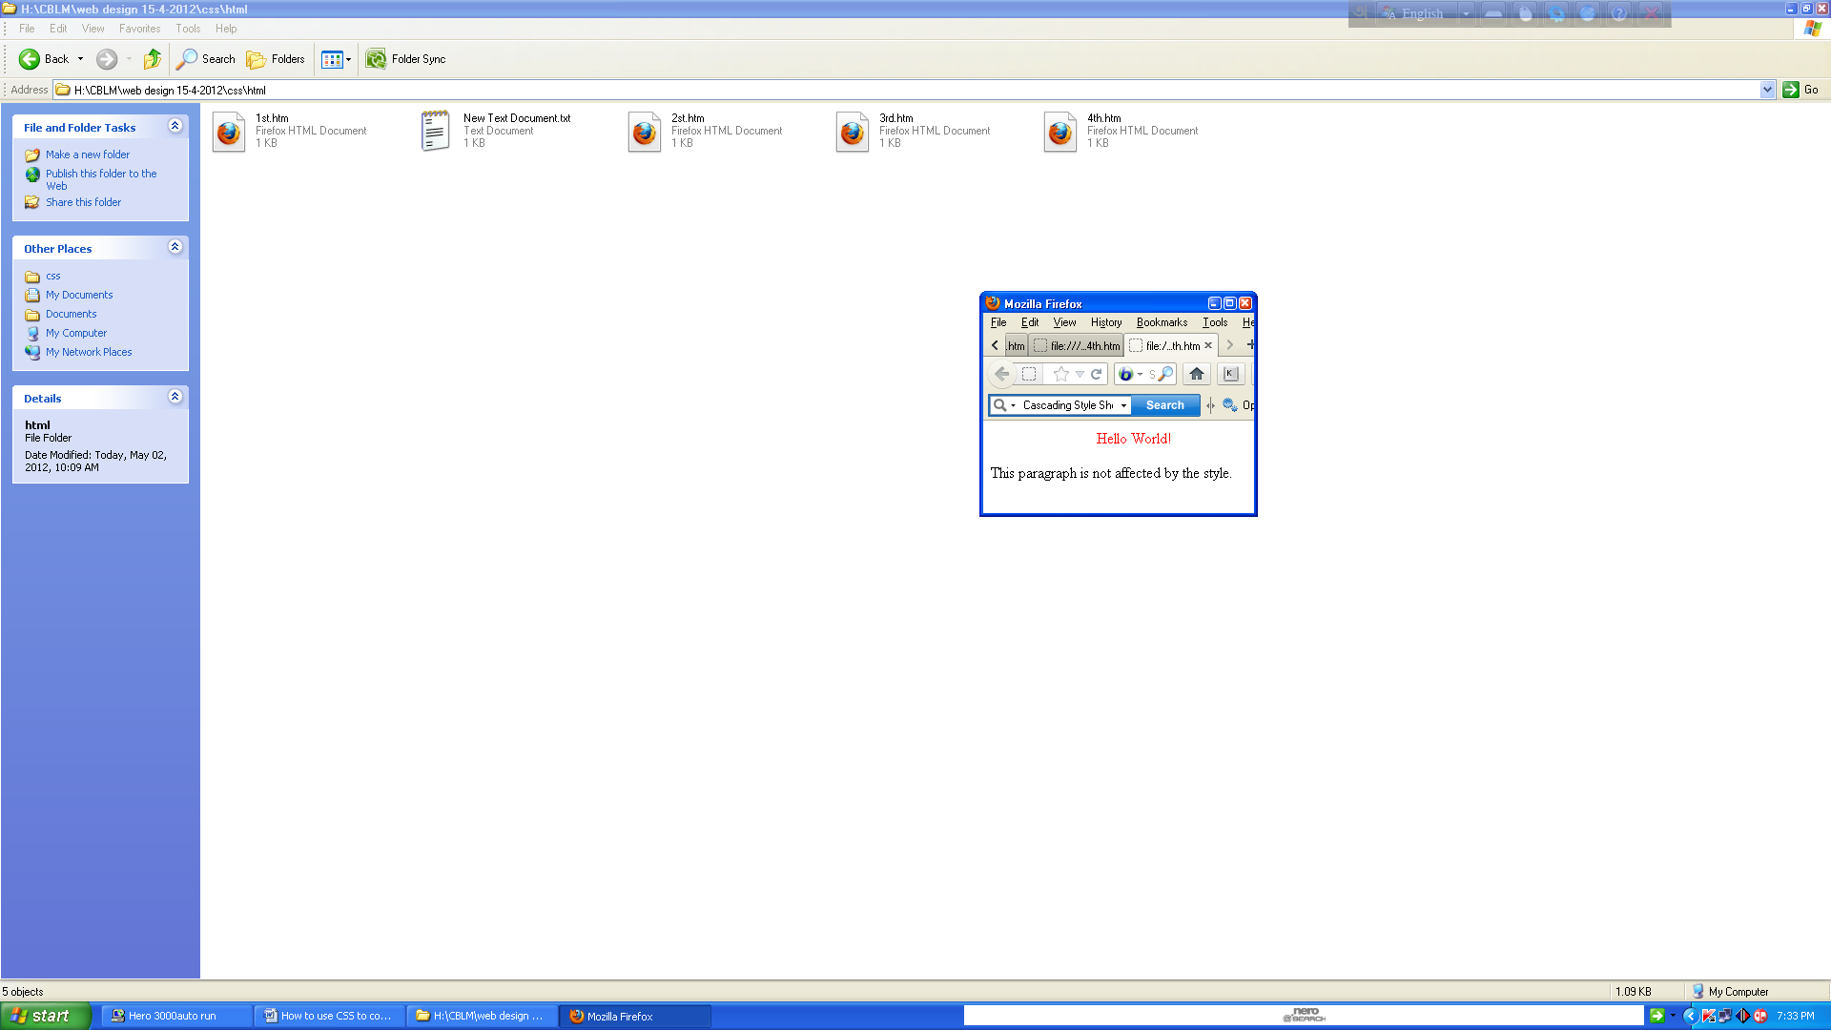

Do **not** start an id name with a number! It will not work in mozilla/firefox.

## The class selector

The class selector is used to specify a style for a group of elements. Unlike the id selector, the class selector is most often used on several elements.

This allows you to set a particular style for many HTML elements with the same class.

The class selector uses the HTML class attribute, and is defined with a "."

In the example below, all HTML elements with class="center" will be center-aligned:

## 

## Example

.center {text-align:center;}

You can also specify that only specific HTML elements should be affected by a class.

In the example below, all p elements with class="center" will be center-aligned:

## 

## Example

<html>

<head>

<style type="text/css">

p.center { text-align:center; }

</style>

</head>

<body>

<h1 class="center">This heading will not be affected</h1>

<p class="center">This paragraph will be center-aligned.</p>

</body>

</html>

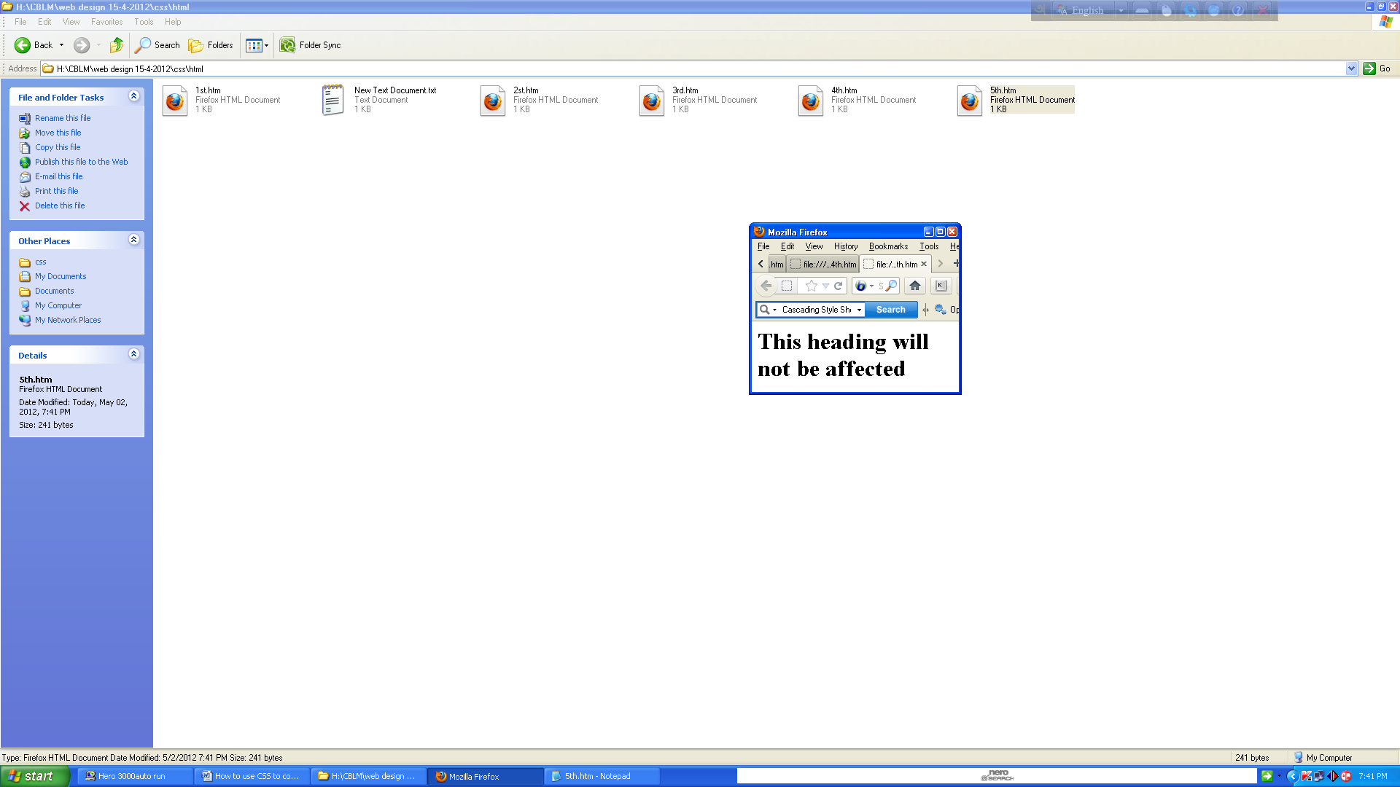

Do **not** start a class name with a number! This is only supported in Internet Explorer.

When a browser reads a style sheet, it will format the document according to it.

## Three Ways to Insert CSS

There are three ways of inserting a style sheet:

* External style sheet
* Internal style sheet
* Inline style

## External Style Sheet

An external style sheet is ideal when the style is applied to many pages. With an external style sheet, you can change the look of an entire website by changing one file. Each page must link to the style sheet using the <link> tag. The <link> tag goes inside the head section:

<head>  
<link rel="stylesheet" type="text/css" href="mystyle.css" />  
</head>

An external style sheet can be written in any text editor (such as notepad). The file should not contain any html tags. Your style sheet should be saved with a .css extension. An example of a style sheet file is shown below:

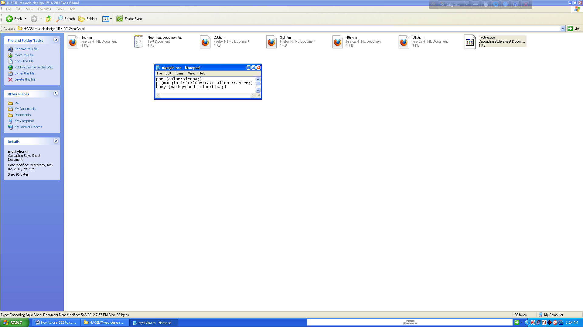

hr {color:sienna;}  
p {margin-left:20px;}  
body {background-image:url("images/back40.gif");}

Do not leave spaces between the property value and the unit (such as margin-left:20 px). Correct way: margin-left:20px

## Internal Style Sheet

An internal style sheet should be used when a single document has a unique style. You define internal styles in the head section of an HTML page, by using the <style> tag, like this:

<head>  
<style type="text/css">  
hr {color:sienna;}  
p {margin-left:20px;}  
body {background-image:url("images/back40.gif");}  
</style>  
</head>

## Inline Styles

An inline style loses many of the advantages of style sheets by mixing content with presentation. Use this method sparingly!

To use inline styles you use the style attribute in the relevant tag. The style attribute can contain any CSS property. The example shows how to change the color and the left margin of a paragraph:

<p style="color:sienna;margin-left:20px">This is a paragraph.</p>

## Multiple Style Sheets

If some properties have been set for the same selector in different style sheets, the values will be inherited from the more specific style sheet.

For example, an external style sheet has these properties for the h3 selector:

h3 { color:red; text-align:left; font-size:8pt; }

And an internal style sheet has these properties for the h3 selector:

h3 { text-align:right; font-size:20pt; }

If the page with the internal style sheet also links to the external style sheet the properties for h3 will be:

color:red; text-align:right; font-size:20pt;

The color is inherited from the external style sheet and the text-alignment and the font-size is replaced by the internal style sheet.

## Multiple Styles Will Cascade into One

Styles can be specified:

* inside an HTML element
* inside the head section of an HTML page
* in an external CSS file

**Tip:** Even multiple external style sheets can be referenced inside a single HTML document.

### Cascading order

Generally speaking we can say that all the styles will "cascade" into a new "virtual" style sheet by the following rules, where number four has the highest priority:

1. Browser default
2. External style sheet
3. Internal style sheet (in the head section)
4. Inline style (inside an HTML element)

So, an inline style (inside an HTML element) has the highest priority, which means that it will override a style defined inside the <head> tag, or in an external style sheet, or in a browser (a default value).

**Note:** If the link to the external style sheet is placed after the internal style sheet in HTML <head>, the external style sheet will override the internal style sheet!

# CSS Background

CSS background properties are used to define the background effects of an element.

CSS properties used for background effects:

* background-color
* background-image
* background-repeat
* background-attachment
* background-position

## 

## Background Color

The background-color property specifies the background color of an element.

The background color of a page is defined in the body selector:

## 

## Example

<html>

<head>

<style type="text/css">

body { background-color:#b0c4de; }

</style>

</head>

<body>

<h1>My CSS web page!</h1>

<p>Hello world! This is a W3Schools.com example.</p>

</body>

</html>

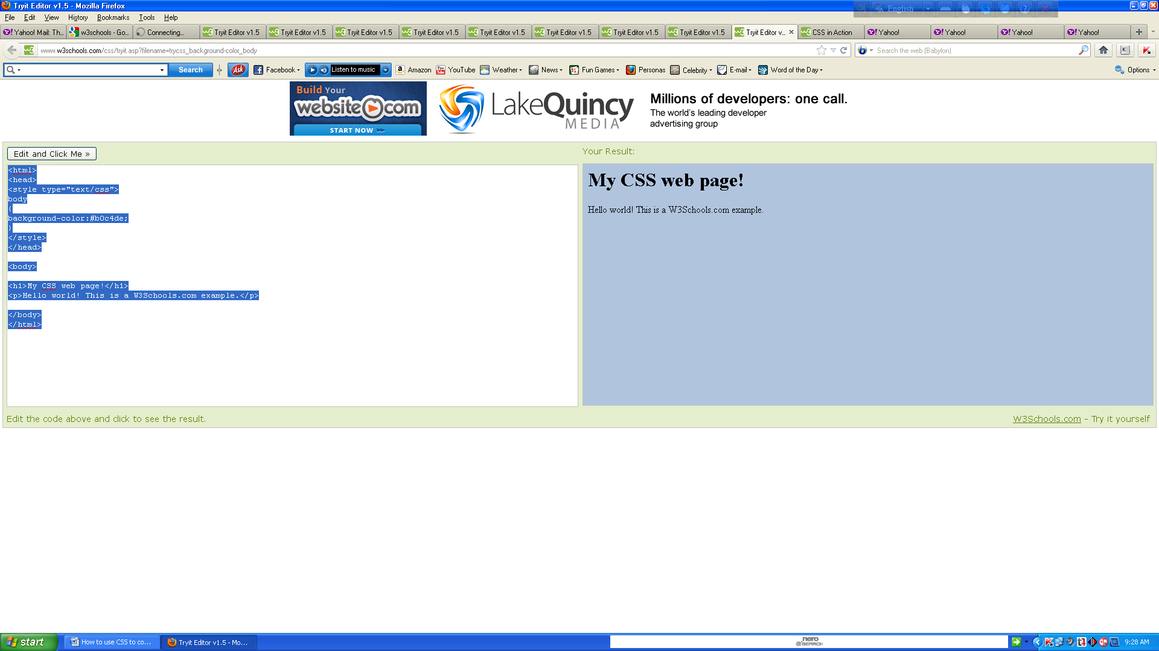

With CSS, a color is most often specified by:

* a HEX value - like "#ff0000"
* an RGB value - like "rgb(255,0,0)"
* a color name - like "red"

Look at CSS Color Values for a complete list of possible color values.

In the example below, the h1, p, and div elements have different background colors:

## 

## Example

<html>

<head>

<style type="text/css">

h1 { background-color:#6495ed; }

p { background-color:#e0ffff; }

div { background-color:#b0c4de; }

</style>

</head>

<body>

<h1>CSS background-color example!</h1>

<div>

This is a text inside a div element.

<p>This paragraph has its own background color.</p>

We are still in the div element.

</div>

</body>

</html>

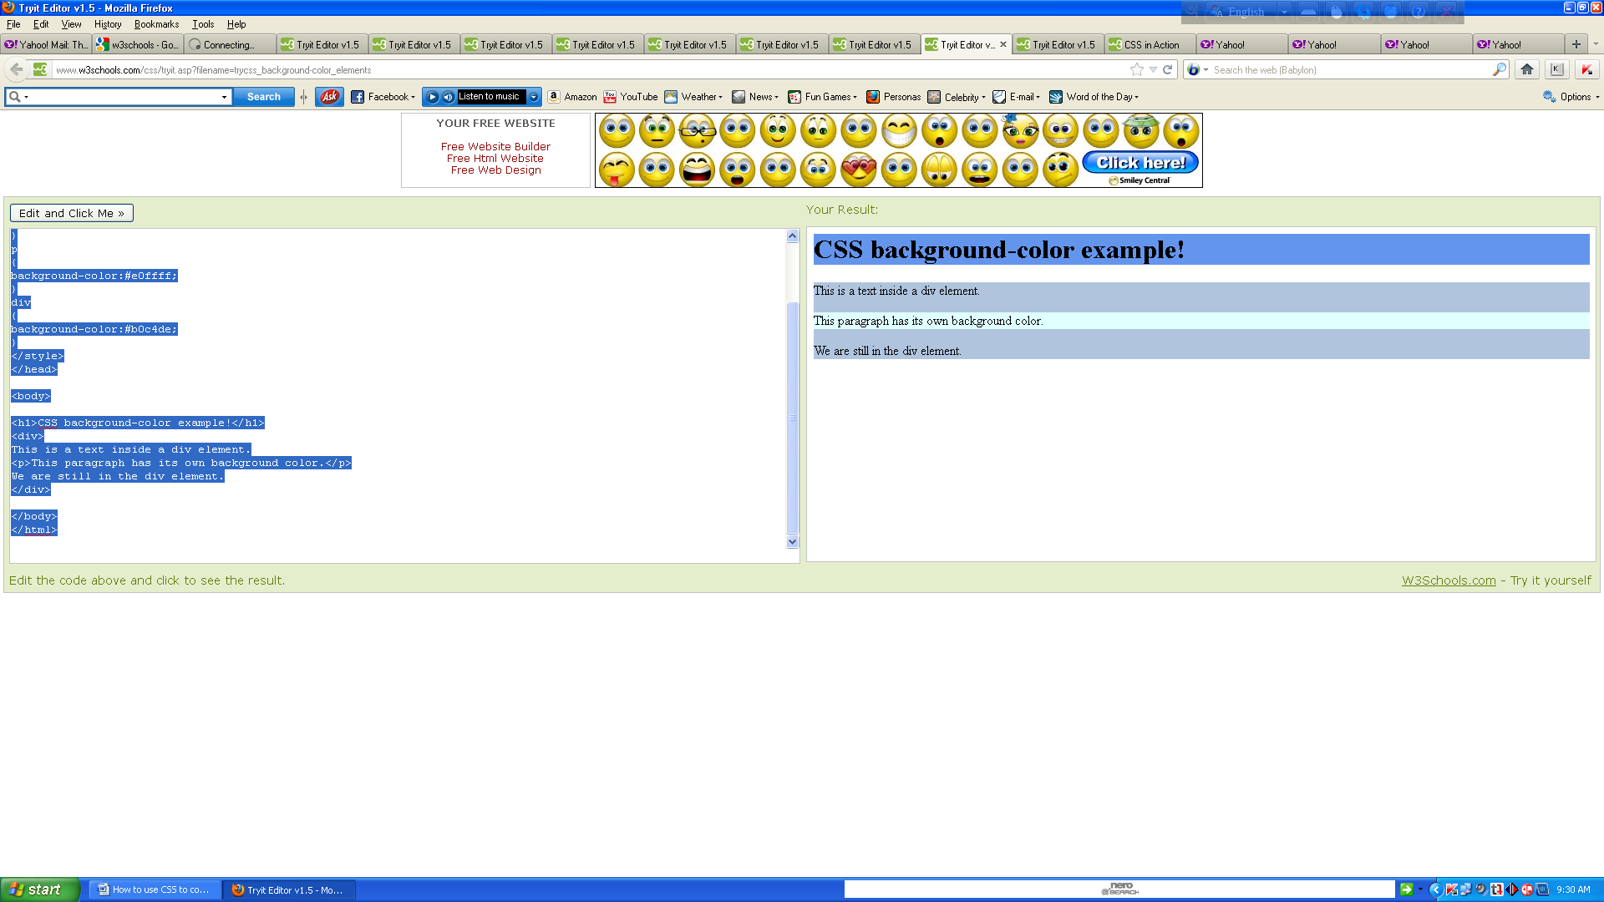

## Background Image

The background-image property specifies an image to use as the background of an element.

By default, the image is repeated so it covers the entire element. The background image for a page can be set like this:

## 

## Example

<html>

<head>

<style type="text/css">

body {background-image:url('paper.gif');}

</style>

</head>

<body>

<h1>Hello World!</h1>

</body>

</html>

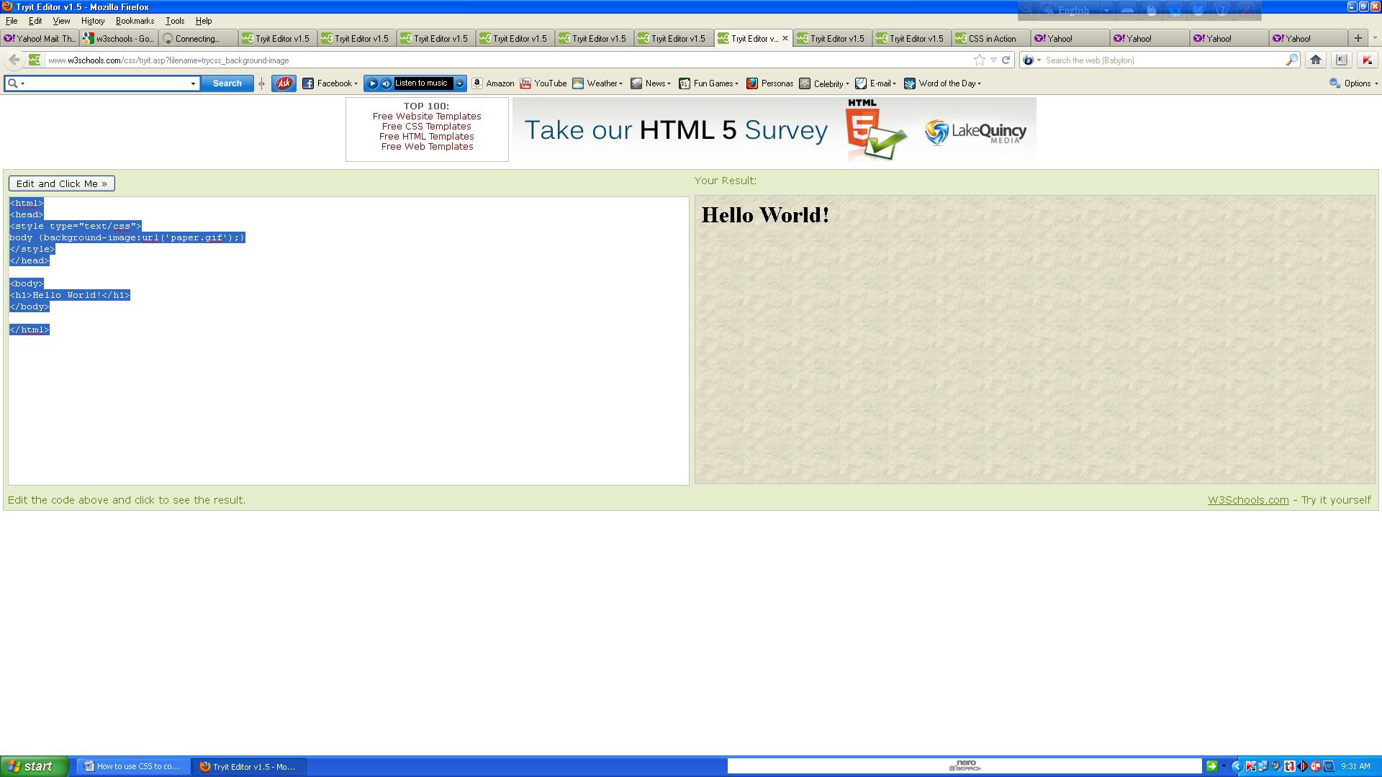

Below is an example of a bad combination of text and background image. The text is almost not readable:

## 

## Example

<html>

<head>

<style type="text/css">

body {background-image:url('bgdesert.jpg');}

</style>

</head>

<body>

<h1>Hello World!</h1>

<p>This text is not easy to read on this background image.</p>

</body>

</html>

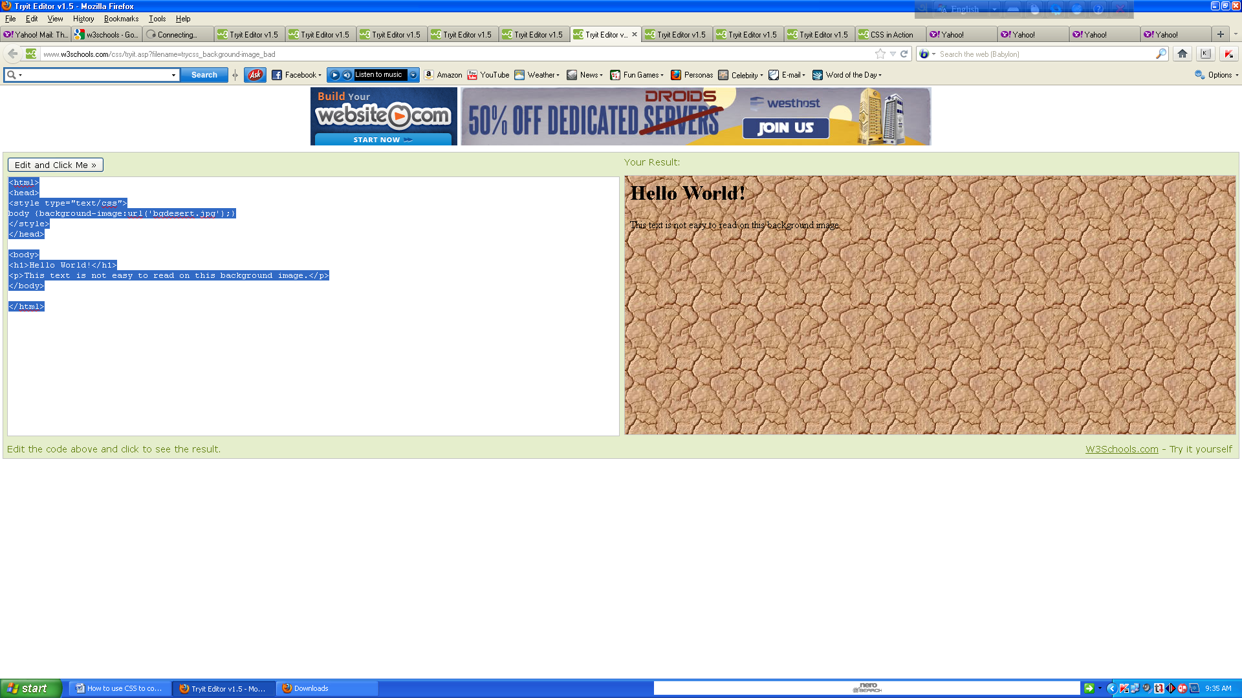

## 

## Background Image - Repeat Horizontally or Vertically

By default, the background-image property repeats an image both horizontally and vertically.

Some images should be repeated only horizontally or vertically, or they will look strange, like this:

## 

## Example

<html>

<head>

<style type="text/css">

Body { background-image:url('gradient2.png'); }

</style>

</head>

<body>

<h1>Hello World!</h1>

</body>

</html>

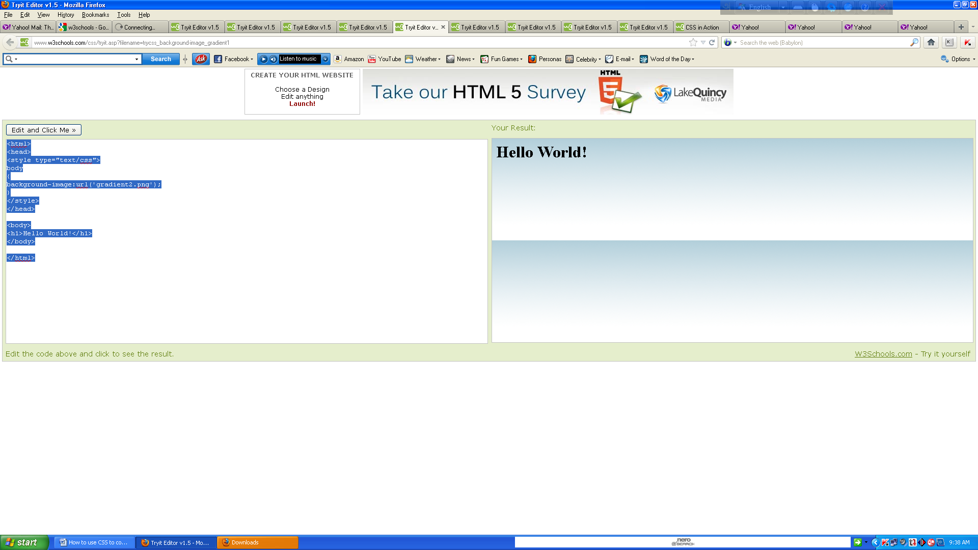

If the image is repeated only horizontally (repeat-x), the background will look better:

## Example

<html>

<head>

<style type="text/css">

body { background-image:url('gradient2.png'); background-repeat:repeat-x; }

</style>

</head>

<body>

<h1>Hello World!</h1>

</body>

</html>  
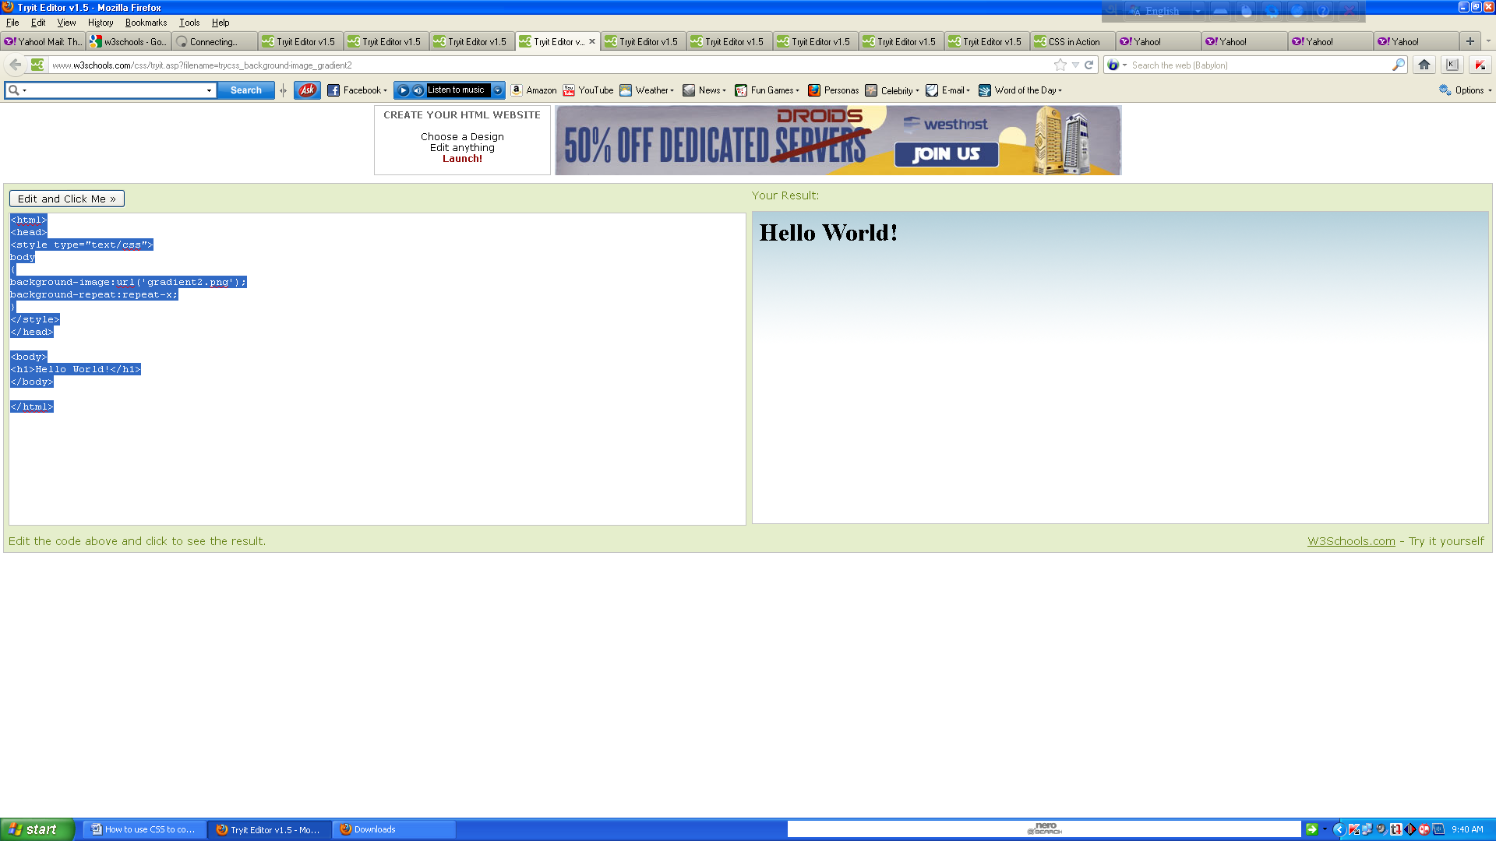

## Background Image - Set position and no-repeat

When using a background image, use an image that does not disturb the text.

Showing the image only once is specified by the background-repeat property:

## 

## Example

<html>

<head>

<style type="text/css">

body { background-image:url('img_tree.png'); background-repeat:no-repeat; }

</style>

</head>

<body>

<h1>Hello World!</h1>

<p>W3Schools background image example.</p>

<p>The background image is only showing once, but it is disturbing the reader!</p>

</body>

</html>  
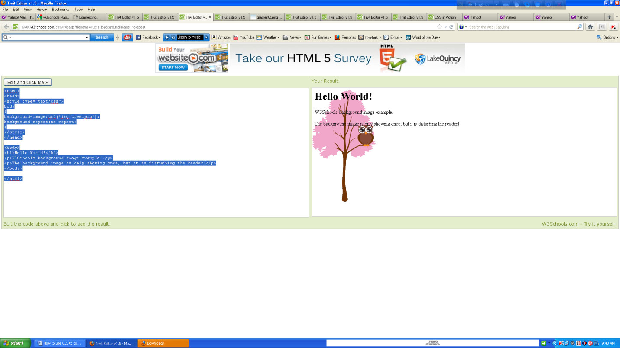

In the example above, the background image is shown in the same place as the text. We want to change the position of the image, so that it does not disturb the text too much.

The position of the image is specified by the background-position property:

## 

## Example

<html>

<head>

<style type="text/css">

body { background-image:url('img_tree.png'); background-repeat:no-repeat; background- position:right top; margin-right:200px; }

</style>

</head>

<body>

<h1>Hello World!</h1>

<p>W3Schools background no-repeat, set postion example.</p>

<p>Now the background image is only shown once, and positioned away from the text.</p>

<p>In this example we have also added a margin on the right side, so the background image will never disturb the text.</p>

</body>

</html>

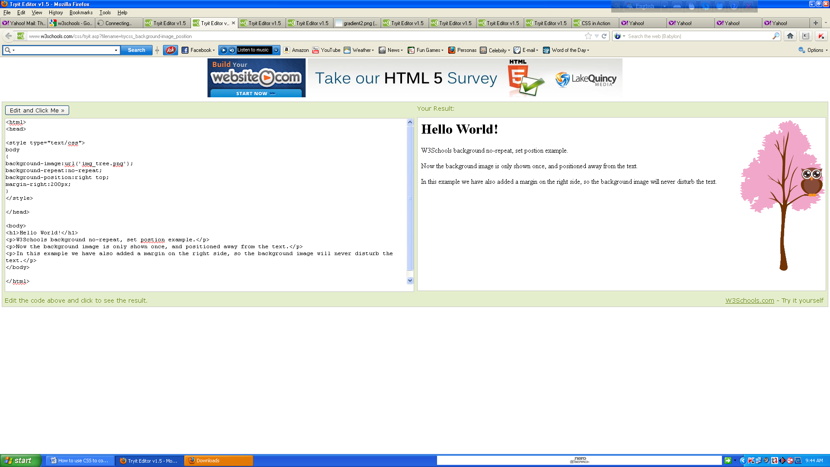

## Background - Shorthand property

As you can see from the examples above, there are many properties to consider when dealing with backgrounds.

To shorten the code, it is also possible to specify all the properties in one single property. This is called a shorthand property.

The shorthand property for background is simply "background":

## 

## Example

<html>

<head>

<style type="text/css">

Body { background:#ffffff url('img_tree.png') no-repeat right top; margin-right:200px; }

</style>

</head>

<body>

<h1>Hello World!</h1>

<p>Now the background image is only shown once, and it is also positioned away from the text.</p>

<p>In this example we have also added a margin on the right side, so that the background image will not disturb the text.</p>

</body>

</html>

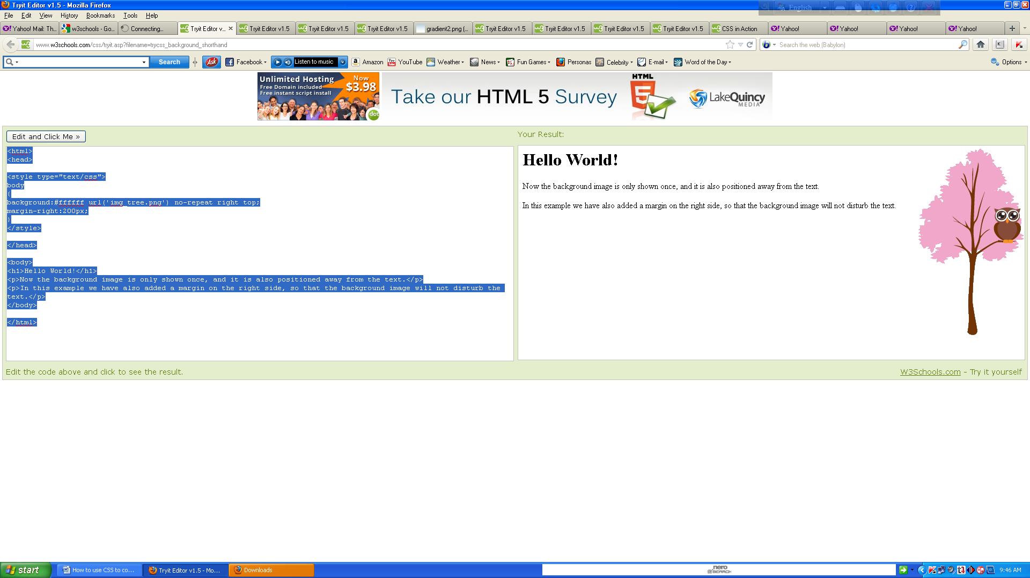

When using the shorthand property the order of the property values are:

* background-color
* background-image
* background-repeat
* background-attachment
* background-position

It does not matter if one of the property values is missing, as long as the ones that are present are in this order.

This example uses more advanced CSS.

# text formatting

This text is styled with some of the text formatting properties. The heading uses the text-align, text-transform, and color properties. The paragraph is indented, aligned, and the space between characters is specified. The underline is removed from the "Try it yourself" link.

## 

## Text Color

The color property is used to set the color of the text.

With CSS, a color is most often specified by:

* a HEX value - like "#ff0000"
* an RGB value - like "rgb(255,0,0)"
* a color name - like "red"

Look at CSS Color Values for a complete list of possible color values.

The default color for a page is defined in the body selector.

## Example

<html>

<head>

<style type="text/css">

body {color:red;}

h1 {color:#00ff00;}

p.ex {color:rgb(0,0,255);}

</style>

</head>

<body>

<h1>This is heading 1</h1>

<p>This is an ordinary paragraph. Notice that this text is red. The default text-color for a page is defined in the body selector.</p>

<p class="ex">This is a paragraph with class="ex". This text is blue.</p>

</body>

</html>  
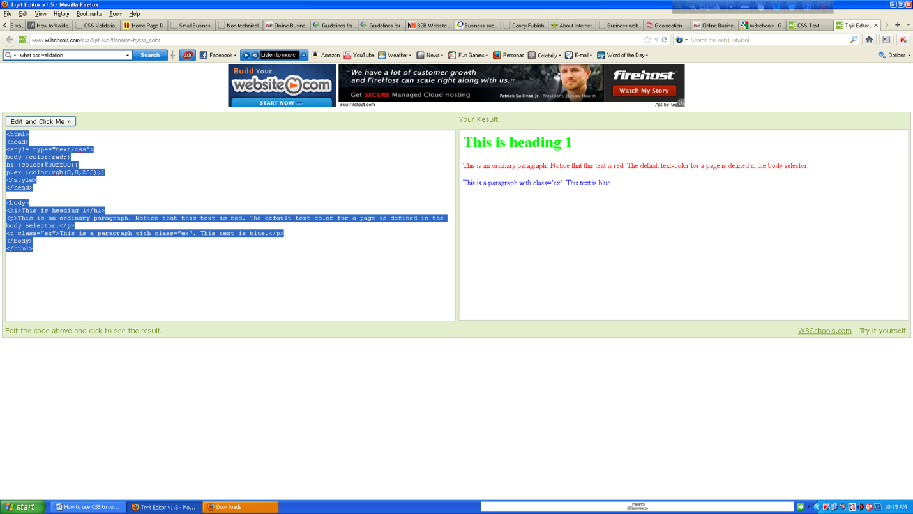

For W3C compliant CSS: If you define the color property, you must also define the background-color property.

## Text Alignment

The text-align property is used to set the horizontal alignment of a text.

Text can be centered, or aligned to the left or right, or justified.

When text-align is set to "justify", each line is stretched so that every line has equal width, and the left and right margins are straight (like in magazines and newspapers).

## 

## Example

<html>

<head>

<style type="text/css">

h1 {text-align:center;} p.date {text-align:right;} p.main {text-align:justify;} </style> </head>

<body>

<h1>CSS text-align Example</h1>

<p class="date">May, 2009</p>

<p class="main">In my younger and more vulnerable years my father gave me some advice that I've been turning over in my mind ever since. 'Whenever you feel like criticizing anyone,' he told me,

'just remember that all the people in this world haven't had the advantages that you've had.'</p>

<p><b>Note:</b> Resize the browser window to see how the value "justify" works.</p>

</body>

</html>

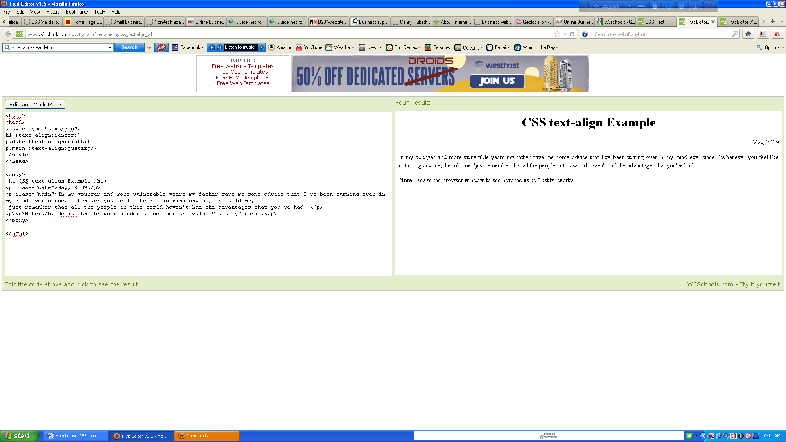

## Text Decoration

The text-decoration property is used to set or remove decorations from text.

The text-decoration property is mostly used to remove underlines from links for design purposes:

## 

## Example

<html>

<head>

<style type="text/css">

a {text-decoration:none;}

</style>

</head>

<body>

<p>Link to: <a href="http://www.w3schools.com">HLSC.com</a></p>

</body>

</html>

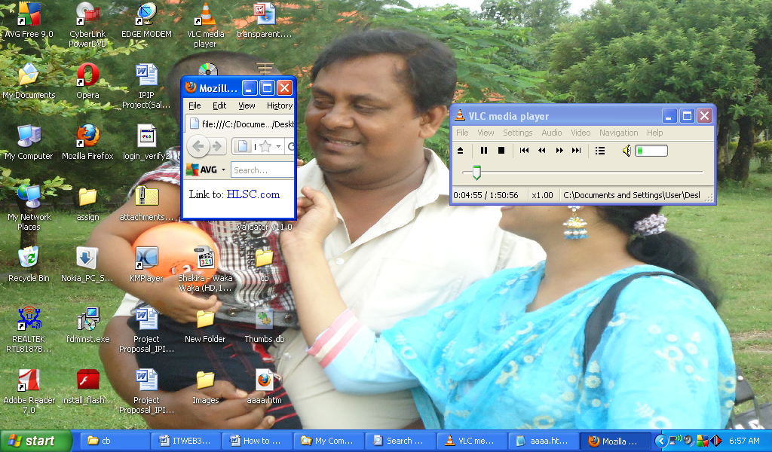

It can also be used to decorate text:

## Example

<html>

<head>

<style type="text/css">

h1 {text-decoration:overline;}

h2 {text-decoration:line-through;}

h3 {text-decoration:underline;}

h4 {text-decoration:blink;}

</style>

</head>

<body>

<h1>This is heading 1</h1>

<h2>This is heading 2</h2>

<h3>This is heading 3</h3>

<h4>This is heading 4</h4>

<p><b>Note:</b> The "blink" value is not supported in IE, Chrome, or Safari.</p>

</body>

</html>

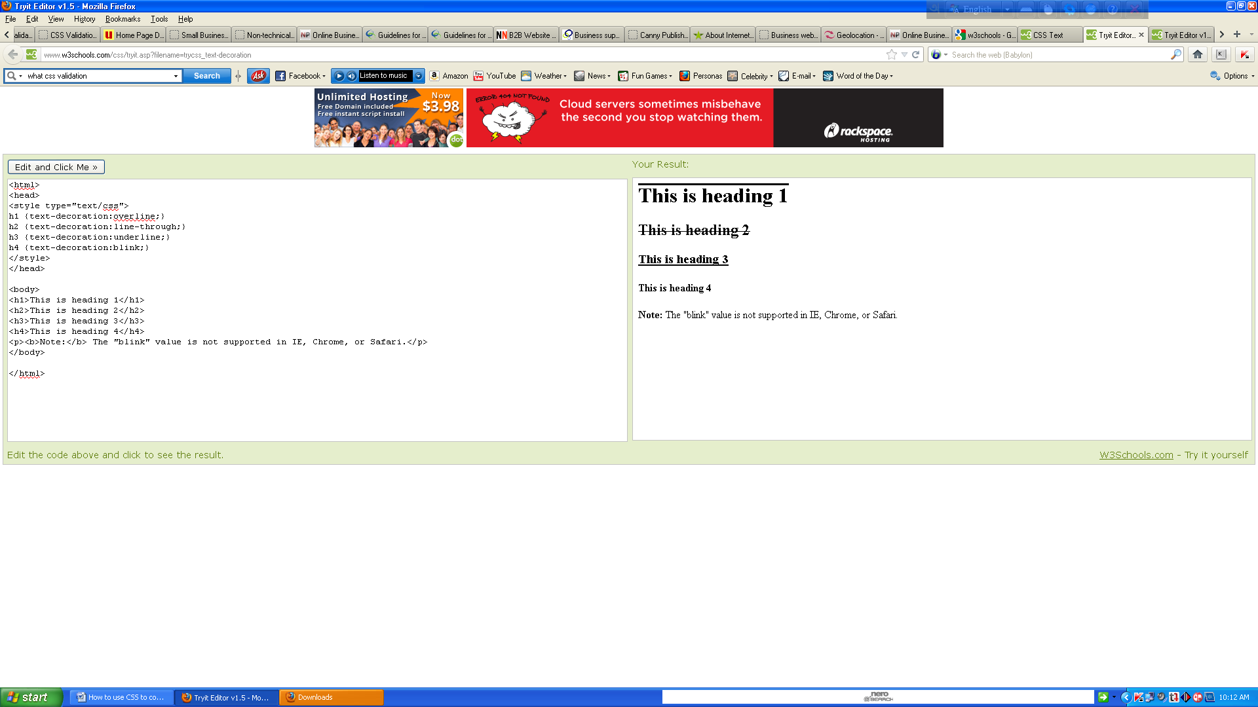

It is not recommended to underline text that is not a link, as this often confuses users.

## Text Transformation

The text-transform property is used to specify uppercase and lowercase letters in a text.

It can be used to turn everything into uppercase or lowercase letters, or capitalize the first letter of each word.

## 

## Example

<html>

<head>

<style type="text/css">

p.uppercase {text-transform:uppercase;} p.lowercase {text-transform:lowercase;}

p.capitalize {text-transform:capitalize;} </style> </head> <body> <p class="uppercase">This is some text.</p> <p class="lowercase">This is some text.</p> <p class="capitalize">This is some text.</p> </body> </html>

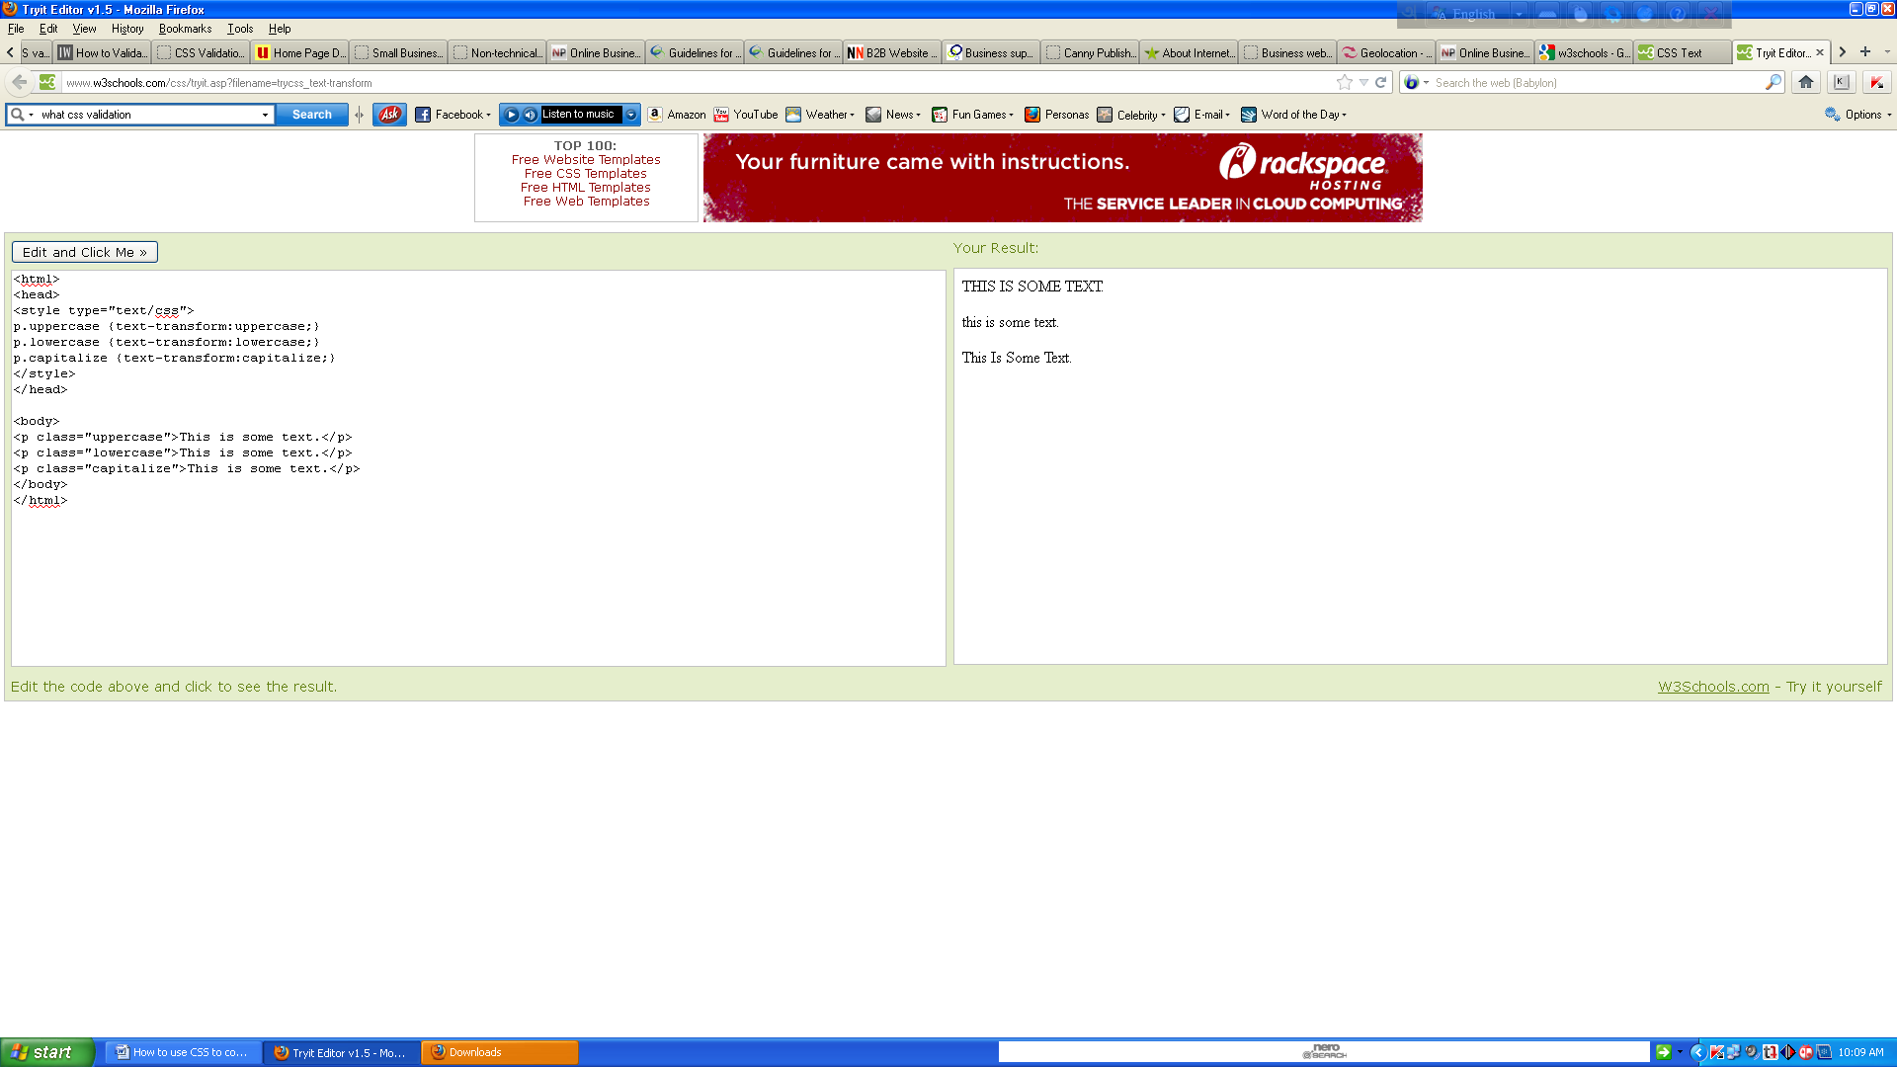

## Text Indentation

The text-indentation property is used to specify the indentation of the first line of a text.

## Example

<html><head><style type="text/css">p {text-indent:50px;}</style></head><body>

<p>In my younger and more vulnerable years my father gave me some advice that I've been turning over in my mind ever since. 'Whenever you feel like criticizing anyone,' he told me, 'just remember that all the people in this world haven't had the advantages that you've had.'</p>

</body>

</html>  
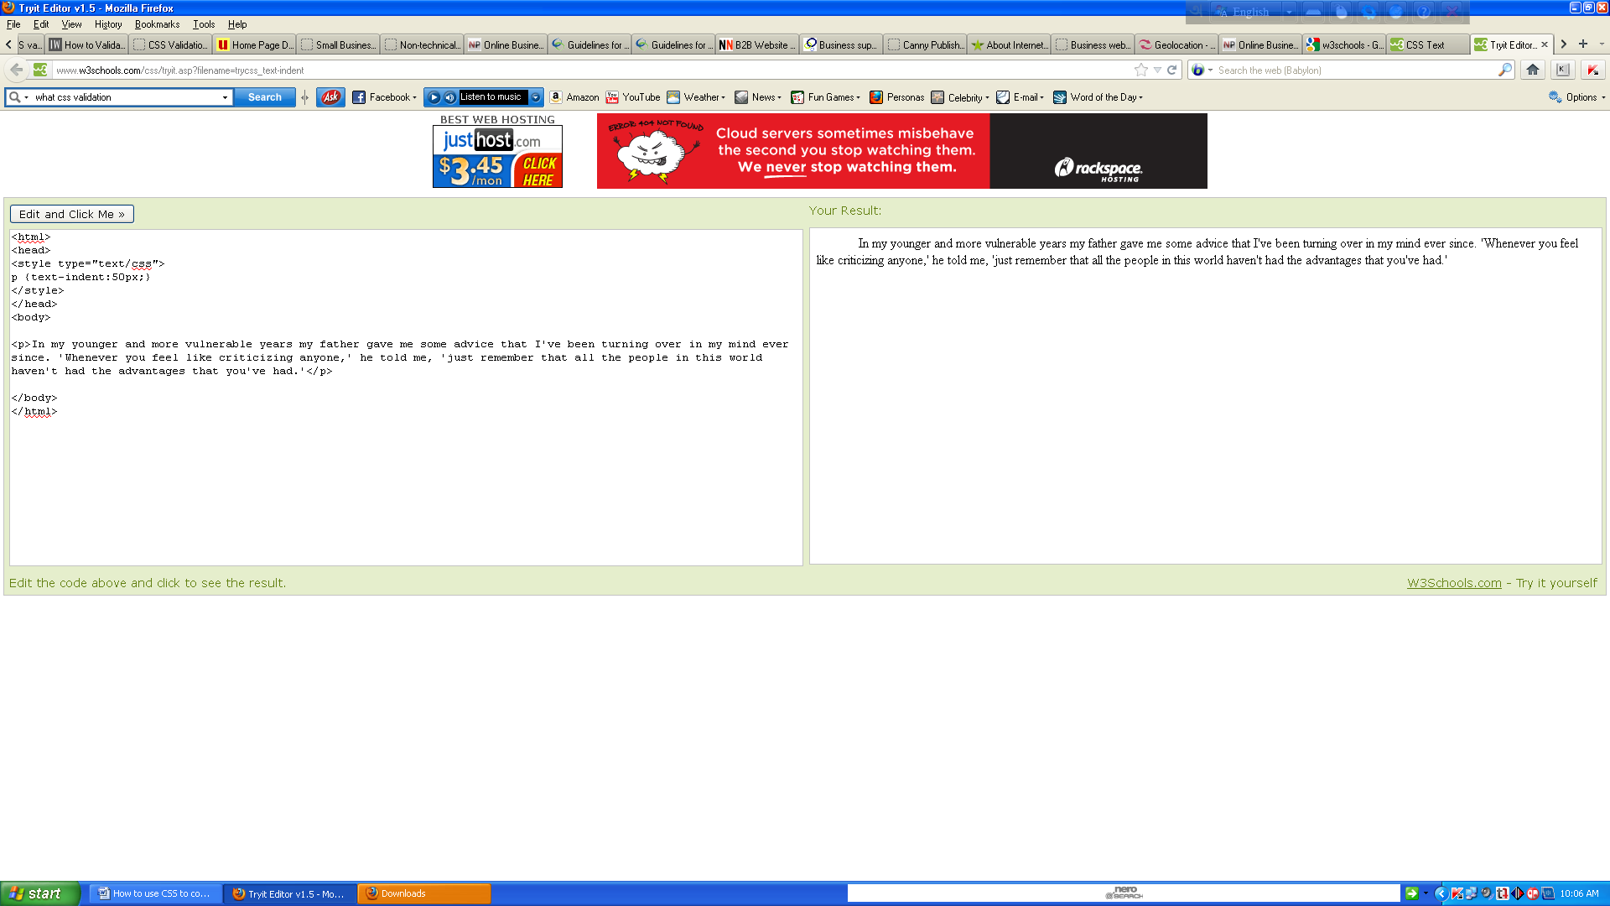

## Difference between Serif and Sans-serif Fonts

# CSS Font

CSS font properties define the font family, boldness, size, and the style of a text.

## Difference between Serif and Sans-serif Fonts

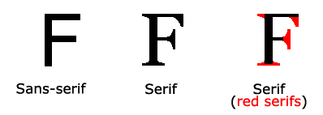

On computer screens, sans-serif fonts are considered easier to read than serif fonts.

## CSS Font Families

In CSS, there are two types of font family names:

* **generic family** - a group of font families with a similar look (like "Serif" or "Monospace")
* **font family** - a specific font family (like "Times New Roman" or "Arial")

|  |  |  |
| --- | --- | --- |
| **Generic family** | **Font family** | **Description** |
| Serif | Times New Roman Georgia | Serif fonts have small lines at the ends on some characters |
| Sans-serif | Arial Verdana | "Sans" means without - these fonts do not have the lines at the ends of characters |
| Monospace | Courier New Lucida Console | All monospace characters have the same width |

## Font Family

The font family of a text is set with the font-family property.

The font-family property should hold several font names as a "fallback" system. If the browser does not support the first font, it tries the next font.

Start with the font you want, and end with a generic family, to let the browser pick a similar font in the generic family, if no other fonts are available.

**Note**: If the name of a font family is more than one word, it must be in quotation marks, like font-family: "Times New Roman".

More than one font family is specified in a comma-separated list:

## 

## Example

<html><head><style type="text/css">p.serif{font-family:"Times New Roman",Times,serif;}

p.sansserif{font-family:Arial,Helvetica,sans-serif;}</style></head><body>

<h1>CSS font-family</h1>

<p class="serif">This is a paragraph, shown in the Times New Roman font.</p>

<p class="sansserif">This is a paragraph, shown in the Arial font.</p></body></html>

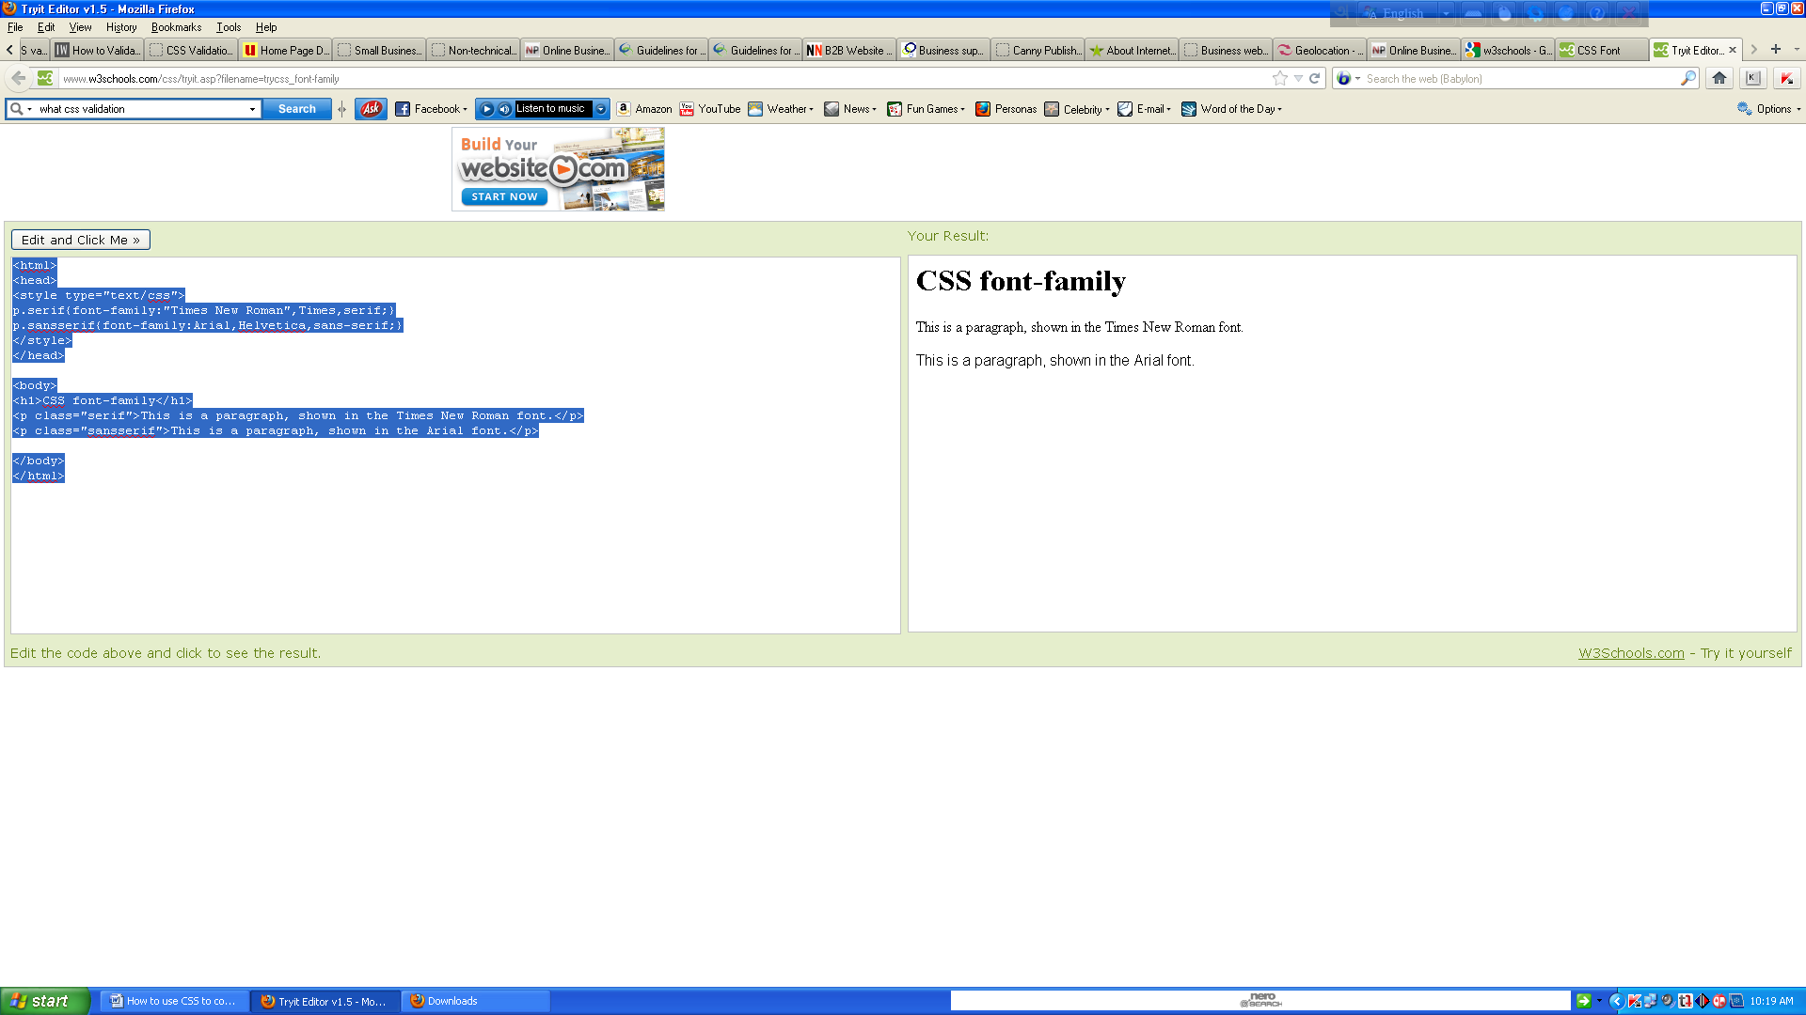

## Font Style

The font-style property is mostly used to specify italic text.

This property has three values:

* normal - The text is shown normally
* italic - The text is shown in italics
* oblique - The text is "leaning" (oblique is very similar to italic, but less supported)

## 

## Example

<html><head><style type="text/css">p.normal {font-style:normal;}p.italic {font-style:italic;}

p.oblique {font-style:oblique;}</style></head><body><p class="normal">This is a paragraph, normal.</p><p class="italic">This is a paragraph, italic.</p><p class="oblique">This is a paragraph, oblique.</p></body></html>

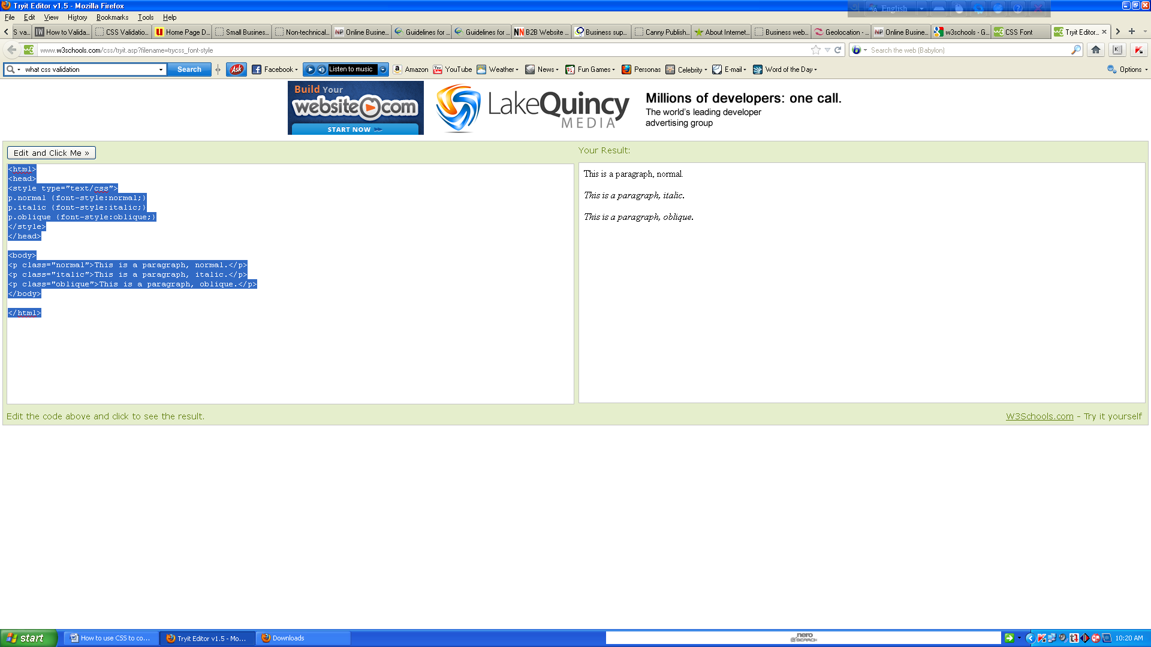

## Font Size

The font-size property sets the size of the text.

Being able to manage the text size is important in web design. However, you should not use font size adjustments to make paragraphs look like headings, or headings look like paragraphs.

Always use the proper HTML tags, like <h1> - <h6> for headings and <p> for paragraphs.

The font-size value can be an absolute or relative size.

Absolute size:

* Sets the text to a specified size
* Does not allow a user to change the text size in all browsers (bad for accessibility reasons)
* Absolute size is useful when the physical size of the output is known
* Relative size:
* Sets the size relative to surrounding elements
* Allows a user to change the text size in browsers

If you do not specify a font size, the default size for normal text, like paragraphs, is 16px (16px=1em).

## Set Font Size with Pixels

Setting the text size with pixels gives you full control over the text size:

## 

## Example

<html><head><style>h1 {font-size:40px;}h2 {font-size:30px;}p {font-size:14px;}</style>

</head><body><h1>This is heading 1</h1><h2>This is heading 2</h2><p>This is a paragraph.</p><p>Specifying the font-size in px allows allows Internet Explorer 9, Firefox, Chrome, Opera, and Safari to resize the text.</p><p><b>Note:</b> This example does not work in IE, prior version 9.</p></body></html>

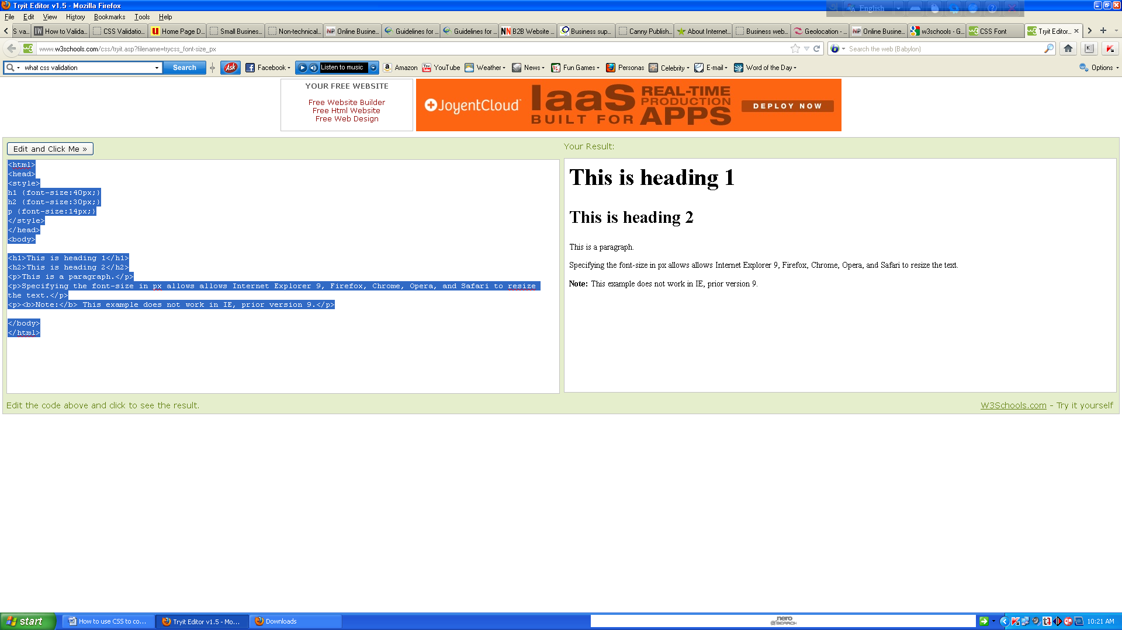

The example above allows Internet Explorer 9, Firefox, Chrome, Opera, and Safari to resize the text.

**Note:** The example above does not work in IE, prior version 9.

The text can be resized in all browsers using the zoom tool (however, this resizes the entire page, not just the text).

The default text size in browsers is 16px.

1em = 16 px

## 

## Set Font Size With Em

To avoid the resizing problem with older versions of Internet Explorer, many developers use em instead of pixels.

The em size unit is recommended by the W3C.

1em is equal to the current font size. The default text size in browsers is 16px. So, the default size of 1em is 16px.

The size can be calculated from pixels to em using this formula: *pixels*/16=*em*

## 

## Example

<html><head><style>h1 {font-size:2.5em;} /* 40px/16=2.5em */h2 {font-size:1.875em;} /* 30px/16=1.875em */p {font-size:0.875em;} /* 14px/16=0.875em */</style></head><body>

<h1>This is heading 1</h1><h2>This is heading 2</h2><p>This is a paragraph.</p>

<p>Specifying the font-size in em allows all major browsers to resize the text.

Unfortunately, there is still a problem with older versions of IE. When resizing the text, it becomes larger/smaller than it should.</p></body></html>

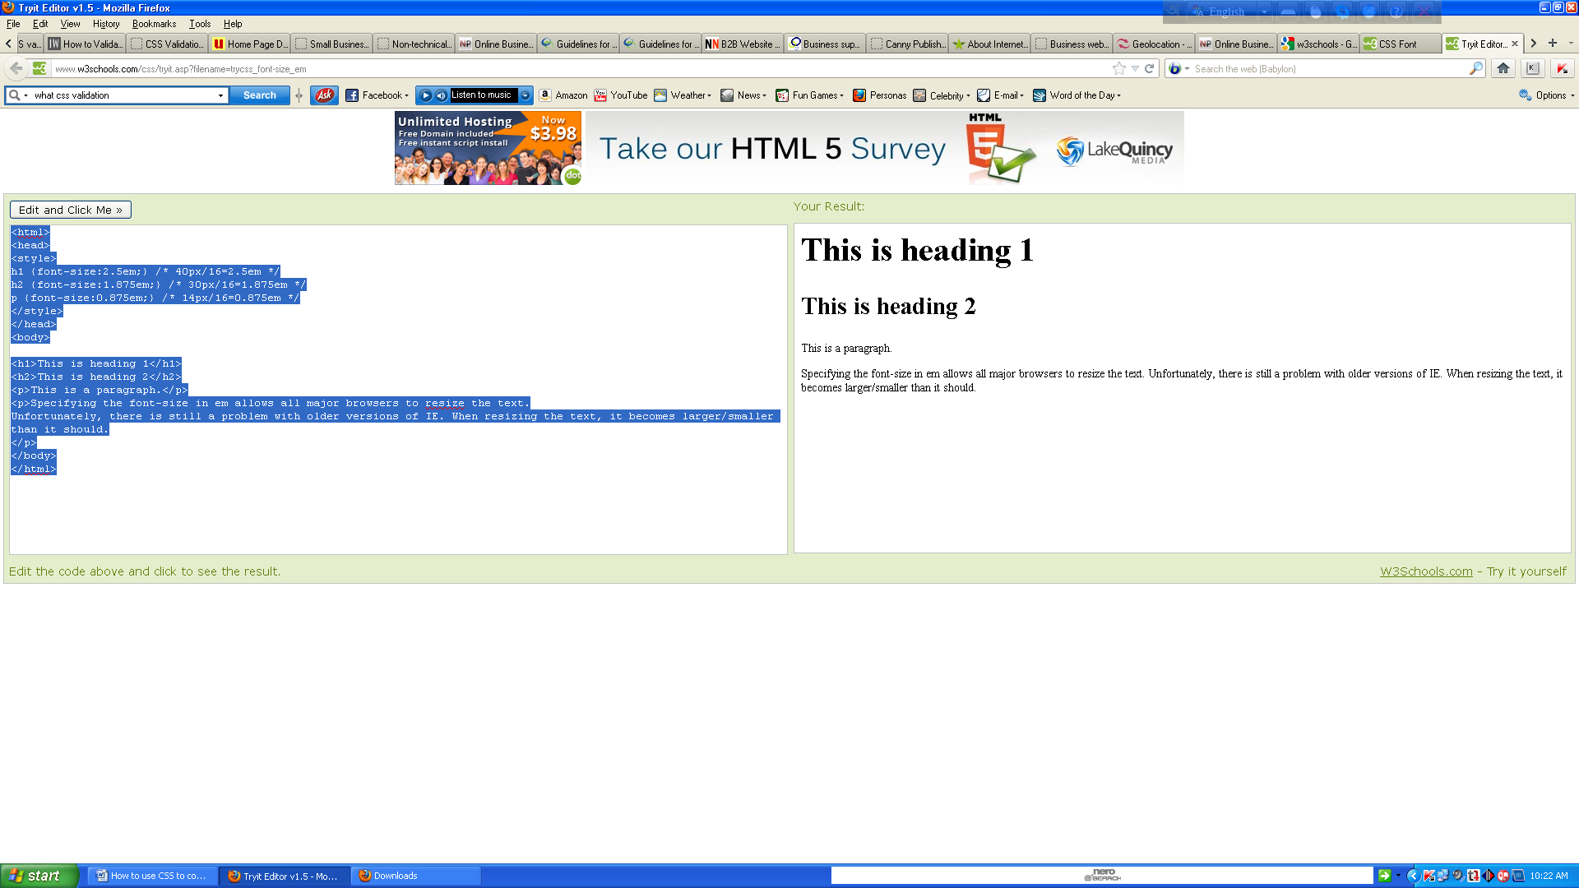In the example above, the text size in em is the same as the previous example in pixels. However, with the em size, it is possible to adjust the text size in all browsers.

Unfortunately, there is still a problem with older versions of IE. The text becomes larger than it should when made larger, and smaller than it should when made smaller.

## Use a Combination of Percent and Em

The solution that works in all browsers is to set a default font-size in percent for the <body> element:

## 

## Example

<html><head><style>body {font-size:100%;}h1 {font-size:2.5em;}h2 {font-size:1.875em;}

p {font-size:0.875em;}</style></head><body><h1>This is heading 1</h1><h2>This is heading 2</h2><p>This is a paragraph.</p><p>Specifying the font-size in percent and em displays the same size in all major browsers, and allows all browsers to resize the text!</p></body></html>

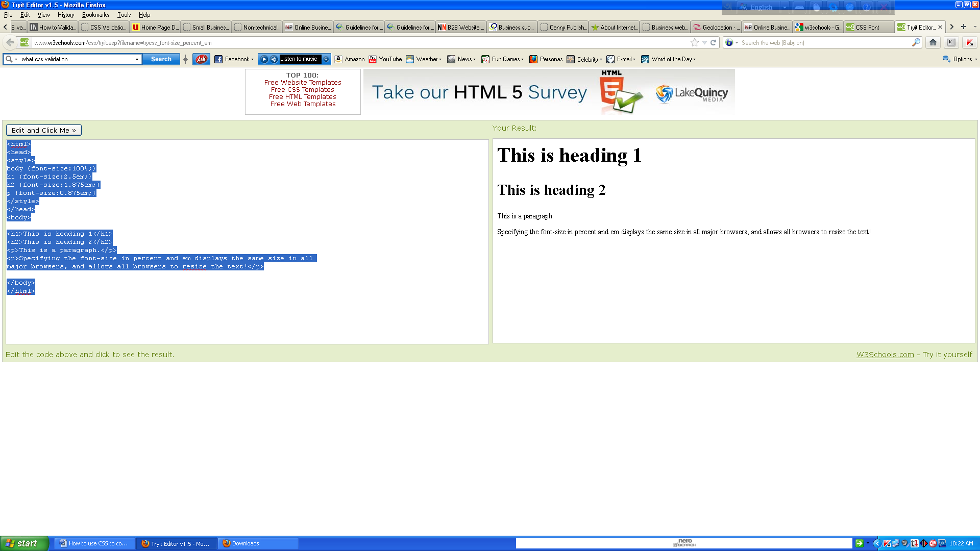

Our code now works great! It shows the same text size in all browsers, and allows all browsers to zoom or resize the text!

## All CSS Font Properties

|  |  |
| --- | --- |
| **Property** | **Description** |
| [font](http://www.w3schools.com/cssref/pr_font_font.asp) | Sets all the font properties in one declaration |
| [font-family](http://www.w3schools.com/cssref/pr_font_font-family.asp) | Specifies the font family for text |
| [font-size](http://www.w3schools.com/cssref/pr_font_font-size.asp) | Specifies the font size of text |
| [font-style](http://www.w3schools.com/cssref/pr_font_font-style.asp) | Specifies the font style for text |
| [font-variant](http://www.w3schools.com/cssref/pr_font_font-variant.asp) | Specifies whether or not a text should be displayed in a small-caps font |
| [font-weight](http://www.w3schools.com/cssref/pr_font_weight.asp) | Specifies the weight of a font |

# How many styles of link?

# CSS Links

Links can be styled in different ways.

## 

## Styling Links

Links can be styled with any CSS property (e.g. color, font-family, background, etc.).

Special for links are that they can be styled differently depending on what state they are in.

The four links states are:

* a:link - a normal, unvisited link
* a:visited - a link the user has visited
* a:hover - a link when the user mouses over it
* a:active - a link the moment it is clicked

## 

## Example

<html><head><style type="text/css">a:link {color:#FF0000;} /* unvisited link */

a:visited {color:#00FF00;} /* visited link */a:hover {color:#FF00FF;} /* mouse over link */

a:active {color:#0000FF;} /* selected link */</style></head><body><p><b><a href="default.asp" target="_blank">This is a link</a></b></p><p><b>Note:</b> a:hover MUST come after a:link and a:visited in the CSS definition in order to be effective.</p>

<p><b>Note:</b> a:active MUST come after a:hover in the CSS definition in order

to be effective.</p></body></html>

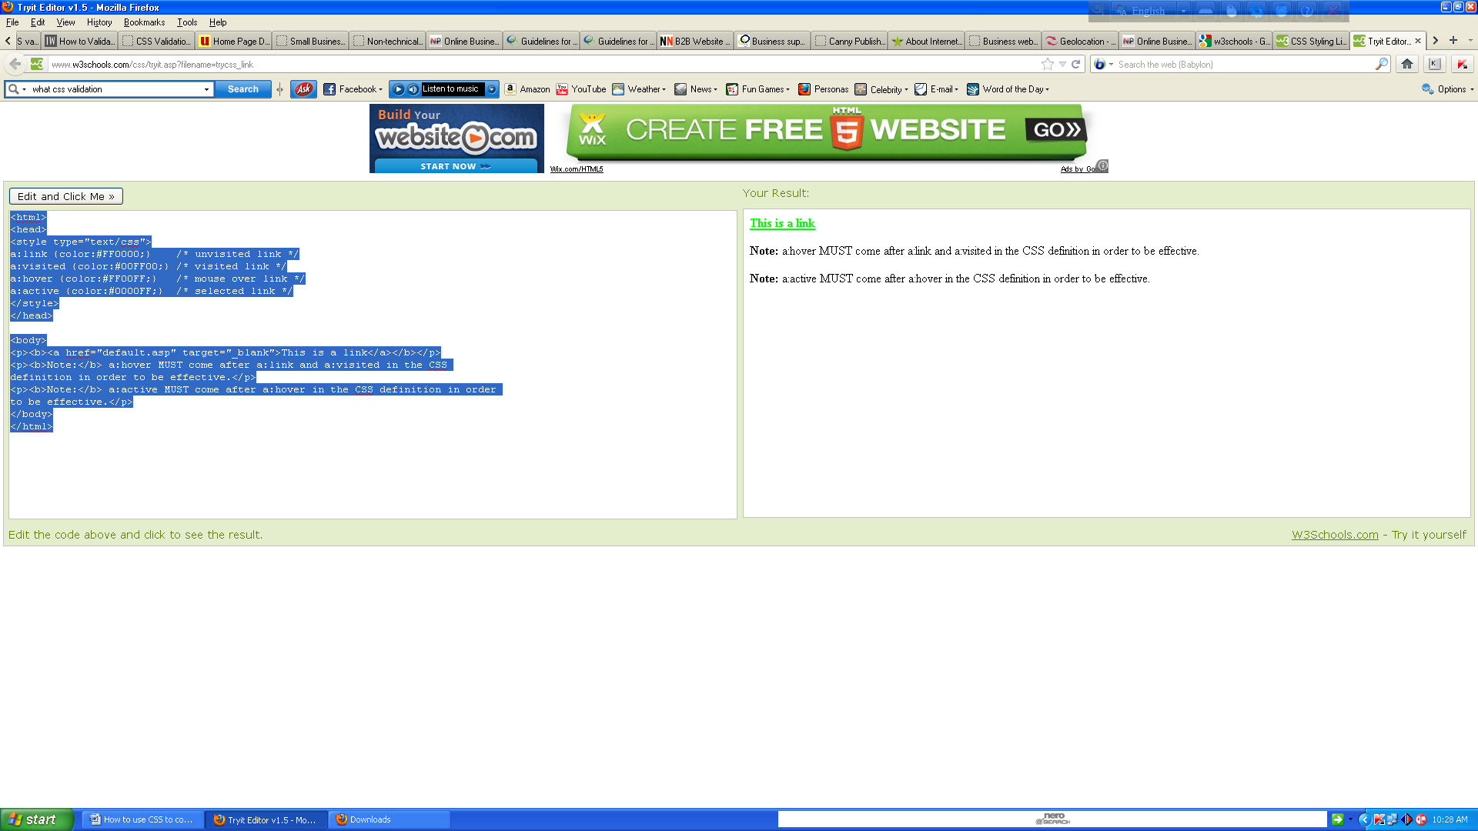  
When setting the style for several link states, there are some order rules:

* a:hover MUST come after a:link and a:visited
* a:active MUST come after a:hover

## Common Link Styles

In the example above the link changes color depending on what state it is in.

Lets go through some of the other common ways to style links:

## 

## Text Decoration

The text-decoration property is mostly used to remove underlines from links:

## 

## Example

<html><head><style type="text/css">a:link {text-decoration:none;} /* unvisited link */

a:visited {text-decoration:none;} /* visited link */a:hover {text-decoration:underline;} /* mouse over link */a:active {text-decoration:underline;} /* selected link */</style></head><body>

<p><b><a href="default.asp" target="_blank">This is a link</a></b></p><p><b>Note:</b> a:hover MUST come after a:link and a:visited in the CSS definition in order to be effective.</p>

<p><b>Note:</b> a:active MUST come after a:hover in the CSS definition in order

to be effective.</p></body></html>

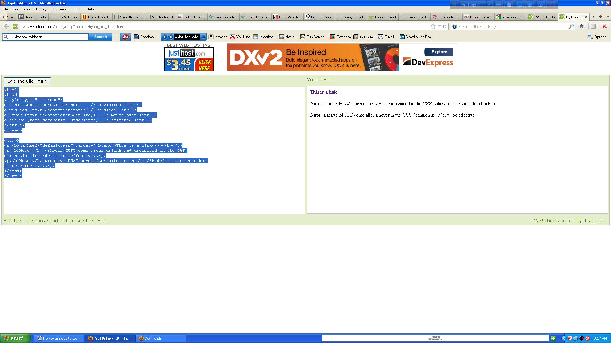

Background Color

The background-color property specifies the background color for links:

## 

## Example

<html><head><style type="text/css">a:link {background-color:#B2FF99;} /* unvisited link */

a:visited {background-color:#FFFF85;} /* visited link */a:hover {background-color:#FF704D;} /* mouse over link */a:active {background-color:#FF704D;} /* selected link */</style></head>

<body><p><b><a href="default.asp" target="_blank">This is a ink</a></b></p><p><b>Note:</b> a:hover MUST come after a:link and a:visited in the CSS

definition in order to be effective.</p><p><b>Note:</b> a:active MUST come after a:hover in the CSS definition in order to be effective.</p></body></html>

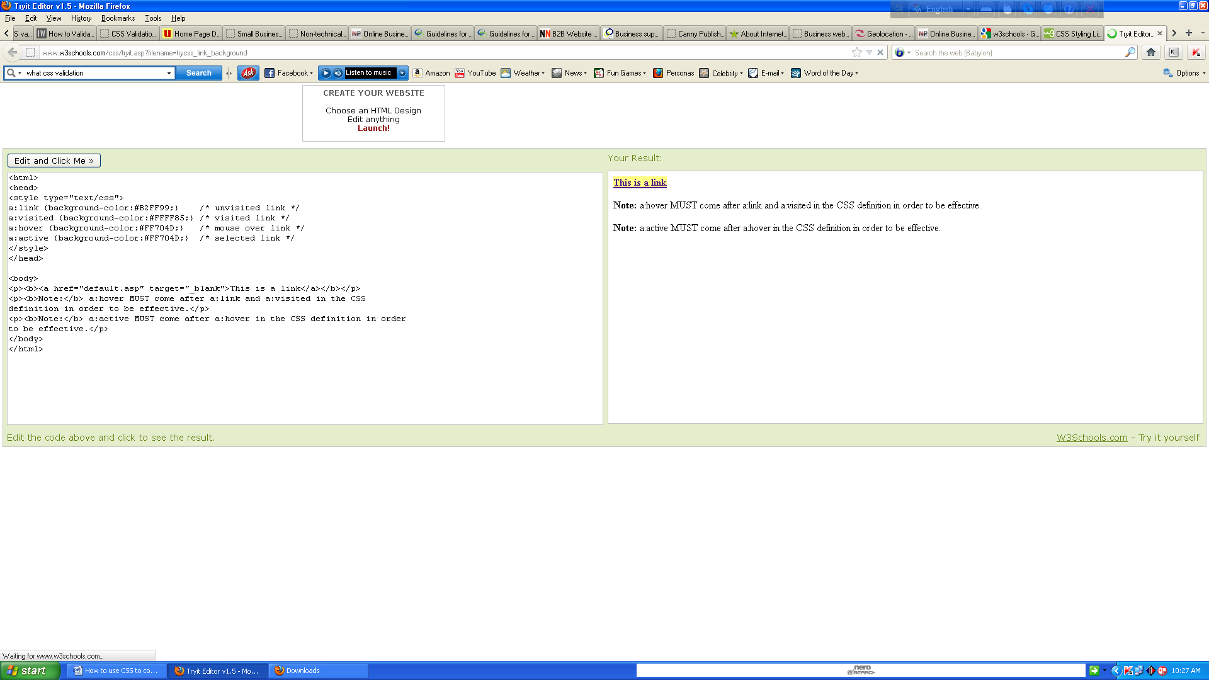

# CSS Lists

The CSS list properties allow you to:

* Set different list item markers for ordered lists
* Set different list item markers for unordered lists
* Set an image as the list item marker

## 

## List

In HTML, there are two types of lists:

* unordered lists - the list items are marked with bullets
* ordered lists - the list items are marked with numbers or letters
* With CSS, lists can be styled further, and images can be used as the list item marker.

## Different List Item Markers

The type of list item marker is specified with the list-style-type property:

## 

## Example

<html><head><style type="text/css">ul.a {list-style-type:circle;}ul.b {list-style-type:square;}

ol.c {list-style-type:upper-roman;}ol.d {list-style-type:lower-alpha;}</style></head><body>

<p>Example of unordered lists:</p><ul class="a"> <li>Coffee</li> <li>Tea</li> <li>Coca Cola</li></ul><ul class="b"> <li>Coffee</li> <li>Tea</li> <li>Coca Cola</li></ul>

<p>Example of ordered lists:</p><ol class="c"> <li>Coffee</li> <li>Tea</li> <li>Coca Cola</li></ol><ol class="d"> <li>Coffee</li> <li>Tea</li> <li>Coca Cola</li></ol>

</body></html>

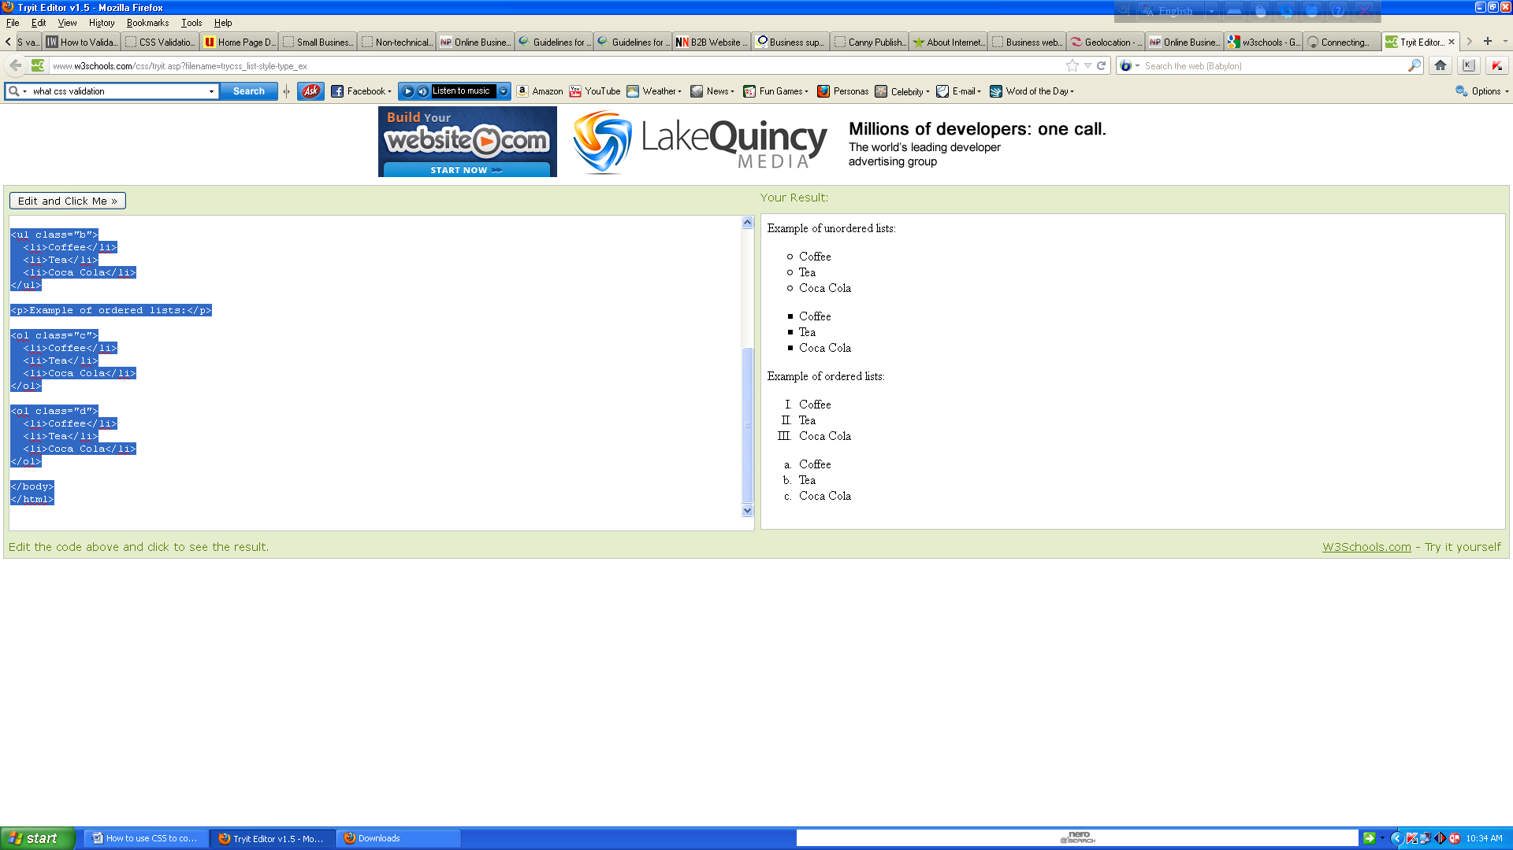

Some of the values are for unordered lists, and some for ordered lists.

## An Image as The List Item Marker

To specify an image as the list item marker, use the list-style-image property:

## 

## Example

<html><head><style type="text/css">ul { list-style-image:url('sqpurple.gif'); }</style>

</head><body><ul><li>Coffee</li><li>Tea</li><li>Coca Cola</li></ul></body></html>

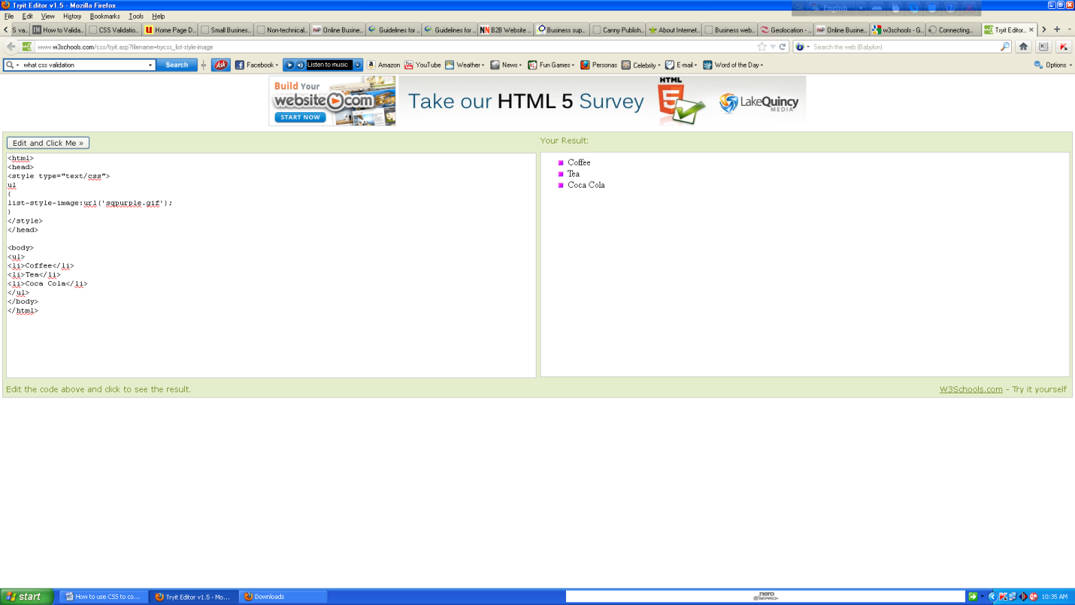

The example above does not display equally in all browsers. IE and Opera will display the image-marker a little bit higher than Firefox, Chrome, and Safari.

If you want the image-marker to be placed equally in all browsers, a crossbrowser solution is explained below.

## Cross browser Solution

The following example displays the image-marker equally in all browsers:

## Example

<html><head><style type="text/css">ul { list-style-type:none;padding:0px;margin:0px; }

li { background-image:url(sqpurple.gif);background-repeat:no-repeat; background-position:0px 5px; padding-left:14px; }</style></head><body><ul><li>Coffee</li><li>Tea</li><li>Coca Cola</li></ul></body></html>

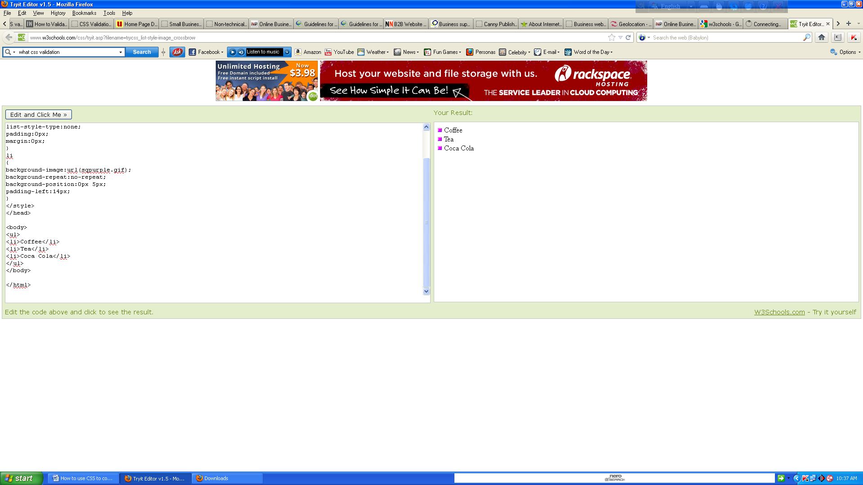  
Example explained:

* For ul:
* Set the list-style-type to none to remove the list item marker
* Set both padding and margin to 0px (for cross-browser compatibility)
* For li:
* Set the URL of the image, and show it only once (no-repeat)
* Position the image where you want it (left 0px and down 5px)
* Position the text in the list with padding-left

What are shorthand properties?

## 

## List - Shorthand property

It is also possible to specify all the list properties in one, single property. This is called a shorthand property.

The shorthand property used for lists is the list-style property:

## 

## Example

<html><head><style type="text/css">ul { list-style:square url("sqpurple.gif"); }</style>

</head><body><ul><li>Coffee</li><li>Tea</li><li>Coca Cola</li></ul></body></html>

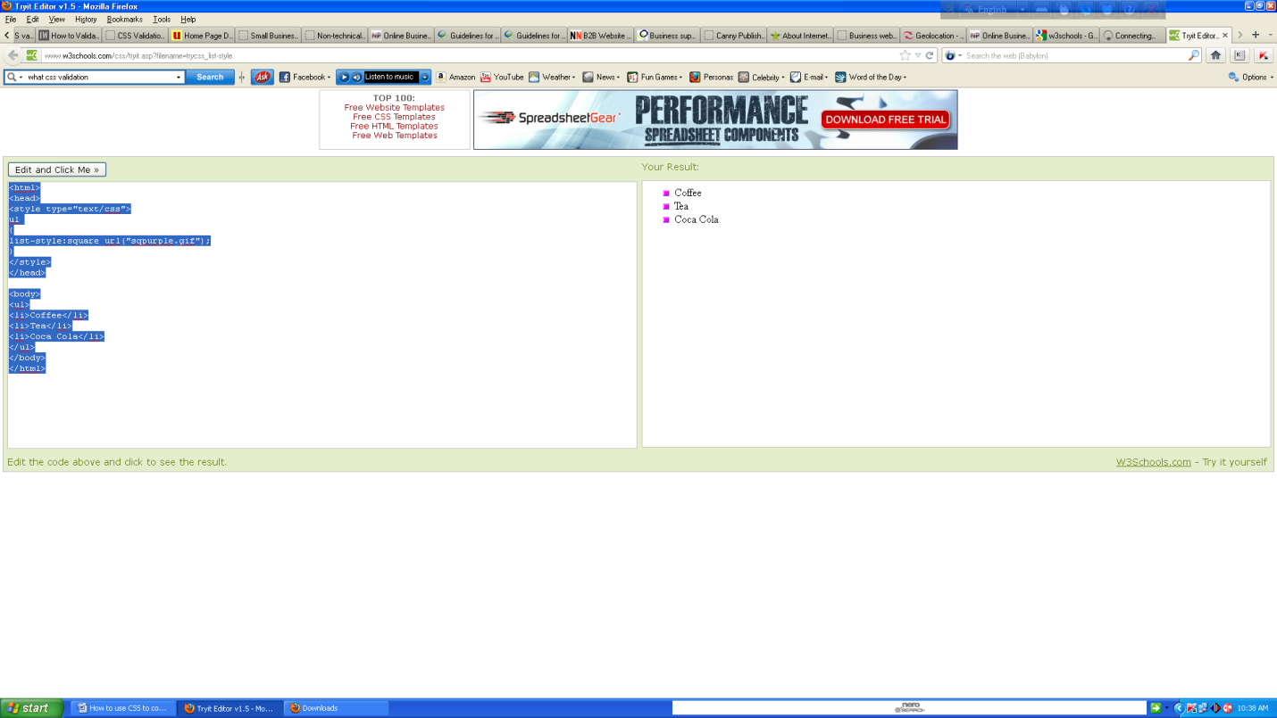

When using the shorthand property, the orders of the values are:

* list-style-type
* list-style-position (for a description, see the CSS properties table below)
* list-style-image

It does not matter if one of the values above is missing, as long as the rest are in the specified order.

## All CSS List Properties

|  |  |
| --- | --- |
| **Property** | **Description** |
| [list-style](http://www.w3schools.com/cssref/pr_list-style.asp) | Sets all the properties for a list in one declaration |
| [list-style-image](http://www.w3schools.com/cssref/pr_list-style-image.asp) | Specifies an image as the list-item marker |
| [list-style-position](http://www.w3schools.com/cssref/pr_list-style-position.asp) | Specifies if the list-item markers should appear inside or outside the content flow |
| [list-style-type](http://www.w3schools.com/cssref/pr_list-style-type.asp) | Specifies the type of list-item marker |

## Table Borders

To specify table borders in CSS, use the border property.

The example below specifies a black border for table, th, and td elements:

## 

## Example

<html><head><style type="text/css">table,th,td { border:1px solid black; }</style>

</head><body><table><tr><th>Firstname</th><th>Lastname</th></tr>

<tr><td>Peter</td><td>Griffin</td></tr><tr><td>Lois</td><td>Griffin</td></tr></table>

</body></html>

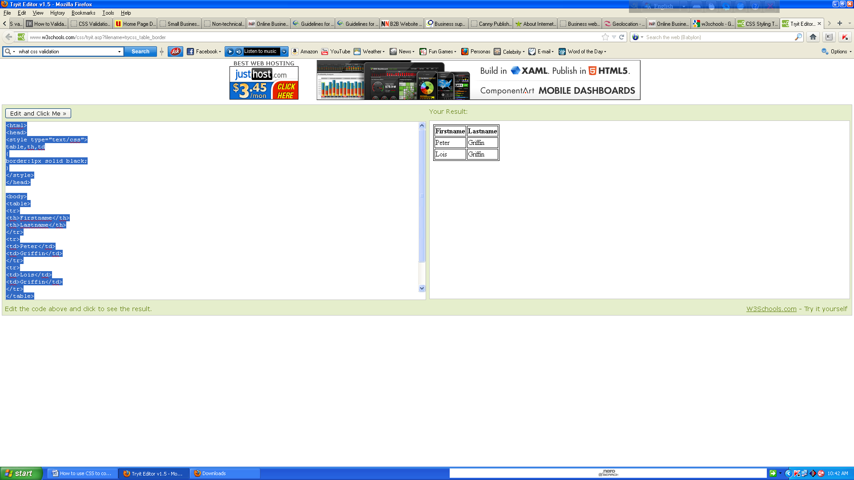

Notice that the table in the example above has double borders. This is because both the table and the th/td elements have separate borders.

To display a single border for the table, use the border-collapse property.

## 

## Collapse Borders

The border-collapse property sets whether the table borders are collapsed into a single border or separated:

## 

## Example

<html><head><style type="text/css">Table {border-collapse:collapse;}table, td, th{border:1px solid black;}</style></head><body><table><tr><th>Firstname</th><th>Lastname</th>

</tr><tr><td>Peter</td><td>Griffin</td></tr><tr><td>Lois</td><td>Griffin</td></tr>

</table><p><b>Note:</b> If a !DOCTYPE is not specified, the border-collapse property can produce unexpected results in IE8 and earlier versions.</p></body></html>

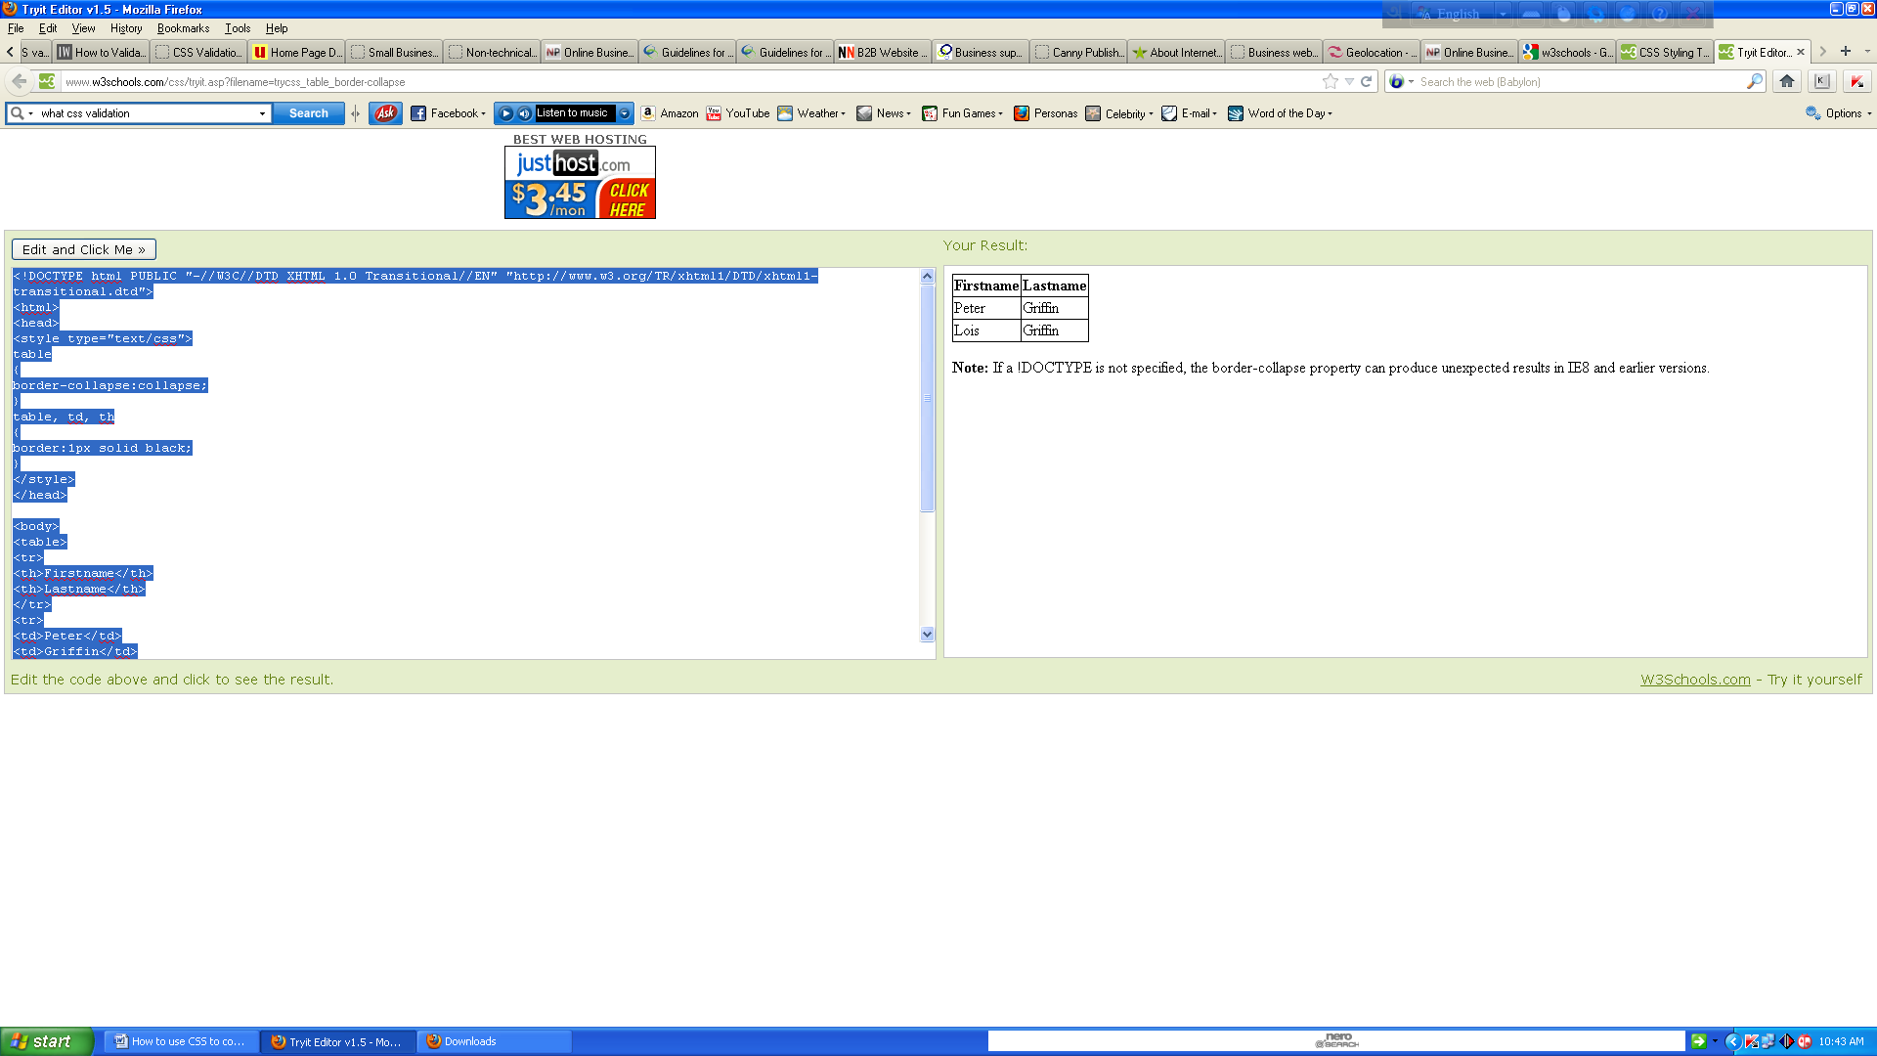

## Table Width and Height

Width and height of a table is defined by the width and height properties.

The example below sets the width of the table to 100%, and the height of the th elements to 50px:

## 

## Example

<html><head><style type="text/css">table,td,th {border:1px solid black;}table{width:100%;}

th{height:50px;}</style></head><body><table><tr><th>Firstname</th><th>Lastname</th>

<th>Savings</th></tr><tr><td>Peter</td><td>Griffin</td><td>$100</td></tr><tr><td>Lois</td>

<td>Griffin</td><td>$150</td></tr><tr><td>Joe</td><td>Swanson</td><td>$300</td></tr>

<tr><td>Cleveland</td><td>Brown</td><td>$250</td></tr></table></body></html>

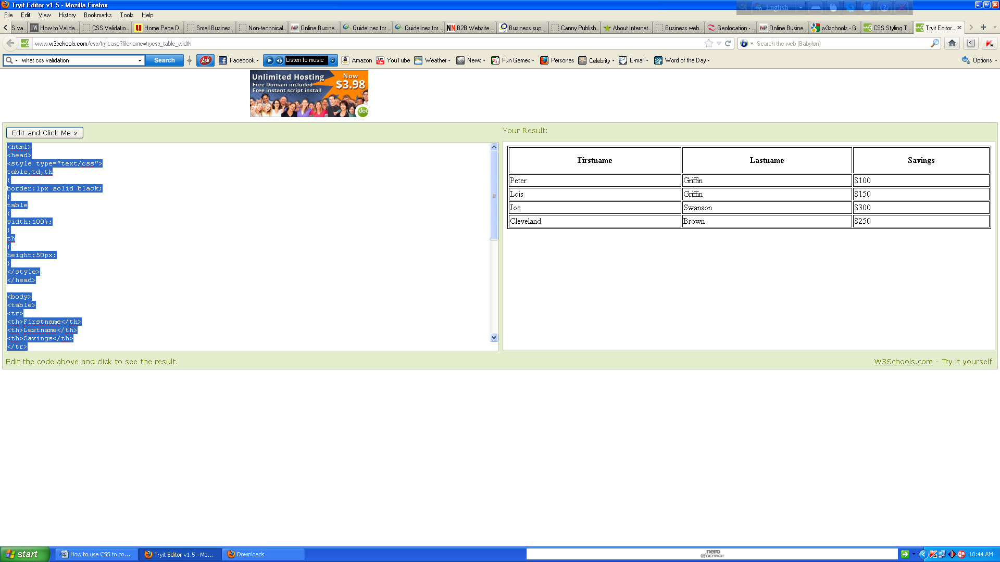

## Table Text Alignment

The text in a table is aligned with the text-align and vertical-align properties.

The text-align property sets the horizontal alignment, like left, right, or center:

## 

## Example

<html><head><style type="text/css">table,td,th{border:1px solid black;}td{text-align:right;}

</style></head><body><table><tr><th>Firstname</th><th>Lastname</th><th>Savings</th>

</tr><tr><td>Peter</td><td>Griffin</td><td>$100</td></tr><tr><td>Lois</td><td>Griffin</td>

<td>$150</td></tr><tr><td>Joe</td><td>Swanson</td><td>$300</td></tr><tr><td>Cleveland</td><td>Brown</td><td>$250</td></tr></table></body></html>

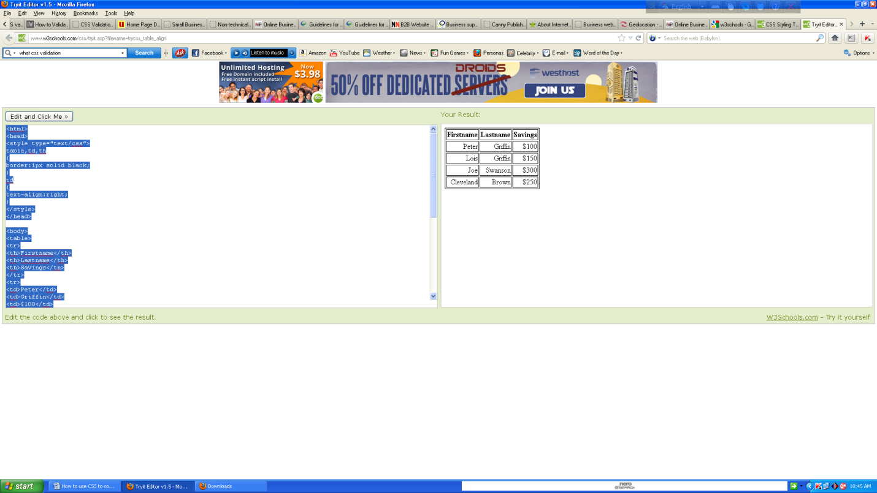

The vertical-align property sets the vertical alignment, like top, bottom, or middle:

## 

## Example

<html><head><style type="text/css">table, td, th {border:1px solid black;}

td{height:50px;vertical-align:bottom;}</style></head><body><table><tr><th>Firstname</th>

<th>Lastname</th><th>Savings</th></tr><tr><td>Peter</td><td>Griffin</td><td>$100</td>

</tr><tr><td>Lois</td><td>Griffin</td><td>$150</td></tr><tr><td>Joe</td><td>Swanson</td>

<td>$300</td></tr><tr><td>Cleveland</td><td>Brown</td><td>$250</td></tr></table>

</body></html>

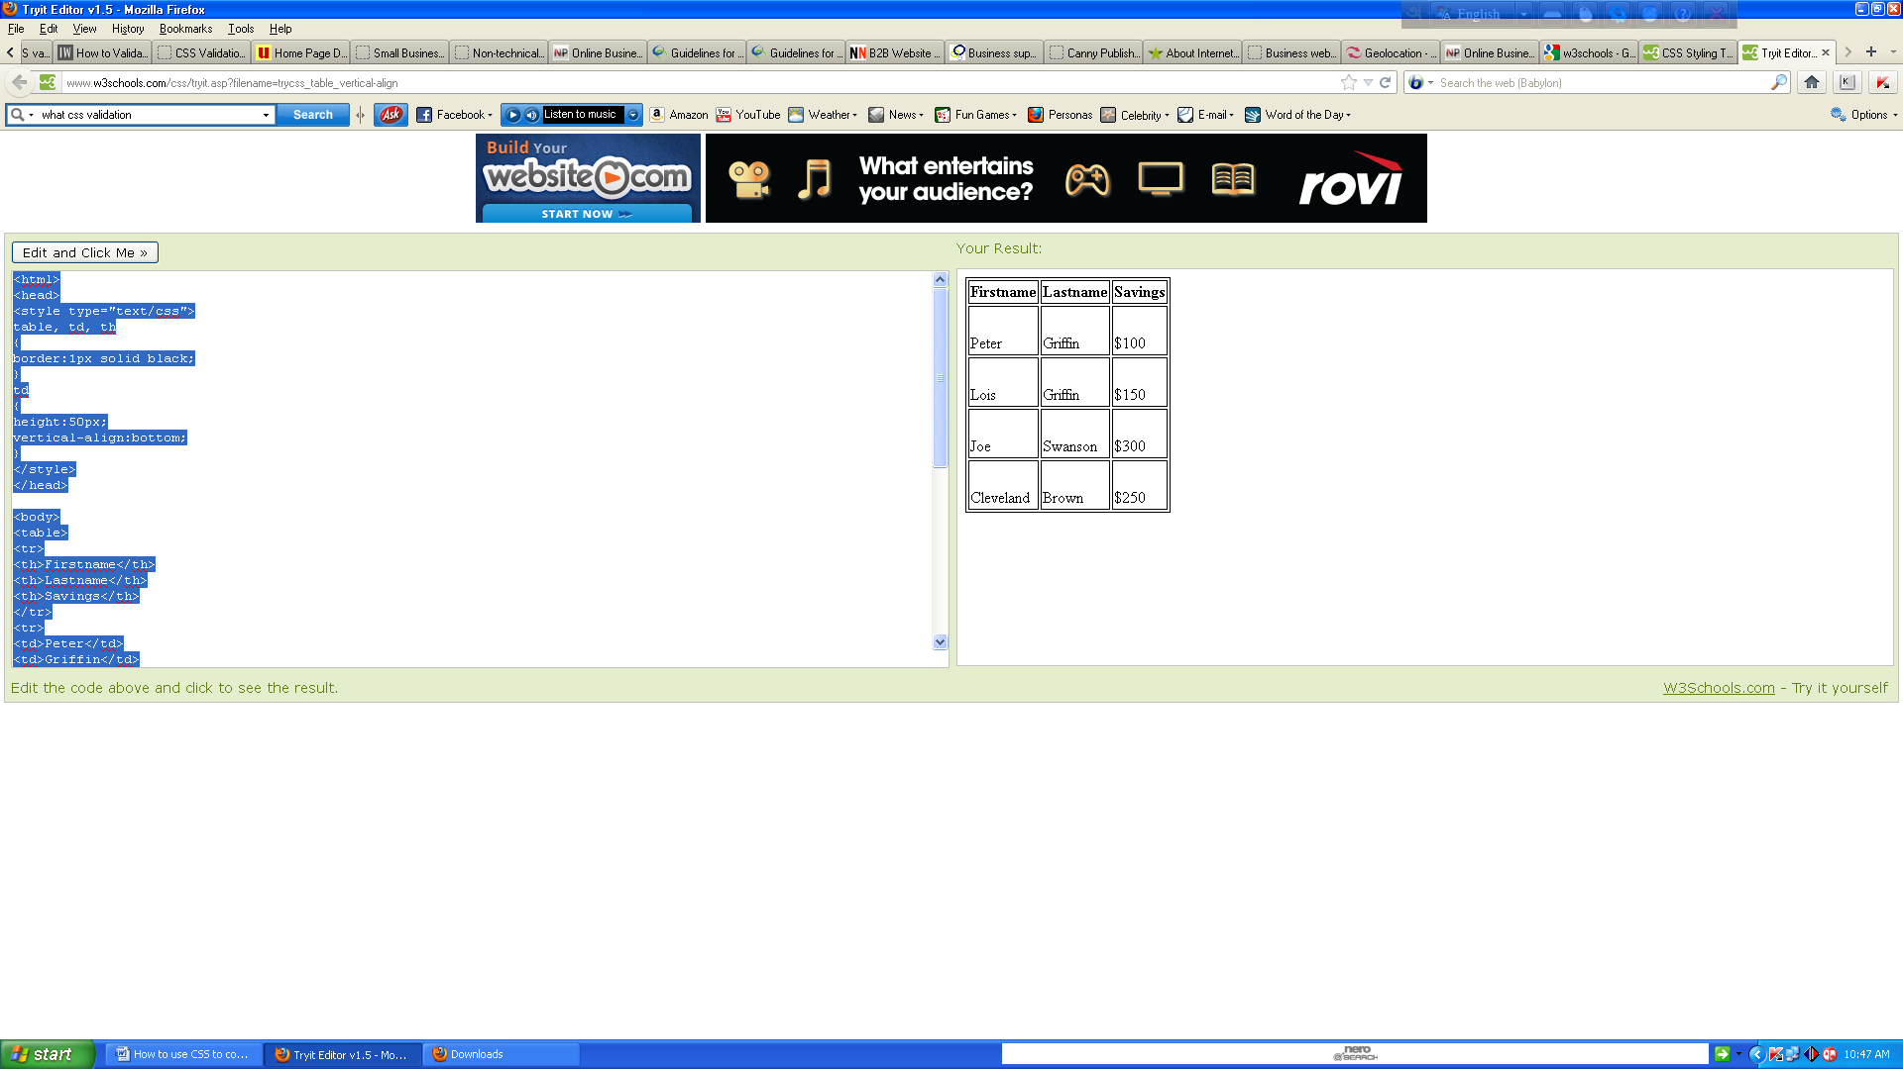

## Table Padding

To control the space between the border and content in a table, use the padding property on td and th elements:

## 

## Example <html><head><style type="text/css">table, td, th{border:1px solid black;}

td{padding:15px;}</style></head><body><table><tr><th>Firstname</th><th>Lastname</th>

<th>Savings</th></tr><tr><td>Peter</td><td>Griffin</td><td>$100</td></tr><tr>

<td>Lois</td><td>Griffin</td><td>$150</td></tr><tr><td>Joe</td><td>Swanson</td>

<td>$300</td></tr><tr><td>Cleveland</td><td>Brown</td><td>$250</td></tr></table>

</body></html>

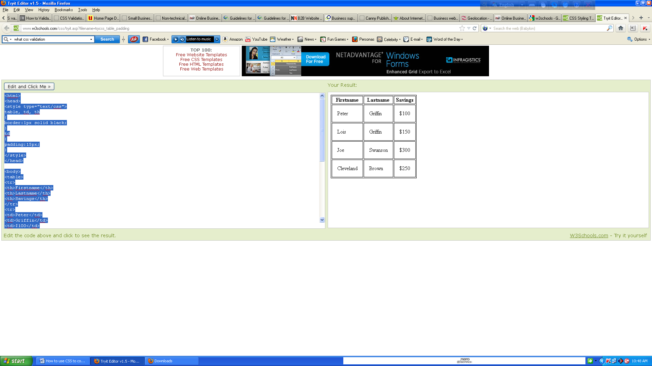

## Table Color

The example below specifies the color of the borders, and the text and background color of th elements:

## 

## Example <html><head><style type="text/css">table, td, th{border:1px solid green;}

th{background-color:green;color:white;}</style></head><body><table><tr><th>Firstname</th>

<th>Lastname</th><th>Savings</th></tr><tr><td>Peter</td><td>Griffin</td><td>$100</td>

</tr><tr><td>Lois</td><td>Griffin</td><td>$150</td></tr><tr><td>Joe</td><td>Swanson</td>

<td>$300</td></tr><tr><td>Cleveland</td><td>Brown</td><td>$250</td></tr>

</table></body></html>

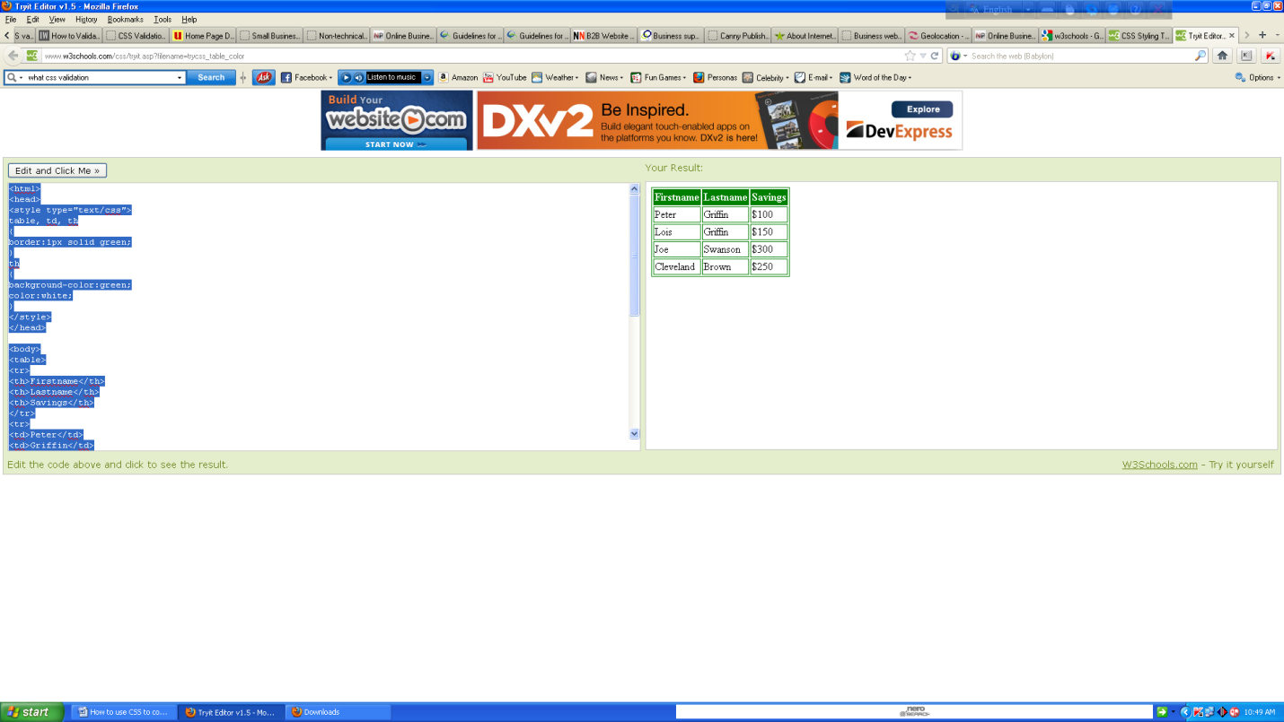

# CSS Box Model

## The CSS Box Model

All HTML elements can be considered as boxes. In CSS, the term "box model" is used when talking about design and layout.

The CSS box model is essentially a box that wraps around HTML elements, and it consists of: margins, borders, padding, and the actual content.

The box model allows us to place a border around elements and space elements in relation to other elements.

The image below illustrates the box model:

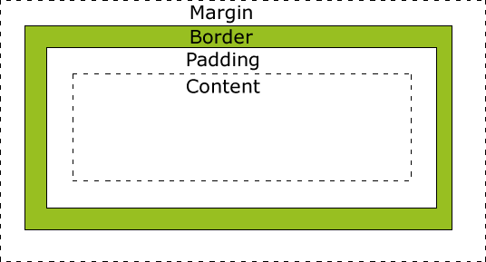

Explanation of the different parts:

* **Margin** - Clears an area around the border. The margin does not have a background color, it is completely transparent
* **Border** - A border that goes around the padding and content. The border is affected by the background color of the box
* **Padding** - Clears an area around the content. The padding is affected by the background color of the box
* **Content** - The content of the box, where text and images appear
* In order to set the width and height of an element correctly in all browsers, you need to know how the box model works.

## Width and Height of an Element

**Important:** When you set the width and height properties of an element with CSS, you just set the width and height of the **content area**. To calculate the full size of an element, you must also add the padding, borders and margins.

Calculate the margin, border, padding and content?

The total width of the element in the example below is 300px:

width:250px;padding:10px;border:5px solid gray;margin:10px; Let's do the math:250px (width)  
+ 20px (left and right padding)+ 10px (left and right border)+ 20px (left and right margin)= 300px

Assume that you had only 250px of space. Let's make an element with a total width of 250px:

## 

## Example

<html><head><style type="text/css">div.ex {width:220px;padding:10px;border:5px solid gray;margin:0px;}</style></head><body><img src="250px.gif" width="250" height="1" /><br /><br /><div class="ex">The line above is 250px wide.<br />The total width of this element is also 250px.</div><p><b>Important:</b> This example will not display correctly in IE8 and earlier versions!<br />However, we will solve that problem in the next example.</p>

</body></html>

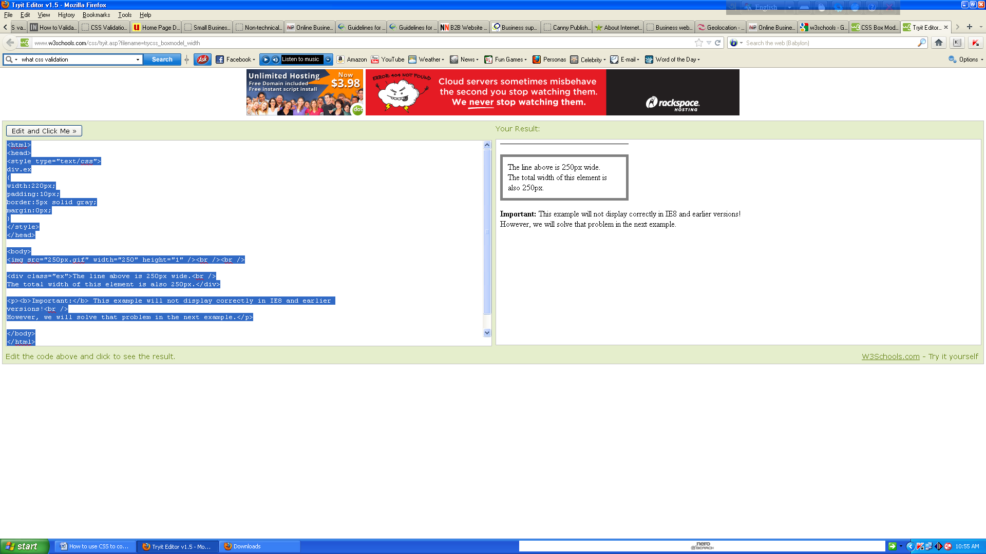  
The total width of an element should be calculated like this:

Total element width = width + left padding + right padding + left border + right border + left margin + right margin

The total height of an element should be calculated like this:

Total element height = height + top padding + bottom padding + top border + bottom border + top margin + bottom margin

**Why we use DOCTYPE?**

## Browsers Compatibility Issue

The example above does not display properly in IE8 and earlier versions.

IE8 and earlier versions includes padding and border in the width, if a **DOCTYPE is NOT declared**.

To fix this problem, just add a DOCTYPE to the HTML page.

## Example

<!DOCTYPE html ><html><head><style type="text/css">div.ex{width:220px;padding:10px;border:5px solid gray;margin:0px;}

</style></head><body><img src="250px.gif" width="250" height="1" /><br /><br />

<div class="ex">The line above is 250px wide.<br />Now the total width of this element is also 250px.</div><p><b>Note:</b> In this example we have added a DOCTYPE declaration (above the html element), so it displays correctly in all browsers.</p></body></html>

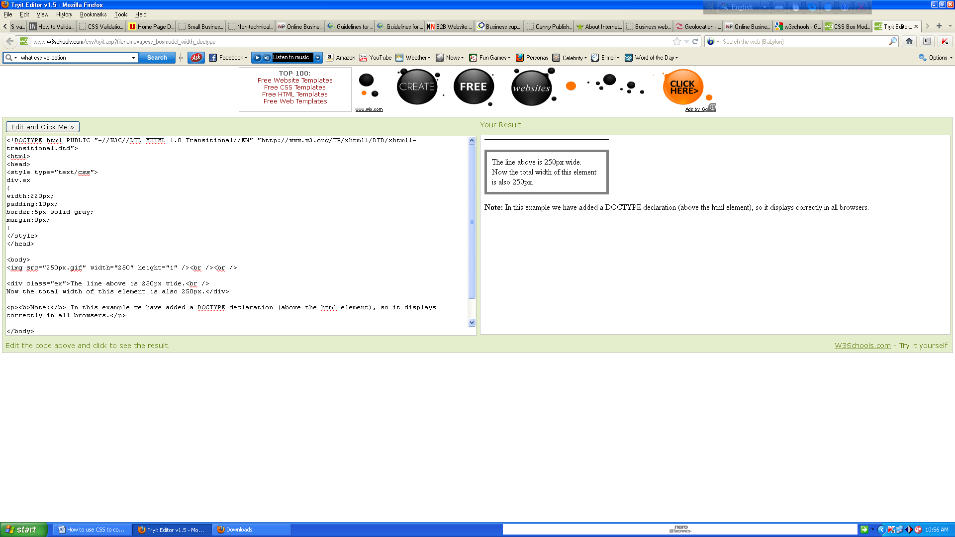

# CSS Border

## CSS Border Properties

The CSS border properties allow you to specify the style and color of an element's border.

## Border Style

The border-style property specifies what kind of border to display.

None of the border properties will have ANY effect unless the **border-style** property is set!

## List the border-style values?

## border-style values:

none: Defines no border

dotted: Defines a dotted border

dashed: Defines a dashed border

solid: Defines a solid border

double: Defines two borders. The width of the two borders are the same as the border-width value

groove: Defines a 3D grooved border. The effect depends on the border-color value

ridge: Defines a 3D ridged border. The effect depends on the border-color value

inset: Defines a 3D inset border. The effect depends on the border-color value

outset: Defines a 3D outset border. The effect depends on the border-color value

## 

## Border Width

The border-width property is used to set the width of the border.

The width is set in pixels, or by using one of the three pre-defined values: thin, medium, or thick.

**Note:** The "border-width" property does not work if it is used alone. Use the "border-style" property to set the borders first.

## Example

<html><head><style type="text/css">p.one{border-style:solid;border-width:5px;}

p.two {border-style:solid;border-width:medium;}p.three{border-style:solid;border-width:1px;}

</style></head><body><p class="one">Some text.</p><p class="two">Some text.</p>

<p class="three">Some text.</p><p><b>Note:</b> The "border-width" property does not work if it is used alone. Use the "border-style" property to set the borders first.</p>

</body></html>

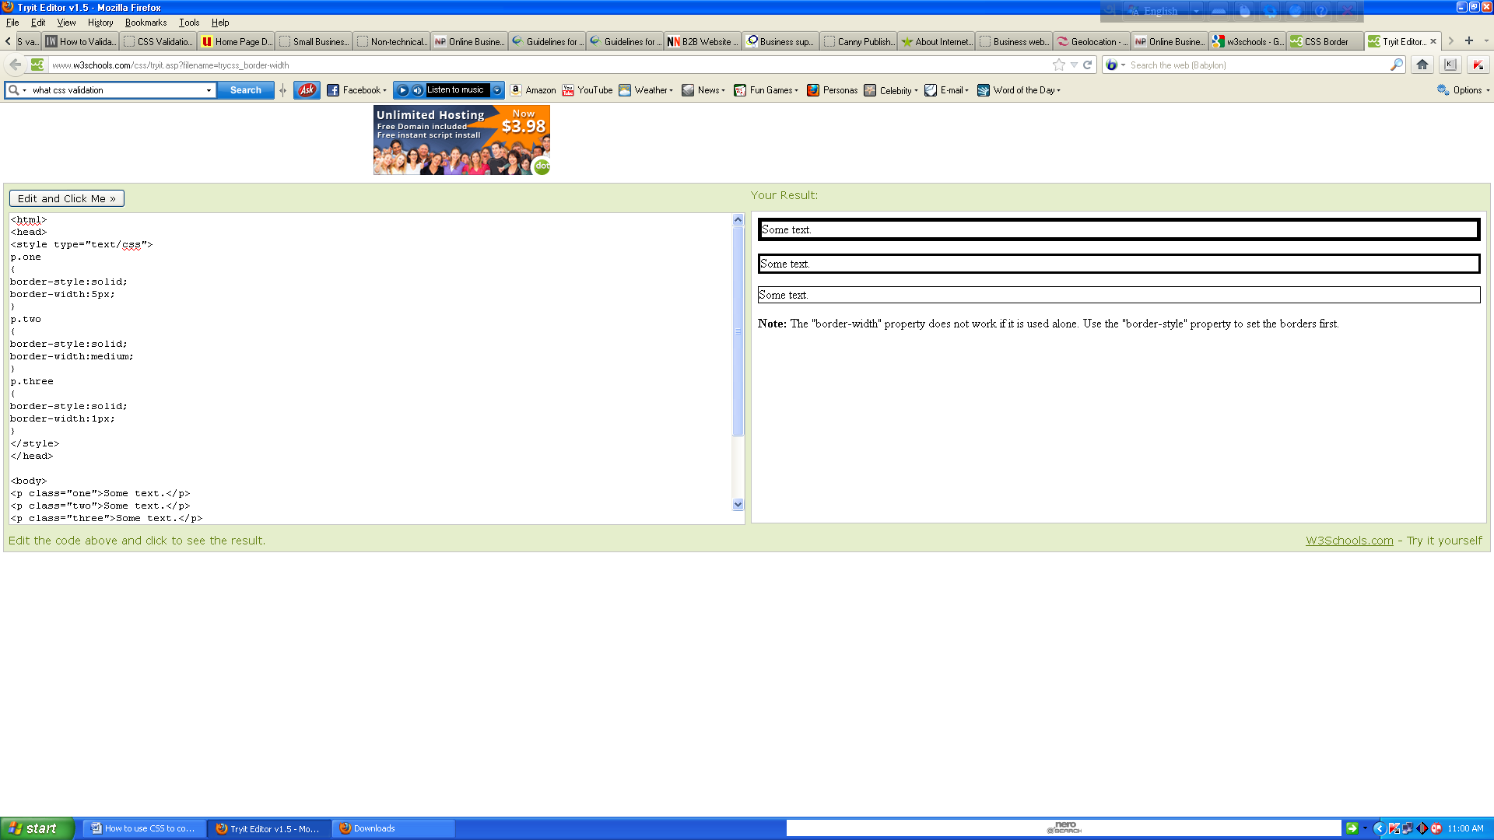Border Color

The border-color property is used to set the color of the border. The color can be set by:

* name - specify a color name, like "red"
* RGB - specify a RGB value, like "rgb(255,0,0)"
* Hex - specify a hex value, like "#ff0000"

You can also set the border color to "transparent".

The "border-color" property does not work if it is used alone. Use the "border-style" property to set the borders first.

## 

## Example

<html><head><style type="text/css">p.one{border-style:solid;border-color:red;}

p.two{border-style:solid;border-color:#98bf21;} </style></head><body>

<p class="one">A solid red border</p><p class="two">A solid green border</p>

<p><b>Note:</b> The "border-color" property does not work if it is used alone. Use the "border-style" property to set the borders first.</p></body></html>

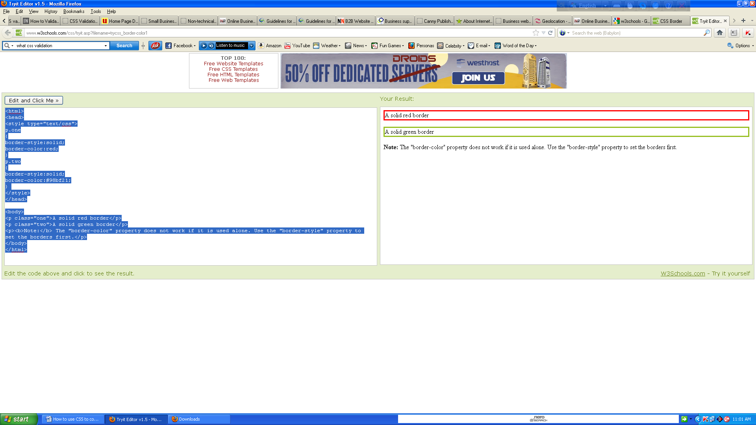Border - Individual sides

In CSS it is possible to specify different borders for different sides:

## 

## Example

<html><head><style type="text/css">p {border-top-style:dotted;border-right-style:solid;border-bottom-style:dotted;border-left-style:solid;}</style></head><body><p>2 different border styles.</p></body></html>

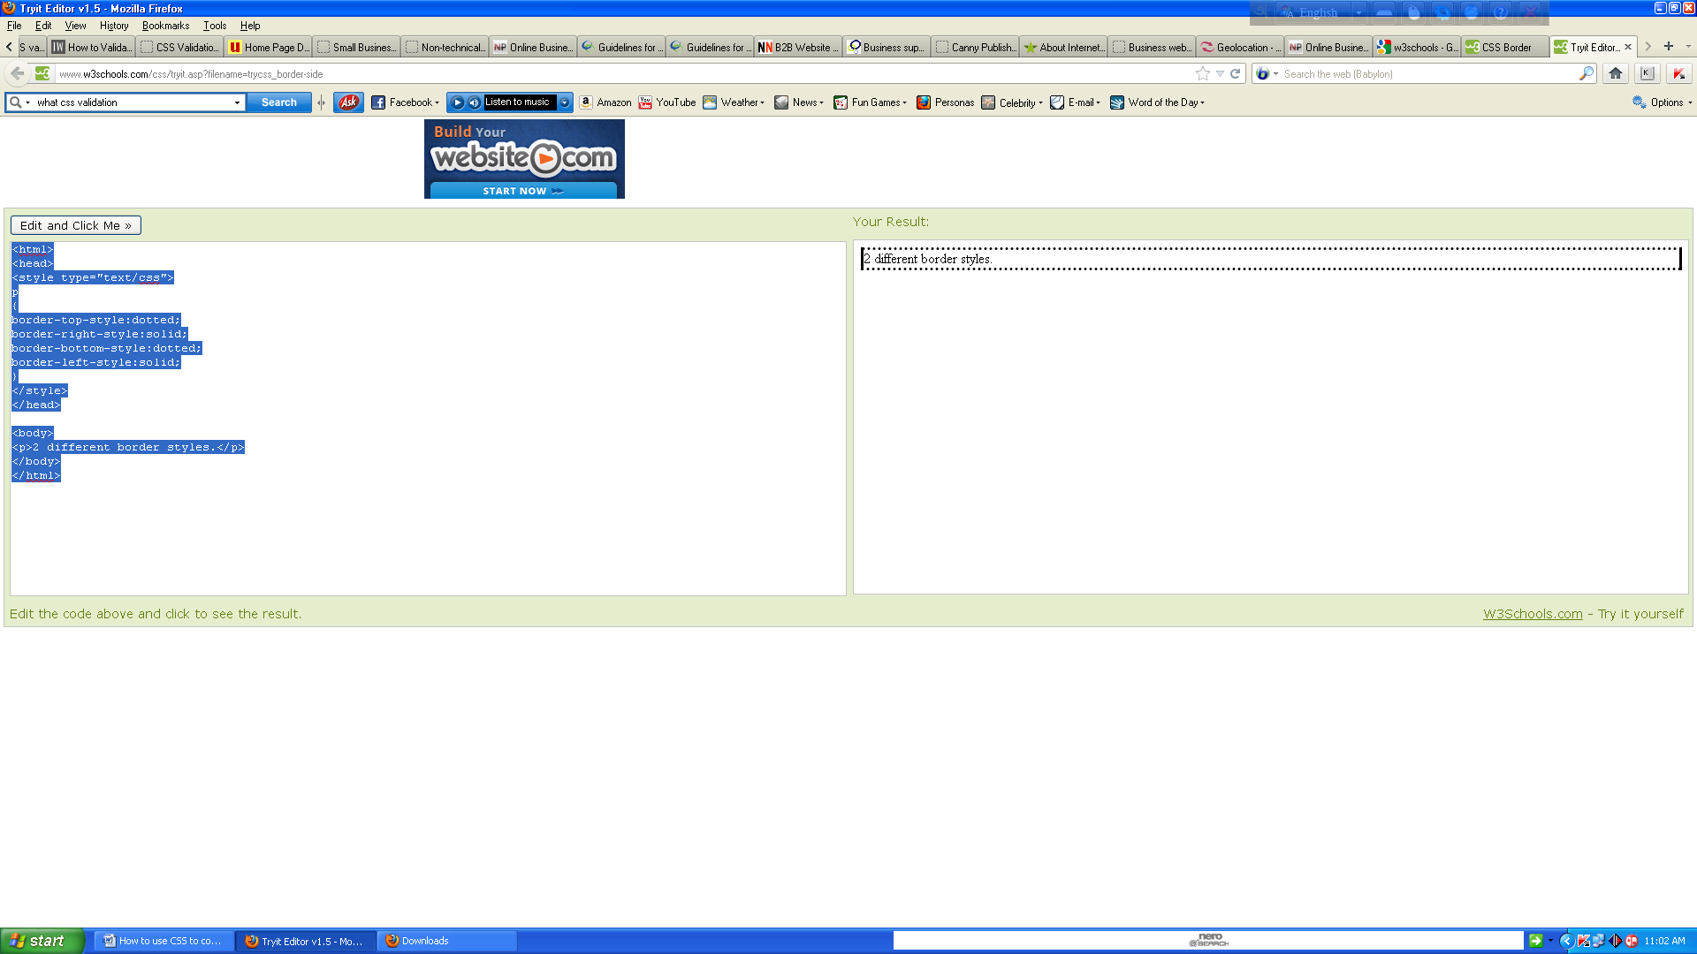

The example above can also be set with a single property:

## 

## Example

<html><head><style type="text/css">p{border-style:dotted solid;}</style></head>

<body><p>2 different border styles.</p></body></html>

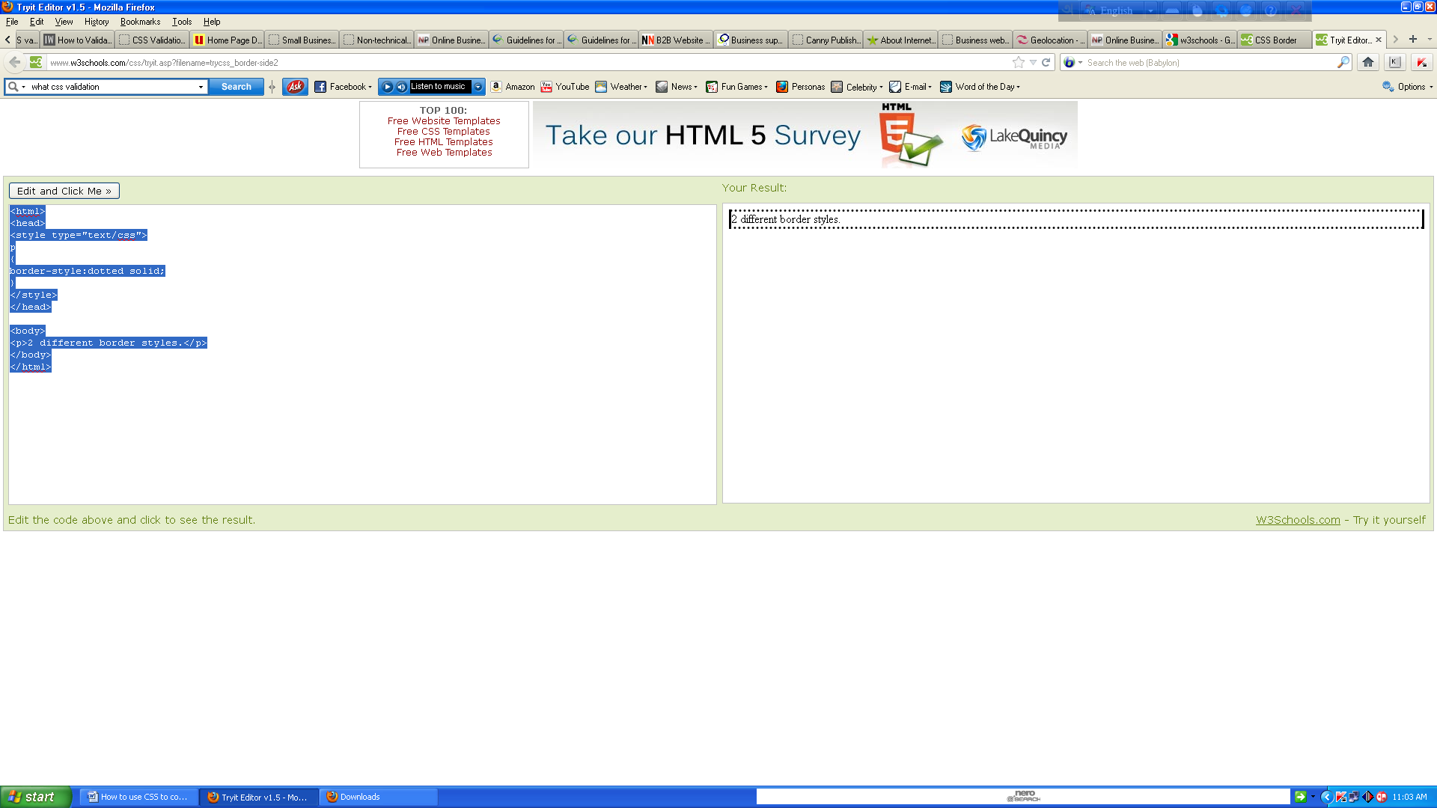

The border-style property can have from one to four values.

* **border-style:dotted solid double dashed;** 
  + top border is dotted
  + right border is solid
  + bottom border is double
  + left border is dashed
* **border-style:dotted solid double;**
  + top border is dotted
  + right and left borders are solid
  + bottom border is double
* **border-style:dotted solid;**
  + top and bottom borders are dotted
  + right and left borders are solid
* **border-style:dotted;**
  + all four borders are dotted
* The border-style property is used in the example above. However, it also works with border-width and border-color.

## 

## Border - Shorthand property

As you can see from the examples above, there are many properties to consider when dealing with borders.

To shorten the code, it is also possible to specify all the border properties in one property. This is called a shorthand property.

The shorthand property for the border properties is "border":

## 

## Example:

<html><head><style type="text/css">p{border:5px solid red;}</style></head>

<body><p>This is some text in a paragraph.</p></body></html>

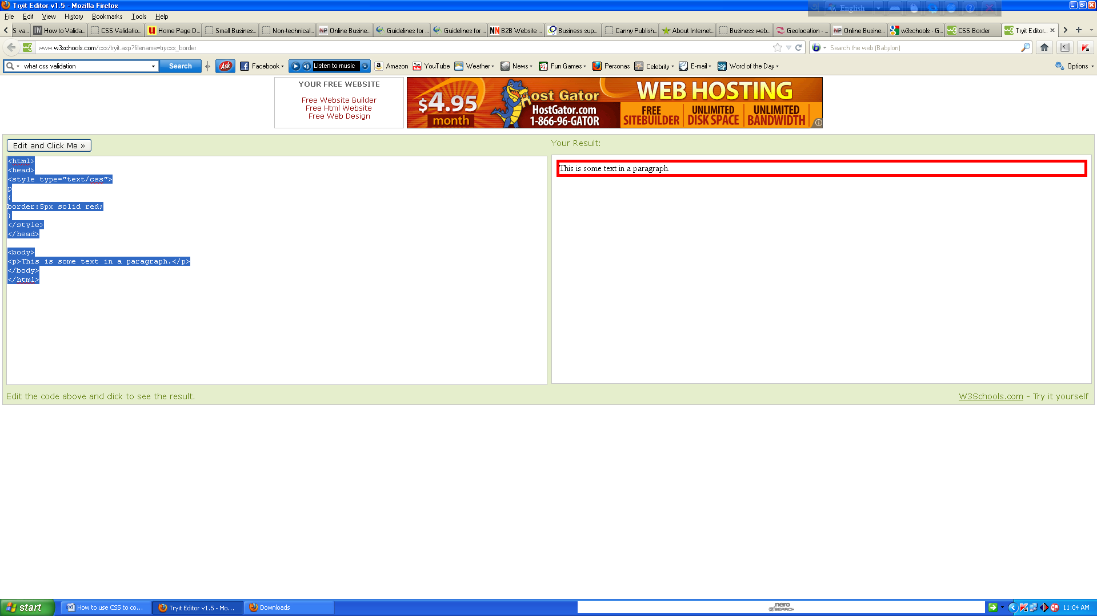 When using the border property, the orders of the values are:

* border-width
* border-style
* border-color

It does not matter if one of the values above are missing (although, border-style is required), as long as the rest are in the specified order.

## CSS Outline

An outline is a line that is drawn around elements (outside the borders) to make the element "stand out”. The outline properties specify the style, color, and width of an outline.

However, the outline property is different from the border property.

The outline is not a part of an element's dimensions; the element's total width and height is not affected by the width of the outline.

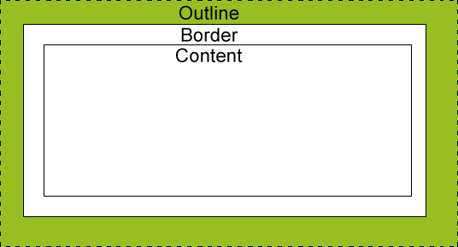

# CSS Margin

The CSS margin properties define the space around elements.

## 

## Margin

The margin clears an area around an element (outside the border). The margin does not have a background color, and is completely transparent.

The top, right, bottom, and left margin can be changed independently using separate properties. A shorthand margin property can also be used, to change all margins at once.

## 

## Possible Values

|  |  |
| --- | --- |
| **Value** | **Description** |
| auto | The browser calculates a margin |
| *length* | Specifies a margin in px, pt, cm, etc. Default value is 0px |
| *%* | Specifies a margin in percent of the width of the containing element |
| inherit | Specifies that the margin should be inherited from the parent element |

It is possible to use negative values, to overlap content.

## Margin - Individual sides

In CSS, it is possible to specify different margins for different sides:

Example

<html><head><style type="text/css">p{background-color:yellow;}p.margin{margin-top:100px;margin-bottom:100px;margin-right:50px;margin-left:50px;}</style></head><body><p>This is a paragraph with no specified margins.</p><p class="margin">This is a paragraph with specified margins.</p>

</body></html>

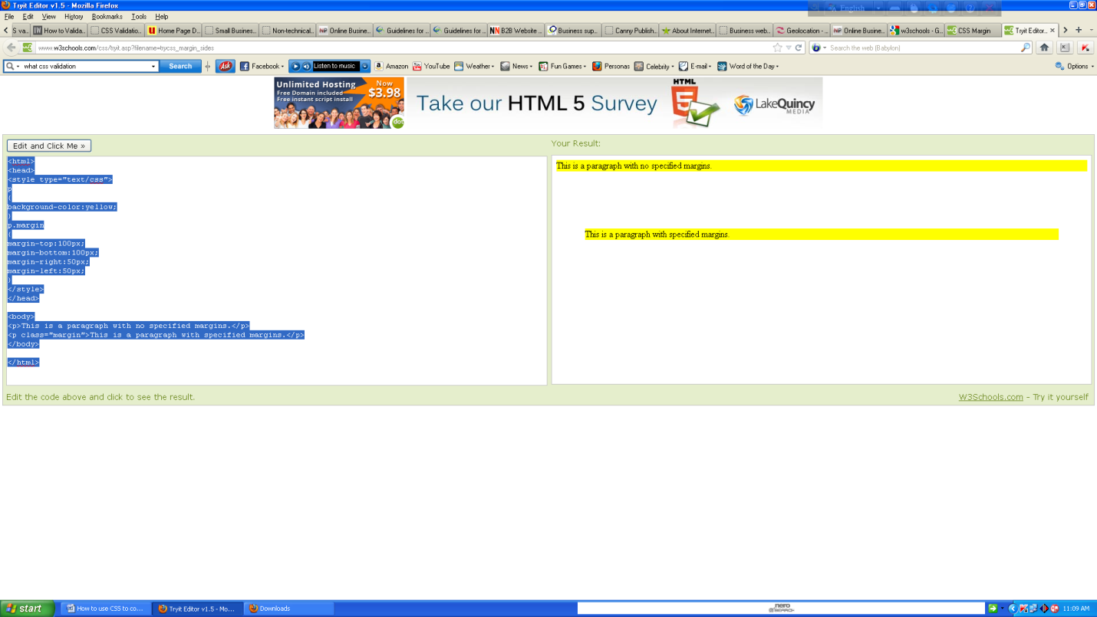

## Margin - Shorthand property

To shorten the code, it is possible to specify all the margin properties in one property. This is called a shorthand property.

The shorthand property for all the margin properties is "margin":

## 

## Example

<html><head><style type="text/css">p{background-color:yellow;}p.margin{margin:100px 50px;}</style></head><body><p>This is a paragraph with no specified margins.</p>

<p class="margin">This is a paragraph with specified margins.</p></body></html>

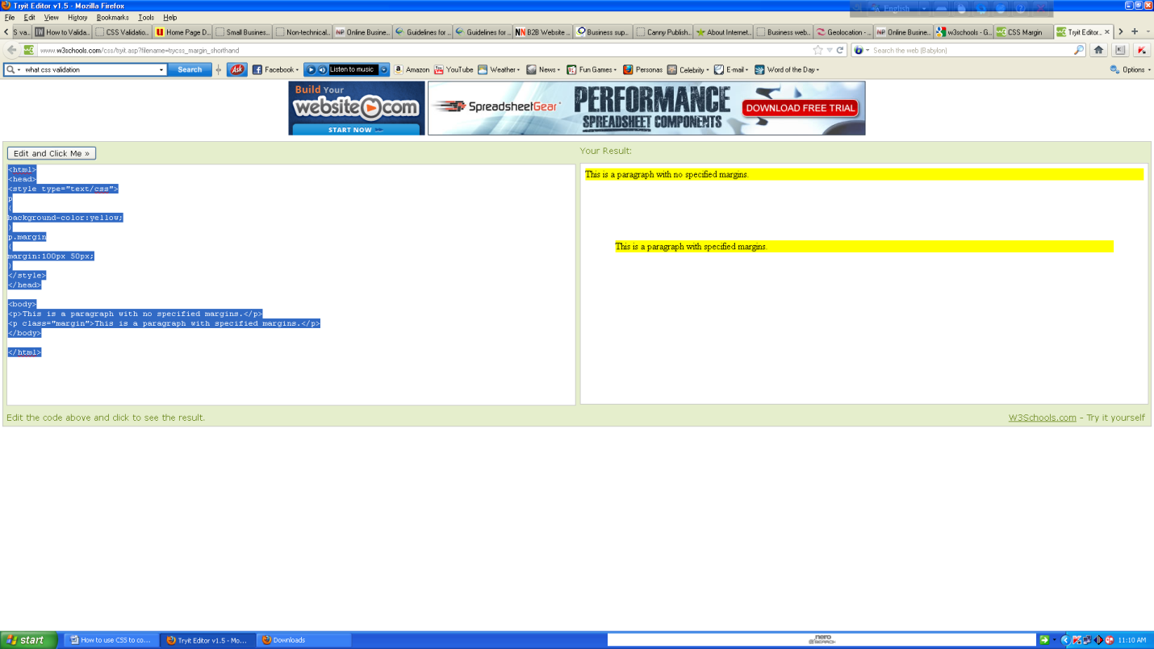

The margin property can have from one to four values.

* **margin:25px 50px 75px 100px;**
* top margin is 25px
* right margin is 50px
* bottom margin is 75px
* left margin is 100px
* **margin:25px 50px 75px;**
* top margin is 25px
* right and left margins are 50px
* bottom margin is 75px
* **margin:25px 50px;**
* top and bottom margins are 25px
* right and left margins are 50px
* **margin:25px;**
* all four margins are 25px

## All CSS Margin Properties

|  |  |
| --- | --- |
| **Property** | **Description** |
| [margin](http://www.w3schools.com/cssref/pr_margin.asp) | A shorthand property for setting the margin properties in one declaration |
| [margin-bottom](http://www.w3schools.com/cssref/pr_margin-bottom.asp) | Sets the bottom margin of an element |
| [margin-left](http://www.w3schools.com/cssref/pr_margin-left.asp) | Sets the left margin of an element |
| [margin-right](http://www.w3schools.com/cssref/pr_margin-right.asp) | Sets the right margin of an element |
| [margin-top](http://www.w3schools.com/cssref/pr_margin-top.asp) | Sets the top margin of an element |

# CSS Padding

The CSS padding properties define the space between the element border and the element content.

## 

## Padding

The padding clears an area around the content (inside the border) of an element. The padding is affected by the background color of the element.

The top, right, bottom, and left padding can be changed independently using separate properties. A shorthand padding property can also be used, to change all paddings at once.

## 

## Possible Values

|  |  |
| --- | --- |
| **Value** | **Description** |
| *length* | Defines a fixed padding (in pixels, pt, em, etc.) |
| *%* | Defines a padding in % of the containing element |

## Padding - Individual sides

In CSS, it is possible to specify different padding for different sides:

## 

## Example <html><head><style type="text/css">p{background-color:yellow;}p.padding{padding-top:25px;padding-bottom:25px;padding-right:50px;padding-left:50px;}</style>

</head><body><p>This is a paragraph with no specified padding.</p><p class="padding">This is a paragraph with specified paddings.</p></body></html>

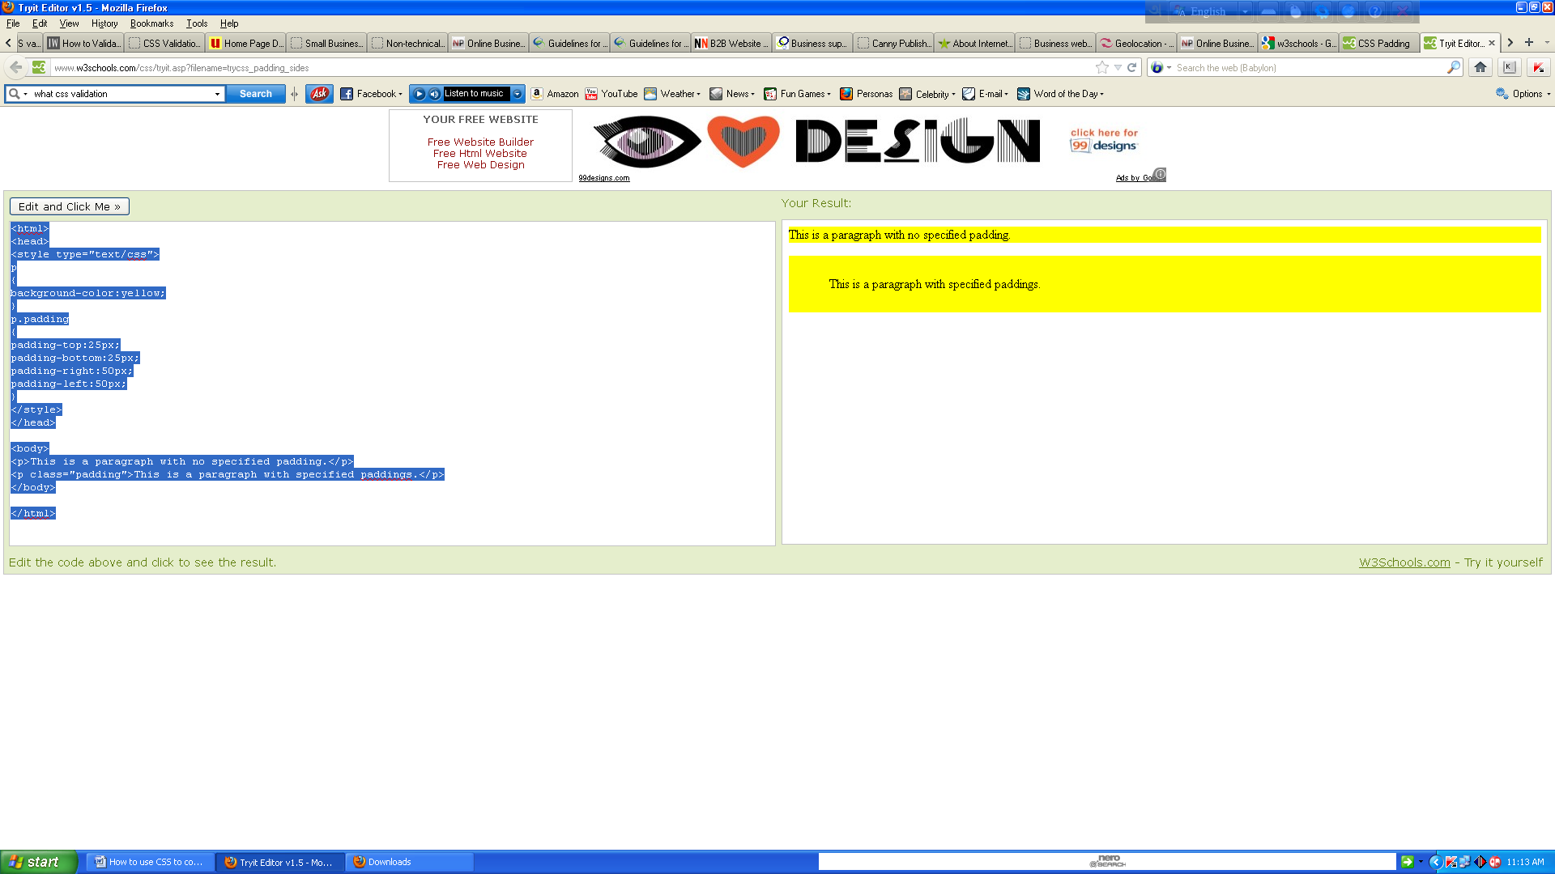

## Padding - Shorthand property

To shorten the code, it is possible to specify all the padding properties in one property. This is called a shorthand property.

The shorthand property for all the padding properties is "padding":

## 

## Example

<html><head><style type="text/css">p{background-color:yellow;}p.padding{padding:25px 50px;}</style></head><body><p>This is a paragraph with no specified padding.</p>

<p class="padding">This is a paragraph with specified paddings.</p></body></html>

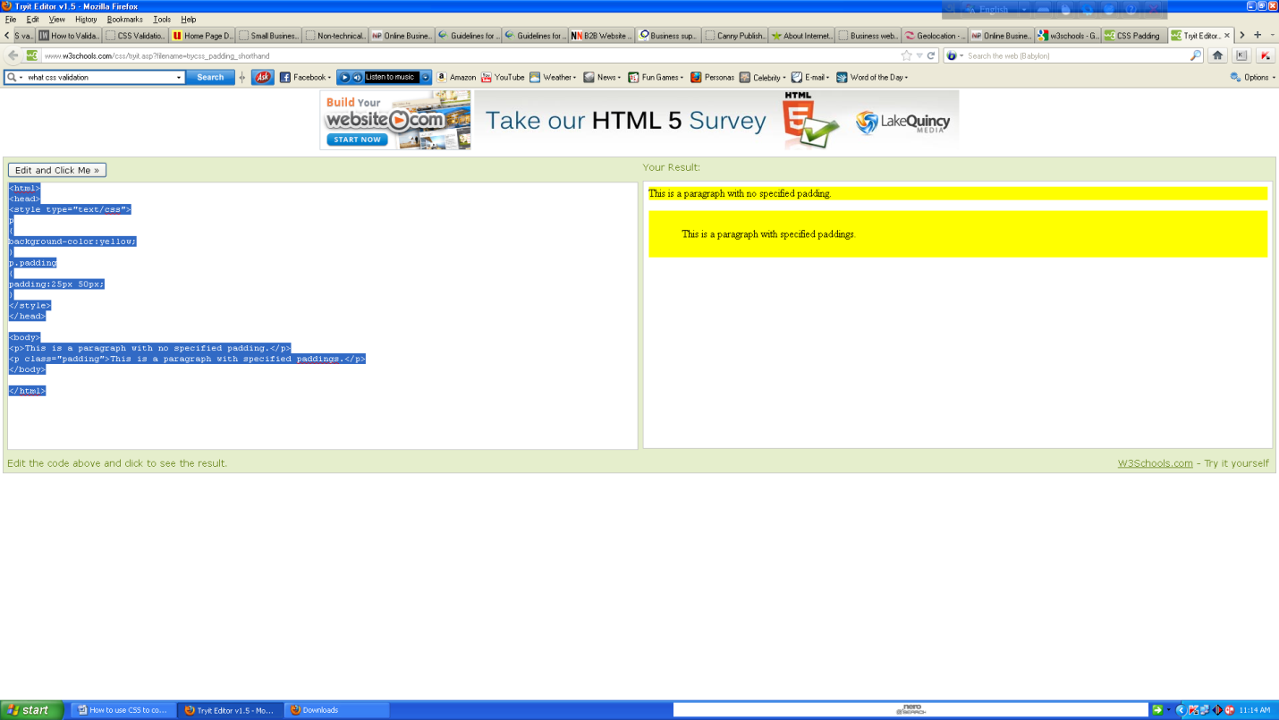

The padding property can have from one to four values.

* **padding:25px 50px 75px 100px;** 
  + top padding is 25px
  + right padding is 50px
  + bottom padding is 75px
  + left padding is 100px
* **padding:25px 50px 75px;**
* top padding is 25px
* right and left paddings are 50px
* bottom padding is 75px
* **padding:25px 50px;**
  + top and bottom paddings are 25px
  + right and left paddings are 50px
* **padding:25px;**
  + all four paddings are 25px

## All CSS Padding Properties

|  |  |
| --- | --- |
| **Property** | **Description** |
| [padding](http://www.w3schools.com/cssref/pr_padding.asp) | A shorthand property for setting all the padding properties in one declaration |
| [padding-bottom](http://www.w3schools.com/cssref/pr_padding-bottom.asp) | Sets the bottom padding of an element |
| [padding-left](http://www.w3schools.com/cssref/pr_padding-left.asp) | Sets the left padding of an element |
| [padding-right](http://www.w3schools.com/cssref/pr_padding-right.asp) | Sets the right padding of an element |
| [padding-top](http://www.w3schools.com/cssref/pr_padding-top.asp) | Sets the top padding of an element |

# CSS Grouping and Nesting Selectors

## Grouping Selectors

In style sheets there are often elements with the same style.

h1 { color:green; }  
h2 { color:green; }  
p { color:green; }

To minimize the code, you can group selectors.

Separate each selector with a comma.

In the example below we have grouped the selectors from the code above:

## 

## Example

<html><head><style type="text/css">h1,h2,p{color:green;}</style></head><body>

<h1>Hello World!</h1><h2>Smaller heading!</h2><p>This is a paragraph.</p>

</body></html>

**Nesting Selectors**

It is possible to apply a style for a selector within a selector.

In the example below, one style is specified for all p elements, one style is specified for all elements with class="marked", and a third style is specified only for p elements within elements with class="marked":

## 

## Example

<html><head><style type="text/css">p{color: blue;text-align:center; }.marked {background-color:red; }.marked p {color:white; }</style></head><body><p>This is a blue, center-aligned paragraph.</p><div class="marked"><p>This p element should not be blue.</p>

</div><p>p elements inside a "marked" classed element keeps the alignment style, but has a different text color.</p></body></html>

# 

# CSS Dimension

The CSS dimension properties allow you to control the height and width of an element.

## All CSS Dimension Properties

The number in the "CSS" column indicates in which CSS version the property is defined (CSS1 or CSS2).

|  |  |  |  |
| --- | --- | --- | --- |
| **Property** | **Description** | **Values** | **CSS** |
| [height](http://www.w3schools.com/cssref/pr_dim_height.asp) | Sets the height of an element | auto *length %* inherit | 1 |
| [max-height](http://www.w3schools.com/cssref/pr_dim_max-height.asp) | Sets the maximum height of an element | none *length %* inherit | 2 |
| [max-width](http://www.w3schools.com/cssref/pr_dim_max-width.asp) | Sets the maximum width of an element | none *length %* inherit | 2 |
| [min-height](http://www.w3schools.com/cssref/pr_dim_min-height.asp) | Sets the minimum height of an element | *length %* inherit | 2 |
| [min-width](http://www.w3schools.com/cssref/pr_dim_min-width.asp) | Sets the minimum width of an element | *length %* inherit | 2 |
| [width](http://www.w3schools.com/cssref/pr_dim_width.asp) | Sets the width of an element | auto *length %* inherit | 1 |

# What is a display property?

# CSS Display and Visibility

The display property specifies if/how an element is displayed, and the visibility property specifies if an element should be visible or hidden.

## Hiding an Element - display:none or visibility:hidden

Hiding an element can be done by setting the display property to "none" or the visibility property to "hidden". However, notice that these two methods produce different results:

visibility:hidden hides an element, but it will still take up the same space as before. The element will be hidden, but still affect the layout.

## 

## Example

<html><head><style type="text/css">h1.hidden {visibility:hidden;}</style>

</head><body><h1>This is a visible heading</h1><h1 class="hidden">This is a hidden heading</h1><p>Notice that the hidden heading still takes up space.</p></body>

</html>

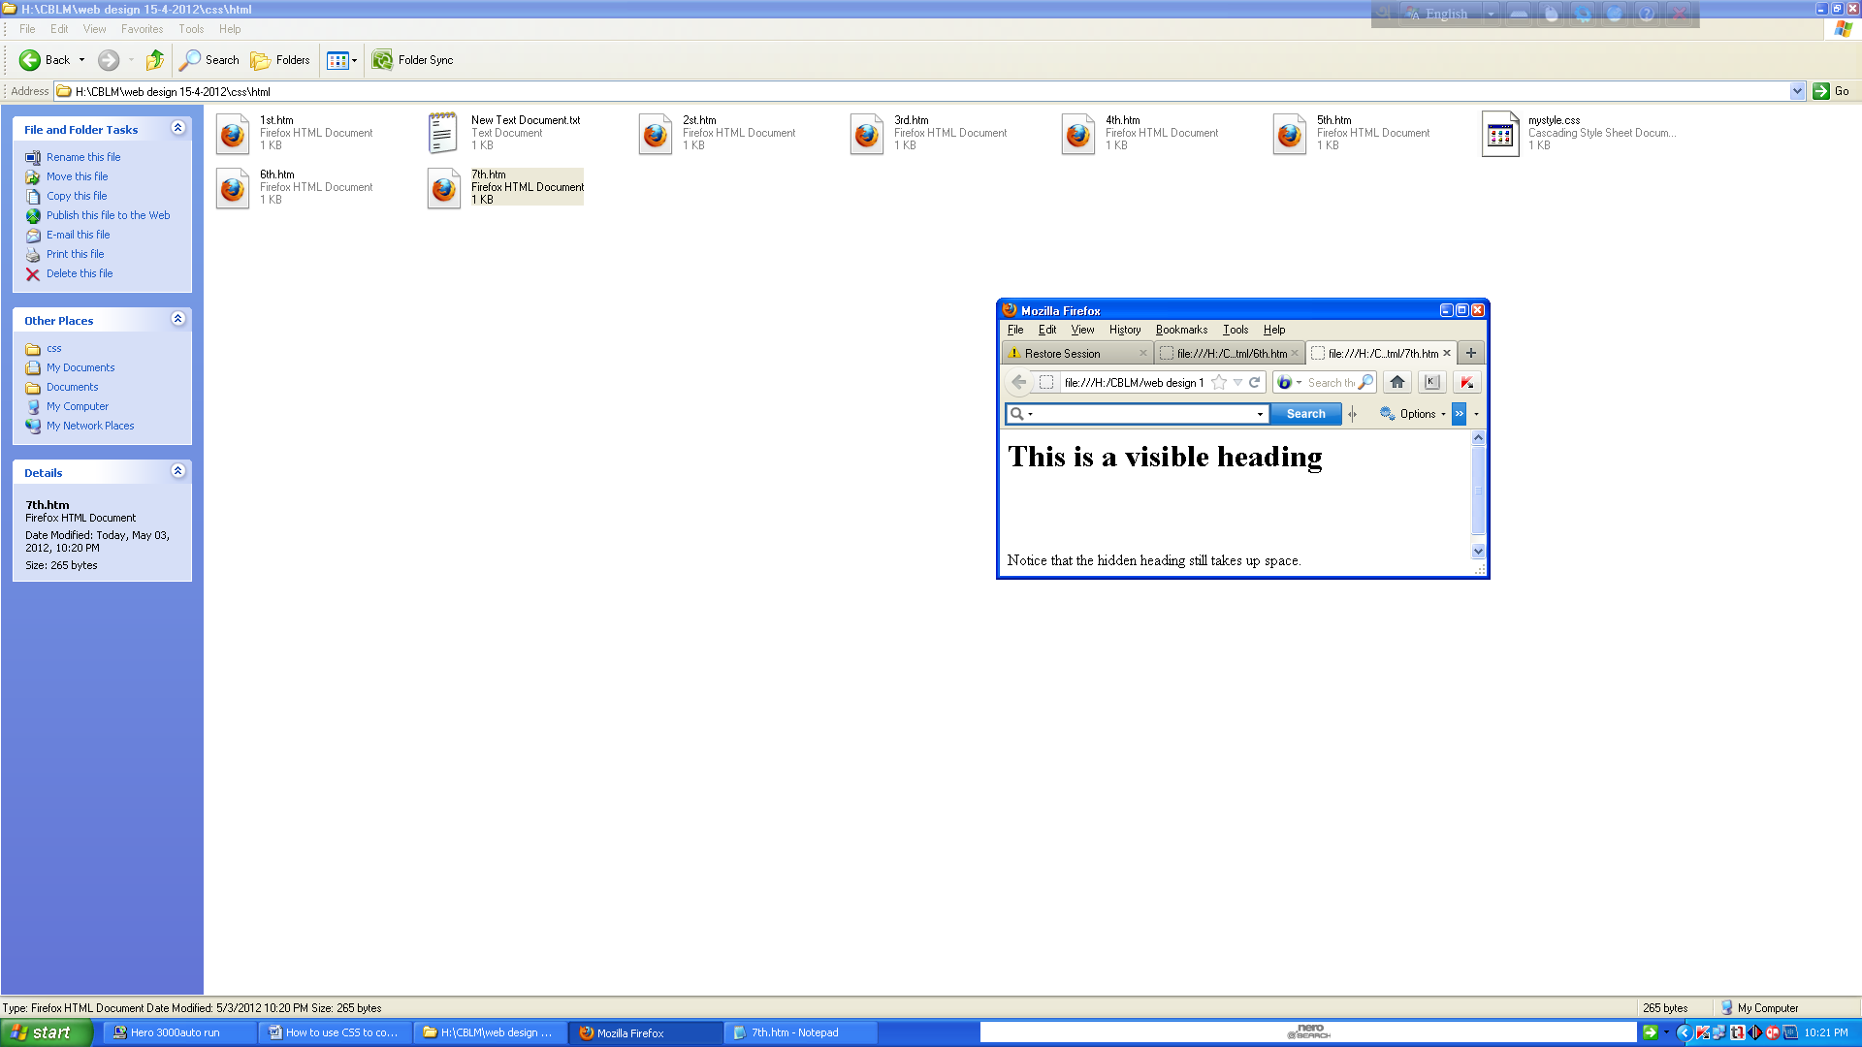

display:none hides an element, and it will not take up any space. The element will be hidden, and the page will be displayed as if the element is not there:

## 

## Example

<html><head><style type="text/css">h1.hidden {display:none;}</style>

</head><body><h1>This is a visible heading</h1><h1 class="hidden">This is a hidden heading</h1><p>Notice that the hidden heading does not take up space.</p>

</body></html>

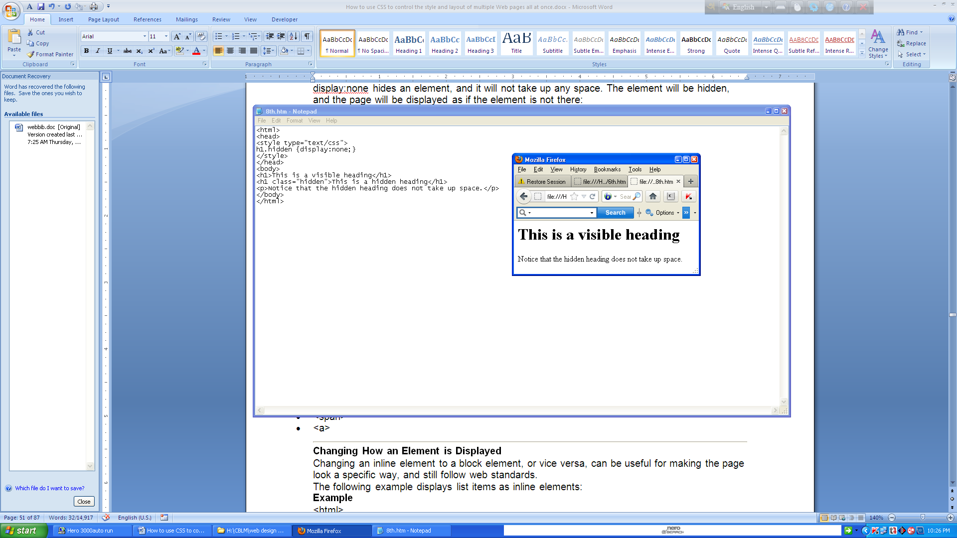  
**Diff between block and inline**

**CSS Display - Block and Inline Elements**

A block element is an element that takes up the full width available, and has a line break before and after it.

Examples of block elements:

* <h1>
* <p>
* <div>

An inline element only takes up as much width as necessary, and does not force line breaks.

Examples of inline elements:

* <span>
* <a>

## Changing How an Element is Displayed

Changing an inline element to a block element, or vice versa, can be useful for making the page look a specific way, and still follow web standards.

The following example displays list items as inline elements:

## 

## Example

<html><head><style type="text/css">li{display:inline;}</style></head><body><p>Display this link list as a horizontal menu:</p><ul><li><a href="/html/default.asp" target="_blank">HTML</a></li><li><a href="/css/default.asp" target="_blank">CSS</a></li>

<li><a href="/js/default.asp" target="_blank">JavaScript</a></li>

<li><a href="/xml/default.asp" target="_blank">XML</a></li></ul></body></html>

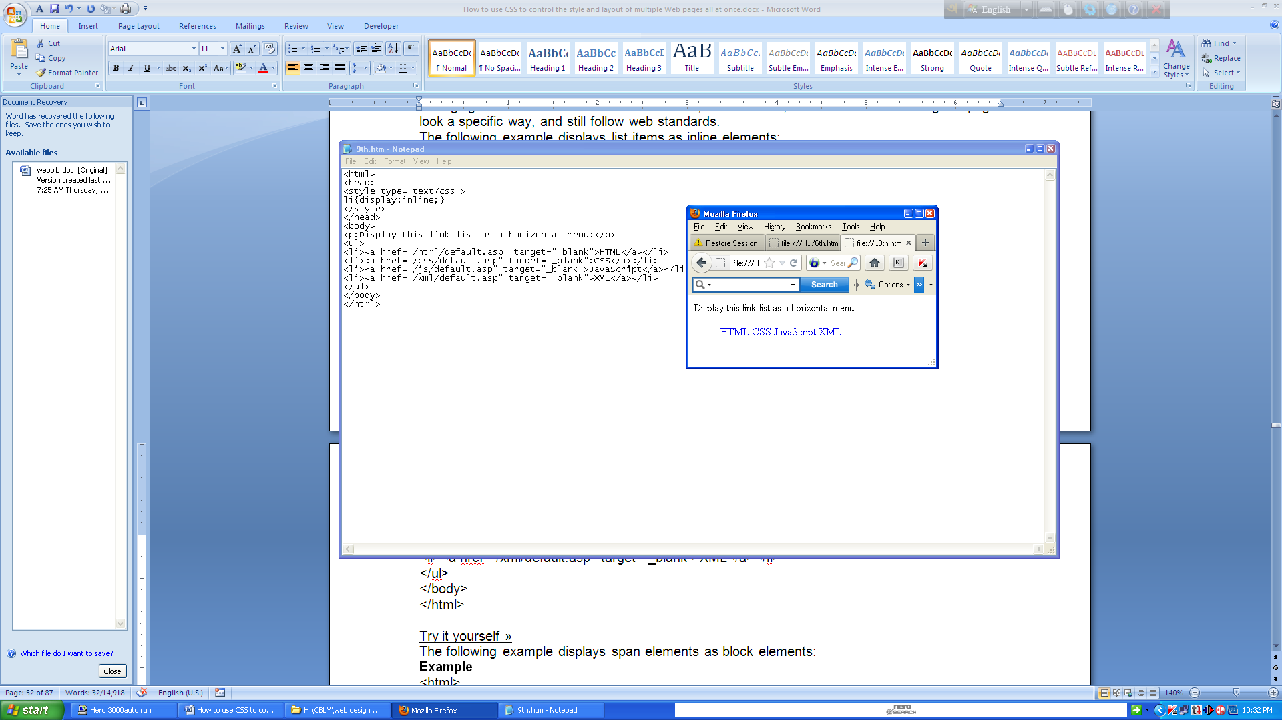

The following example displays span elements as block elements:

## 

## Example

<html><head><style type="text/css">span{display:block;}</style></head><body>

<h2>Nirvana</h2><span>Record: MTV Unplugged in New York</span>

<span>Year: 1993</span><h2>Radiohead</h2><span>Record: OK Computer</span>

<span>Year: 1997</span></body></html>

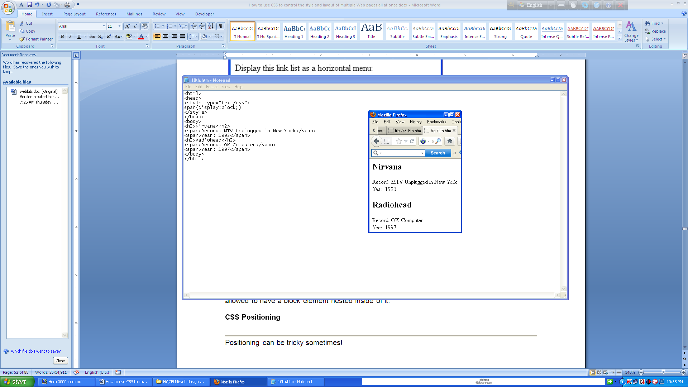  
**Note:** Changing the display type of an element changes only how the element is displayed, NOT what kind of element it is. For example: An inline element set to display:block is not allowed to have a block element nested inside of it.

## Positioning

The CSS positioning properties allow you to position an element. It can also place an element behind another, and specify what should happen when an element's content is too big.

Elements can be positioned using the top, bottom, left, and right properties. However, these properties will not work unless the position property is set first. They also work differently depending on the positioning method.

There are four different positioning methods.

## Static Positioning

HTML elements are positioned static by default. A static positioned element is always positioned according to the normal flow of the page.

Static positioned elements are not affected by the top, bottom, left, and right properties.

## Fixed Positioning

An element with fixed position is positioned relative to the browser window.

It will not move even if the window is scrolled:

## 

## Example

<html><head><style type="text/css">p.pos_fixed{position:fixed;top:30px;right:5px;}

</style></head><body><p class="pos_fixed">Some more text</p>

<p><b>Note:</b> IE7 and IE8 supports the fixed value only if a !DOCTYPE is specified.</p>

<p>Some text</p><p>Some text</p><p>Some text</p><p>Some text</p><p>Some text</p><p>Some text</p><p>Some text</p><p>Some text</p><p>Some text</p><p>Some text</p><p>Some text</p><p>Some text</p><p>Some text</p><p>Some text</p><p>Some text</p><p>Some text</p></body></html>

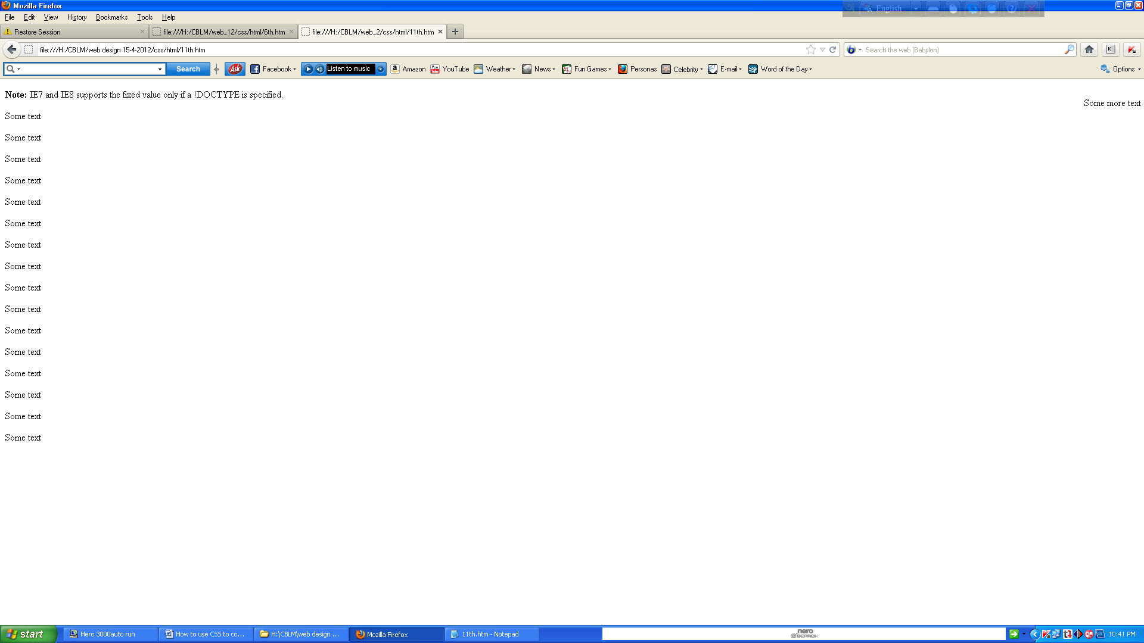

**Note:** IE7 and IE8 support the fixed value only if a! DOCTYPE is specified.

Fixed positioned elements are removed from the normal flow. The document and other elements behave like the fixed positioned element does not exist.

Fixed positioned elements can overlap other elements.

## Relative Positioning

A relative positioned element is positioned relative to its normal position.

## 

## Example

<html><head><style type="text/css">h2.pos_left{position:relative;left:-20px;}

h2.pos_right{position:relative;left:20px;}</style></head><body><h2>This is a heading with no position</h2><h2 class="pos_left">This heading is moved left according to its normal position</h2><h2 class="pos_right">This heading is moved right according to its normal position</h2><p>Relative positioning moves an element RELATIVE to its original position.</p>

<p>The style "left:-20px" subtracts 20 pixels from the element's original left position.</p>

<p>The style "left:20px" adds 20 pixels to the element's original left position.</p>

</body></html>

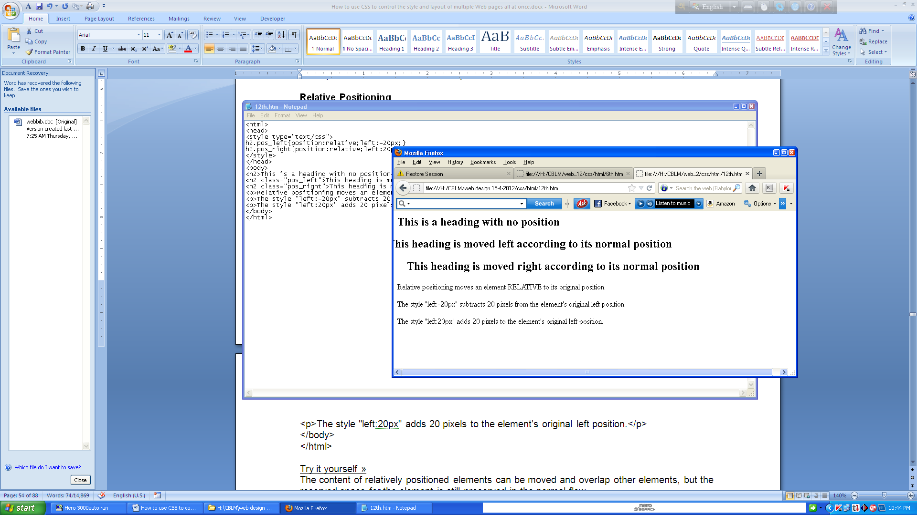  
The content of relatively positioned elements can be moved and overlap other elements, but the reserved space for the element is still preserved in the normal flow.

## 

## Example

<html><head><style type="text/css">h2.pos_top{position:relative;top:-50px;}

</style></head><body><h2>This is a heading with no position</h2>

<h2 class="pos_top">This heading is moved upwards according to its normal position</h2>

<p><b>Note:</b> Even if the content of the relatively positioned element is moved, the reserved space for the element is still preserved in the normal flow.</p>

</body></html>

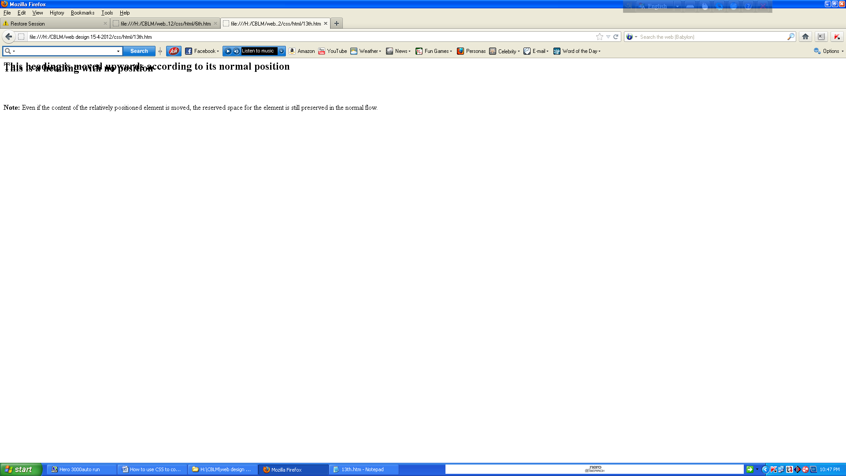

Relatively positioned elements are often used as container blocks for absolutely positioned elements.

## 

## Absolute Positioning

An absolute position element is positioned relative to the first parent element that has a position other than static. If no such element is found, the containing block is <html>:

## 

## Example

<html><head><style type="text/css">h2{position:absolute;left:100px;top:150px;}

</style></head><body><h2>This is a heading with an absolute position</h2>

<p>With absolute positioning, an element can be placed anywhere on a page. The heading below is placed 100px from the left of the page and 150px from the top of the page.</p>

</body></html>

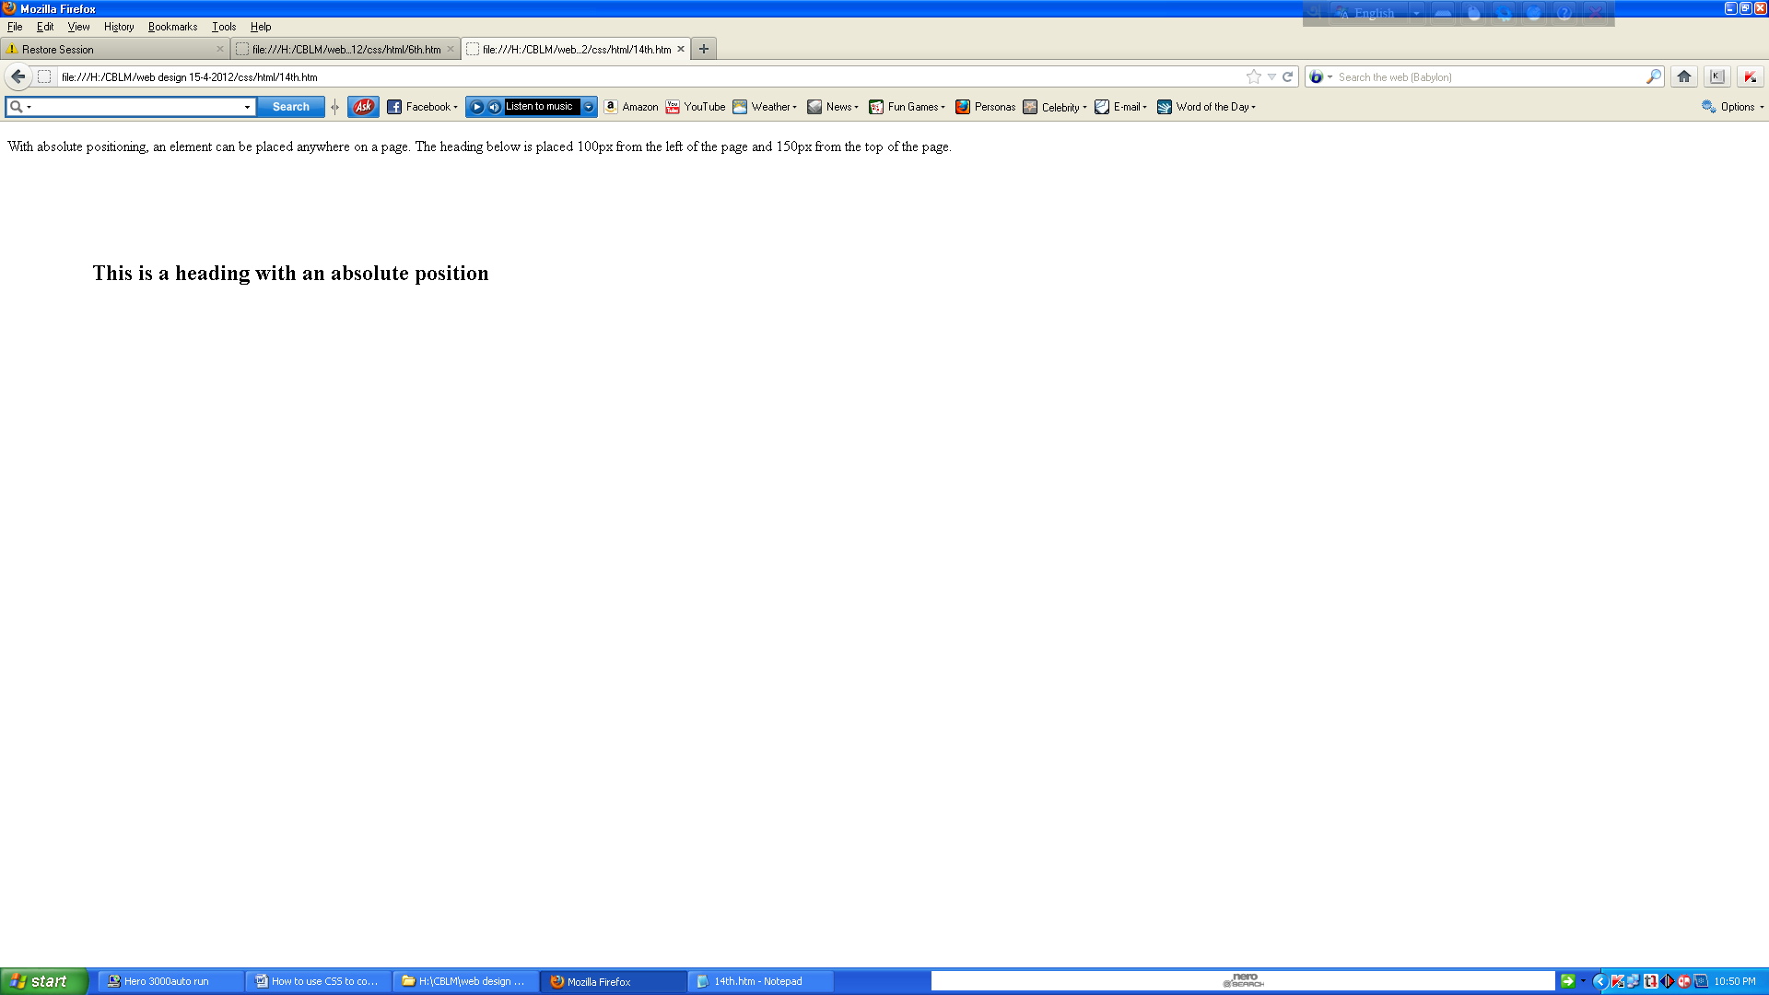

Absolutely positioned elements are removed from the normal flow. The document and other elements behave like the absolutely positioned element does not exist.

Absolutely positioned elements can overlap other elements.

## Overlapping Elements

When elements are positioned outside the normal flow, they can overlap other elements.

The z-index property specifies the stack order of an element (which element should be placed in front of, or behind, the others).

An element can have a positive or negative stack order:

## 

## Example

<html><head><style type="text/css">img{position:absolute;left:0px;top:0px;z-index:-1;}

</style></head><body><h1>This is a heading</h1><img src="w3css.gif" width="100" height="140" /><p>Because the image has a z-index of -1, it will be placed behind the text.</p>

</body></html>

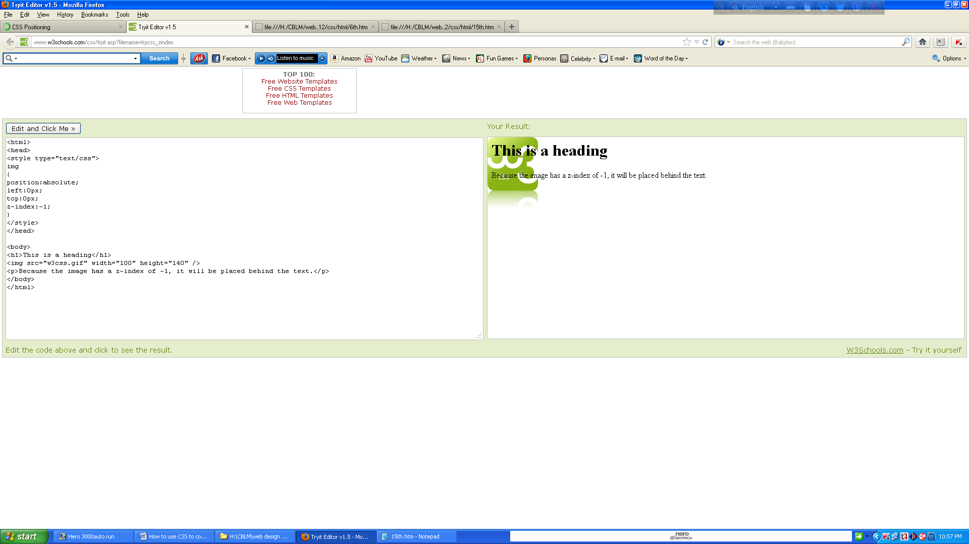

An element with greater stack order is always in front of an element with a lower stack order.

**Note:** If two positioned elements overlap, without a z-index specified, the element positioned last in the HTML code will be shown on top.

## What is CSS Float?

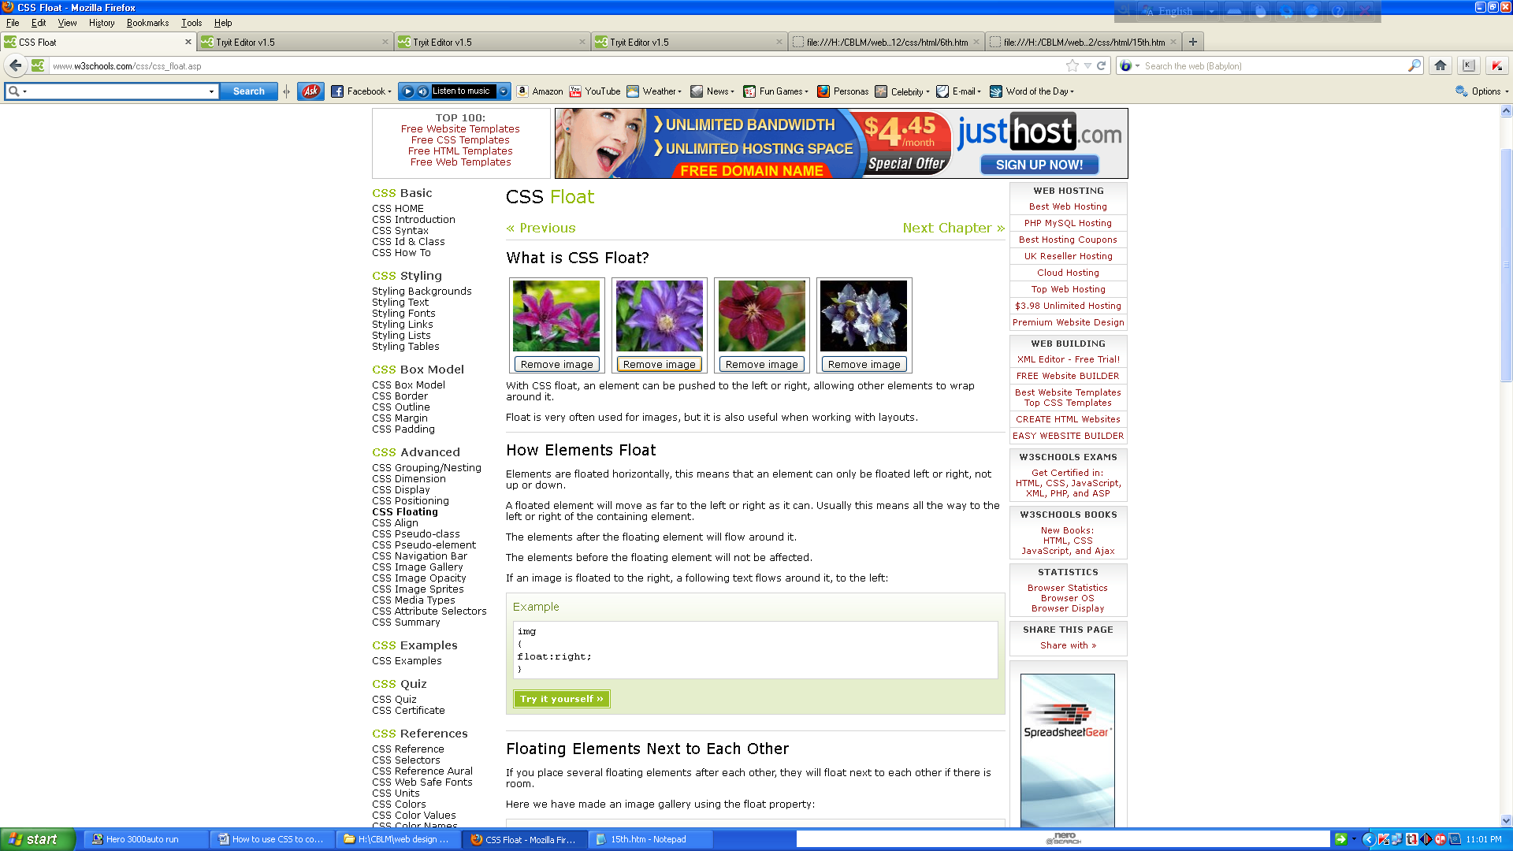

With CSS float, an element can be pushed to the left or right, allowing other elements to wrap around it.

Float is very often used for images, but it is also useful when working with layouts.

## 

## How Elements Float

Elements are floated horizontally, this means that an element can only be floated left or right, not up or down.

A floated element will move as far to the left or right as it can. Usually this means all the way to the left or right of the containing element.

The elements after the floating element will flow around it.

The elements before the floating element will not be affected.

If an image is floated to the right, a following text flows around it, to the left:

## Example

<html><head><style type="text/css">img{float:right;}</style></head><body>

<p>In the paragraph below, we have added an image with style <b>float:right</b>. The result is that the image will float to the right in the paragraph.</p><p>

<img src="logocss.gif" width="95" height="84" />This is some text. This is some text. This is some text.This is some text. This is some text. This is some text.

This is some text. This is some text. This is some text.This is some text. This is some text. This is some text.This is some text. This is some text. This is some text.

This is some text. This is some text. This is some text.This is some text. This is some text. This is some text.This is some text. This is some text. This is some text.This is some text. This is some text. This is some text.This is some text. This is some text. This is some text.

</p></body></html>

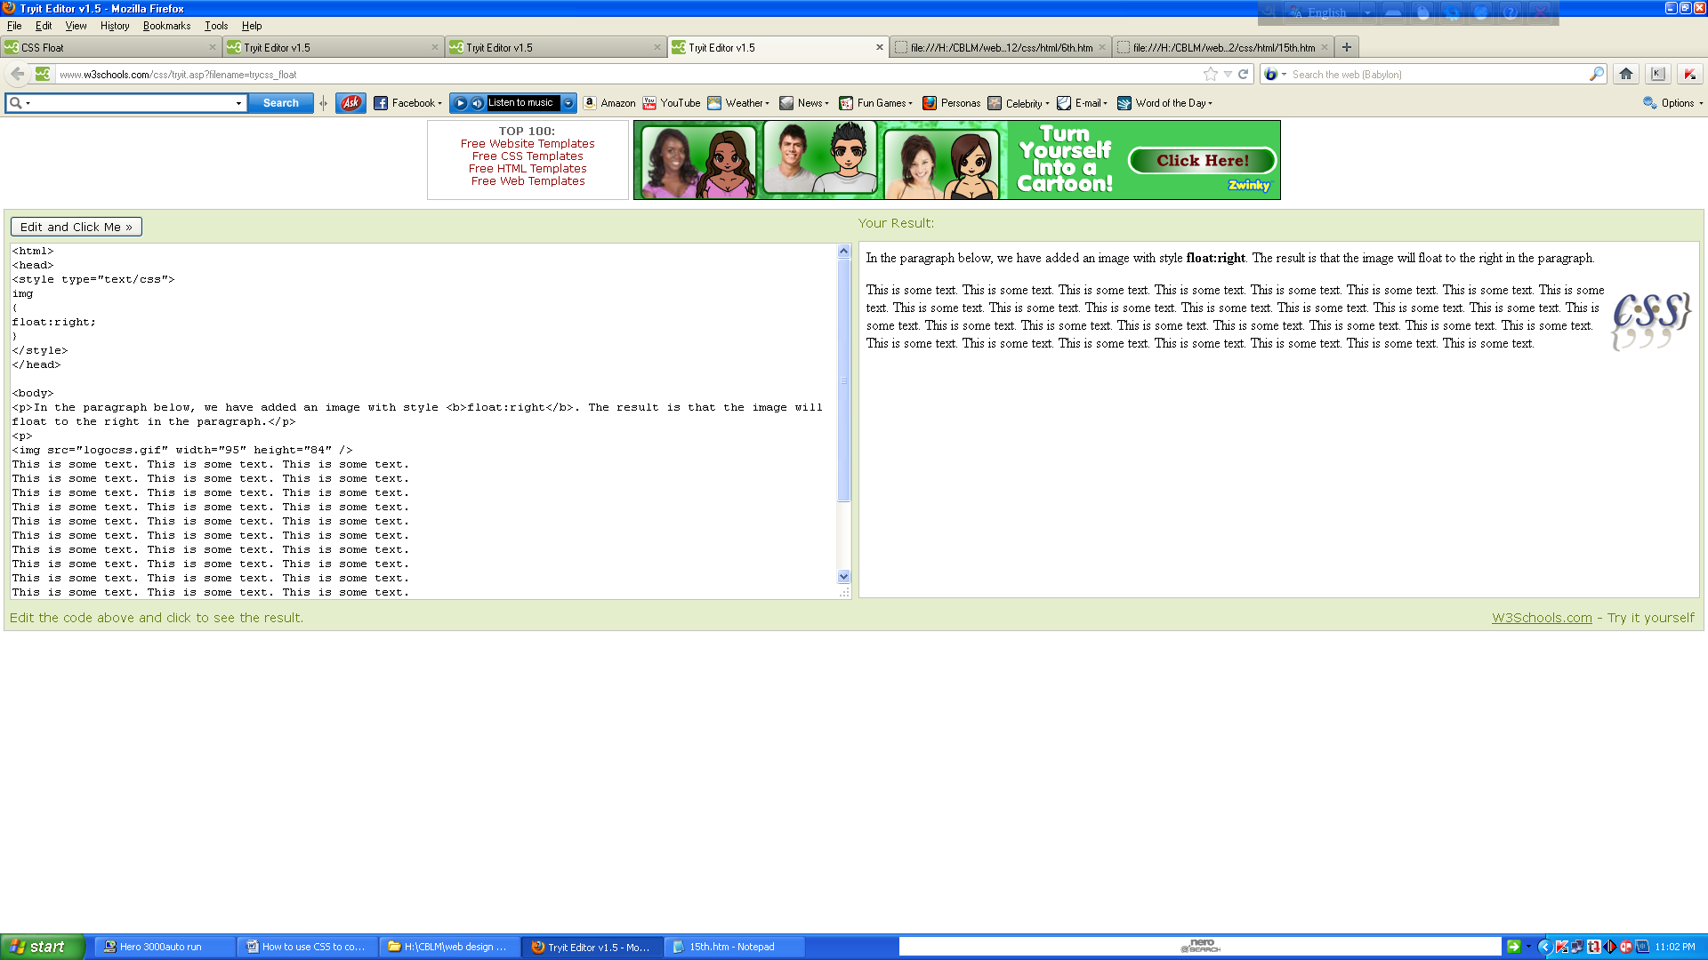

## Floating Elements Next to Each Other

If you place several floating elements after each other, they will float next to each other if there is room.

Here we have made an image gallery using the float property:

## Example

<html><head><style type="text/css">.thumbnail{float:left;width:110px;height:90px;margin:5px;}

</style></head><body><h3>Image Gallery</h3><p>Try resizing the window to see what happens when the images does not have enough room.</p>

<img class="thumbnail" src="klematis_small.jpg" width="107" height="90">

<img class="thumbnail" src="klematis2_small.jpg" width="107" height="80">

<img class="thumbnail" src="klematis3_small.jpg" width="116" height="90">

<img class="thumbnail" src="klematis4_small.jpg" width="120" height="90">

<img class="thumbnail" src="klematis_small.jpg" width="107" height="90">

<img class="thumbnail" src="klematis2_small.jpg" width="107" height="80">

<img class="thumbnail" src="klematis3_small.jpg" width="116" height="90">

<img class="thumbnail" src="klematis4_small.jpg" width="120" height="90">

</body>

</html>

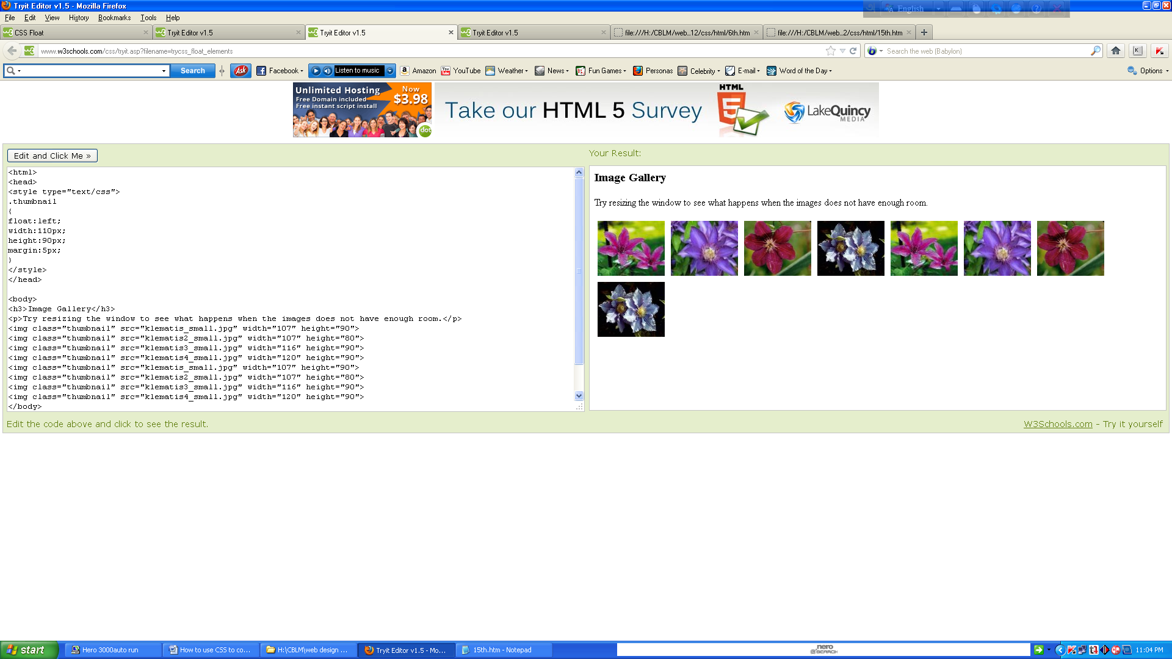

## Turning off Float - Using Clear

Elements after the floating element will flow around it. To avoid this, use the clear property.

The clear property specifies which sides of an element other floating elements are not allowed.

Add a text line into the image gallery, using the clear property:

## 

## Example

<html><head><style type="text/css">.thumbnail{float:left;width:110px;height:90px;margin:5px;}

</style></head><body><h3>Image Gallery</h3><p>Try resizing the window to see what happens when the images does not have enough room.</p>

<img class="thumbnail" src="klematis_small.jpg" width="107" height="90">

<img class="thumbnail" src="klematis2_small.jpg" width="107" height="80">

<img class="thumbnail" src="klematis3_small.jpg" width="116" height="90">

<img class="thumbnail" src="klematis4_small.jpg" width="120" height="90">

<img class="thumbnail" src="klematis_small.jpg" width="107" height="90">

<img class="thumbnail" src="klematis2_small.jpg" width="107" height="80">

<img class="thumbnail" src="klematis3_small.jpg" width="116" height="90">

<img class="thumbnail" src="klematis4_small.jpg" width="120" height="90">

</body></html>

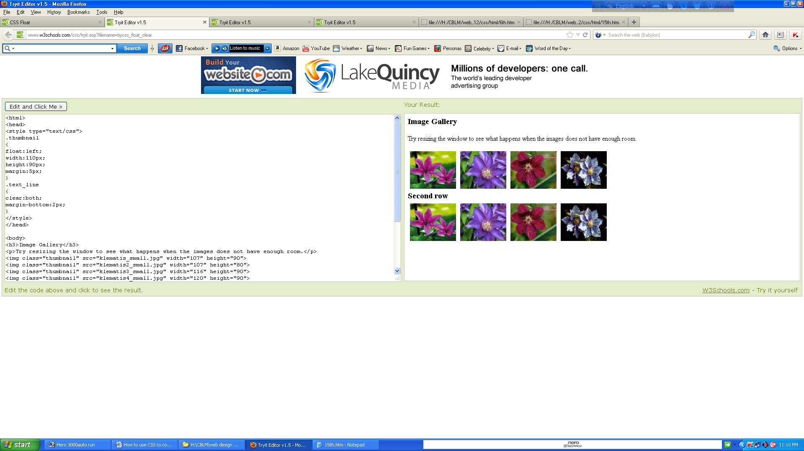

## All CSS Float Properties

The number in the "CSS" column indicates in which CSS version the property is defined (CSS1 or CSS2).

|  |  |  |  |
| --- | --- | --- | --- |
| **Property** | **Description** | **Values** | **CSS** |
| clear | Specifies which sides of an element where other floating elements are not allowed | left right both none inherit | 1 |
| float | Specifies whether or not a box should float | left right none inherit | 1 |

# 

# CSS Horizontal Align

## Aligning Block Elements

A block element is an element that takes up the full width available, and has a line break before and after it.

Examples of block elements:

* <h1>
* <p>
* <div>

## Centre Aligning using the margin Property

Block elements can be aligned by setting the left and right margins to "auto".

**Note:** Using margin: auto will not work in IE8 and earlier, **unless a! DOCTYPE is declared.**

Setting the left and right margins to auto specifies that they should split the available margin equally. The result is a centered element:

## 

## Example

<! DOCTYPE html ><html><head><style type="text/css">.center{margin:auto;width:70%;background-color:#b0e0e6;}

</style></head><body><div class="center"><p>In my younger and more vulnerable years my father gave me some advice that I've been turning over in my mind ever since.</p>

<p>'Whenever you feel like criticizing anyone,' he told me, 'just remember that all the people in this world haven't had the advantages that you've had.'</p></div><p><b>Note: </b>Using margin:auto will not work in IE8, unless a !DOCTYPE is declared.</p></body></html>

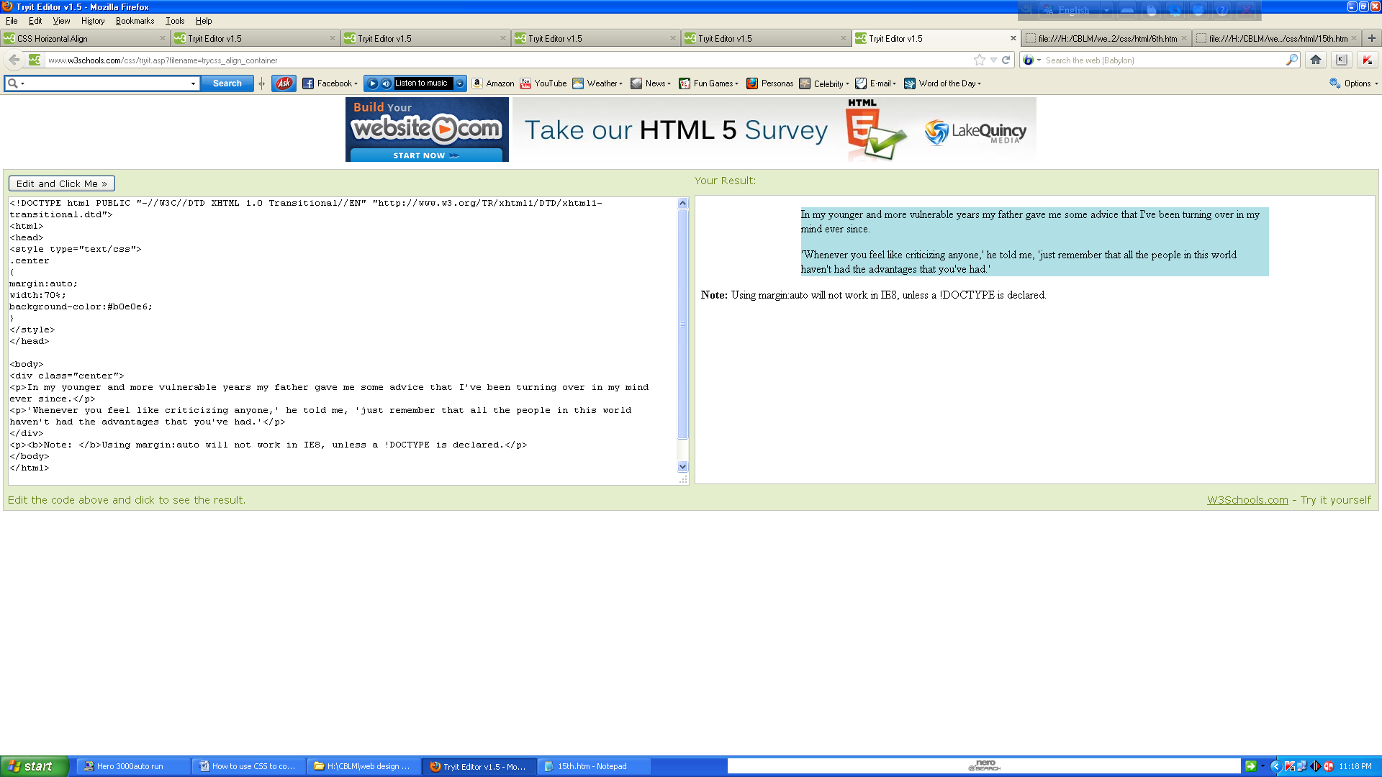

**Tip:** Aligning has no effect if the width is 100%.

**Note:** In IE5 there is a margin handling bug for block elements. To make the example above work in IE5, add some extra code.

## 

## Left and Right Aligning Using the position Property

One method of aligning elements is to use absolute positioning:

## 

## Example

<html><head><style type="text/css">.right{position:absolute;right:0px;width:300px;background-color:#b0e0e6;}

</style></head><body><div class="right"><p>In my younger and more vulnerable years my father gave me some advice that I've been turning over in my mind ever since.</p>

<p>'Whenever you feel like criticizing anyone,' he told me, 'just remember that all the people in this world haven't had the advantages that you've had.'</p>

</div></body></html>

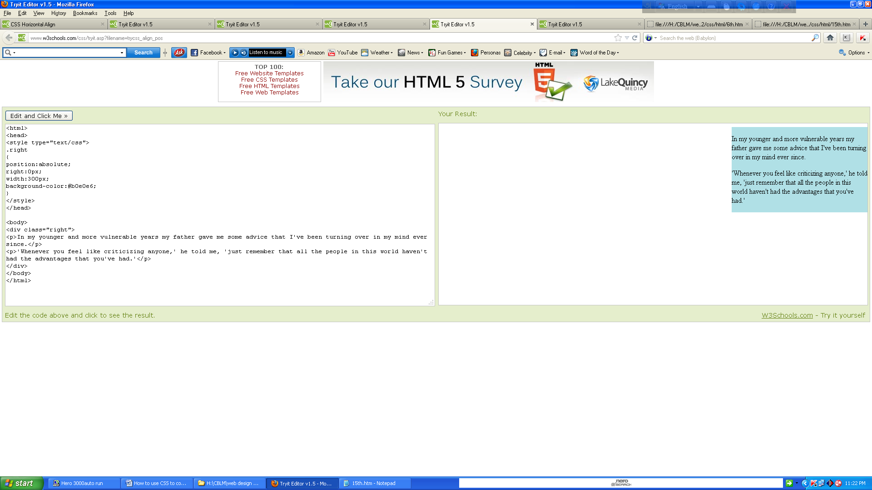

**Note:** Absolute positioned elements are removed from the normal flow, and can overlap elements.

## Cross browser Compatibility Issues

When aligning elements like this, it is always a good idea to predefine margin and padding for the <body> element. This is to avoid visual differences in different browsers.

There is a problem with IE8 and earlier, when using the position property. If a container element (in our case <div class="container">) has a specified width, and the !DOCTYPE declaration is missing, IE8 and earlier versions will add a 17px margin on the right side. This seems to be space reserved for a scrollbar. Always set the !DOCTYPE declaration when using the position property:

## Example

<!DOCTYPE html >

<html><head><style type="text/css">body{margin:0;padding:0;}.container{position:relative;width:100%;}

.right{position:absolute;right:0px;width:300px;background-color:#b0e0e6;}</style>

</head><body><div class="container"><div class="right"><p><b>Note: </b>When aligning using the position property, always include the !DOCTYPE declaration! If missing, it can produce strange results in IE browsers.</p></div></div></body></html>

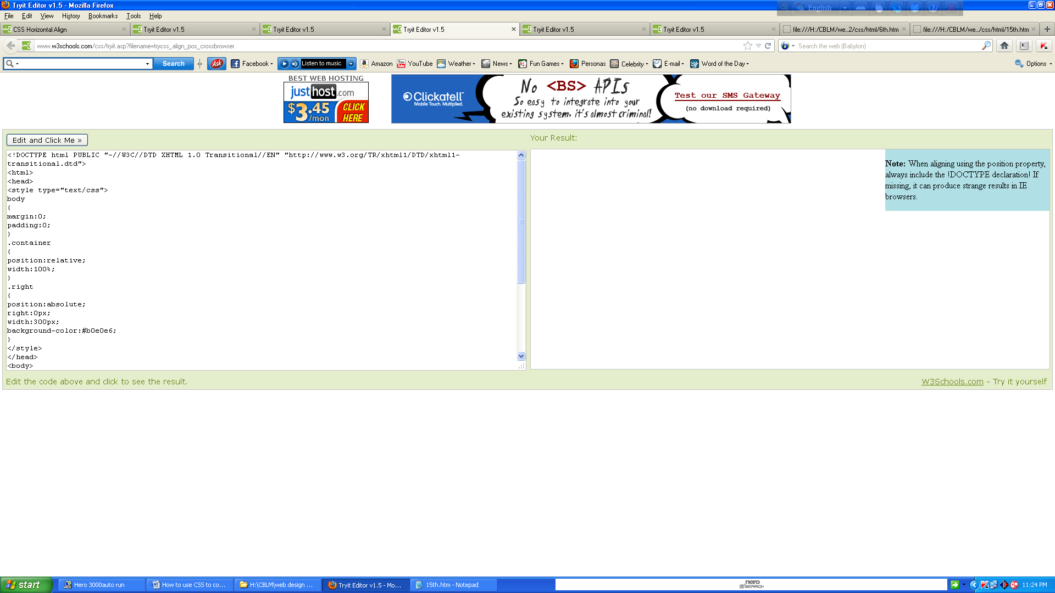

## 

## Left and Right Aligning Using the float Property

One method of aligning elements is to use the float property:

## 

## Example

<html><head><style type="text/css">.right{float:right;width:300px;background-color:#b0e0e6;}

</style></head><body><div class="right"><p>In my younger and more vulnerable years my father gave me some advice that I've been turning over in my mind ever since.</p>

<p>'Whenever you feel like criticizing anyone,' he told me, 'just remember that all the people in this world haven't had the advantages that you've had.'</p></div></body></html>

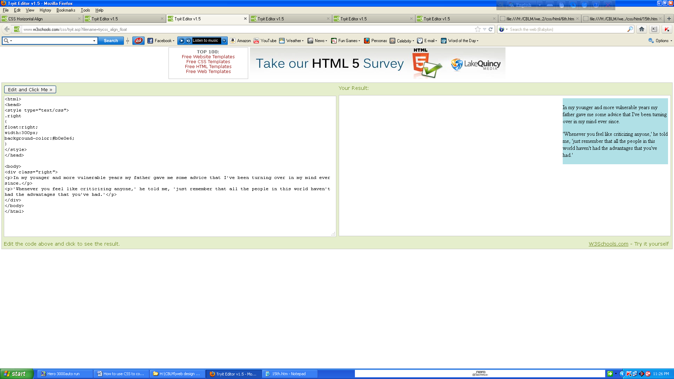

## Cross browser Compatibility Issues

When aligning elements like this, it is always a good idea to predefine margin and padding for the <body> element. This is to avoid visual differences in different browsers.

There is a problem with IE8 and earlier when using the float property. If the !DOCTYPE declaration is missing, IE8 and earlier versions will add a 17px margin on the right side. This seems to be space reserved for a scrollbar. Always set the !DOCTYPE declaration when using the float property:

## 

## Example

<!DOCTYPE html ><html><head><style type="text/css">body{margin:0;padding:0;}

.right{float:right;width:300px;background-color:#b0e0e6;}</style></head>

<body><div class="right"><p><b>Note: </b>When aligning using the float property, always include the !DOCTYPE declaration! If missing, it can produce strange results in IE browsers.</p></div></body></html>

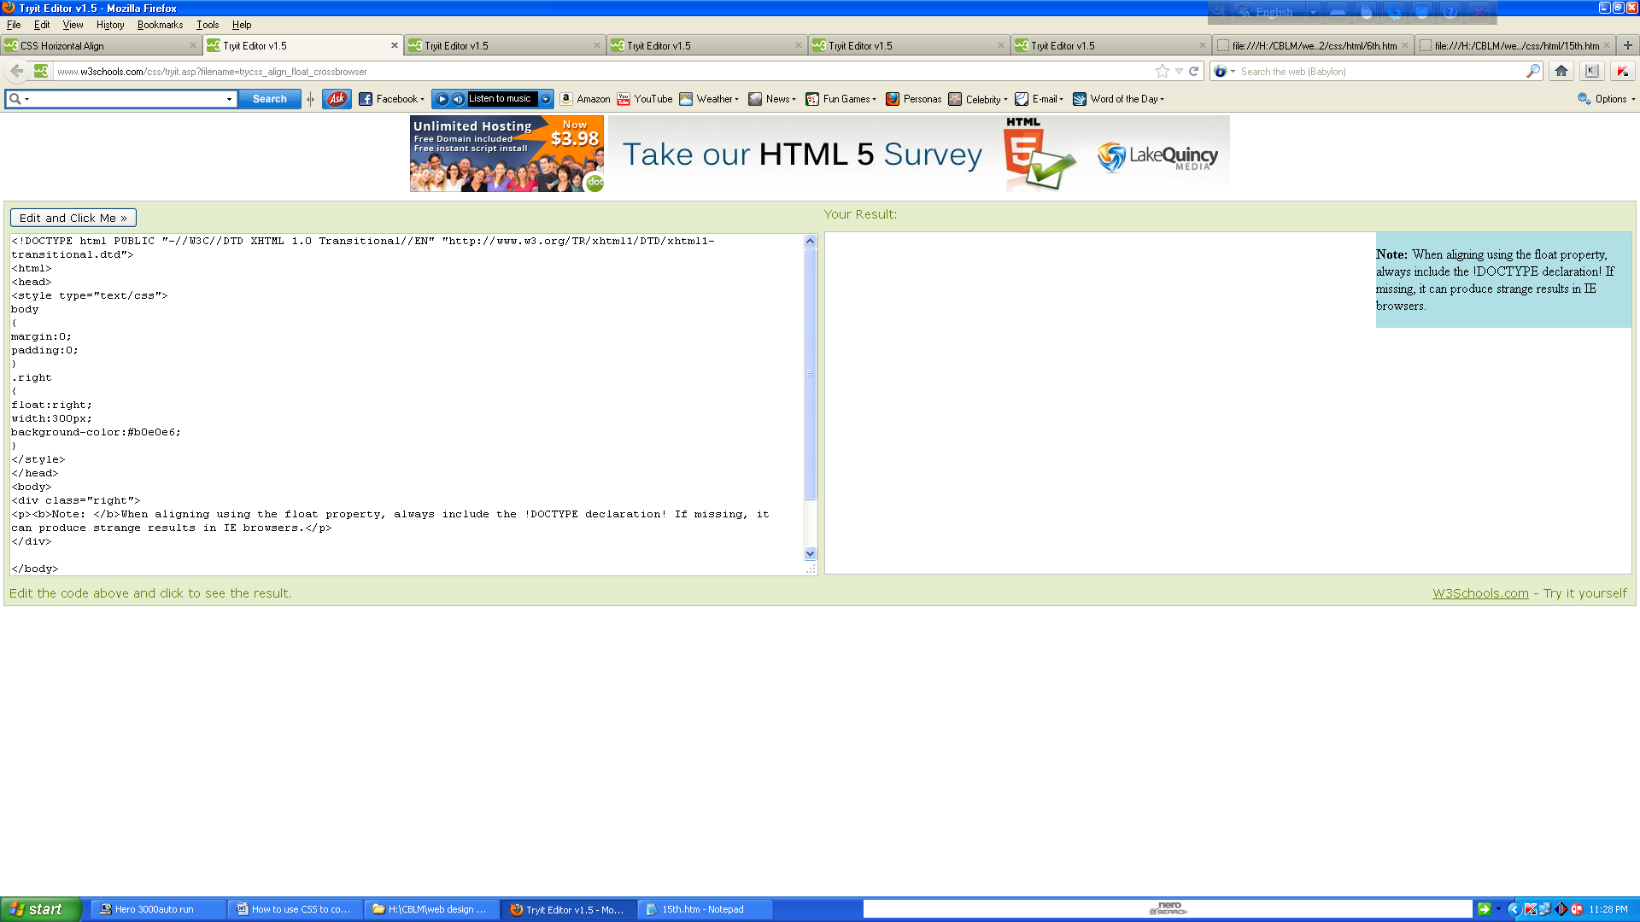

# CSS Navigation Bars

Having easy-to-use navigation is important for any web site.

With CSS you can transform boring HTML menus into good-looking navigation bars.

## Demo: Navigation Bar

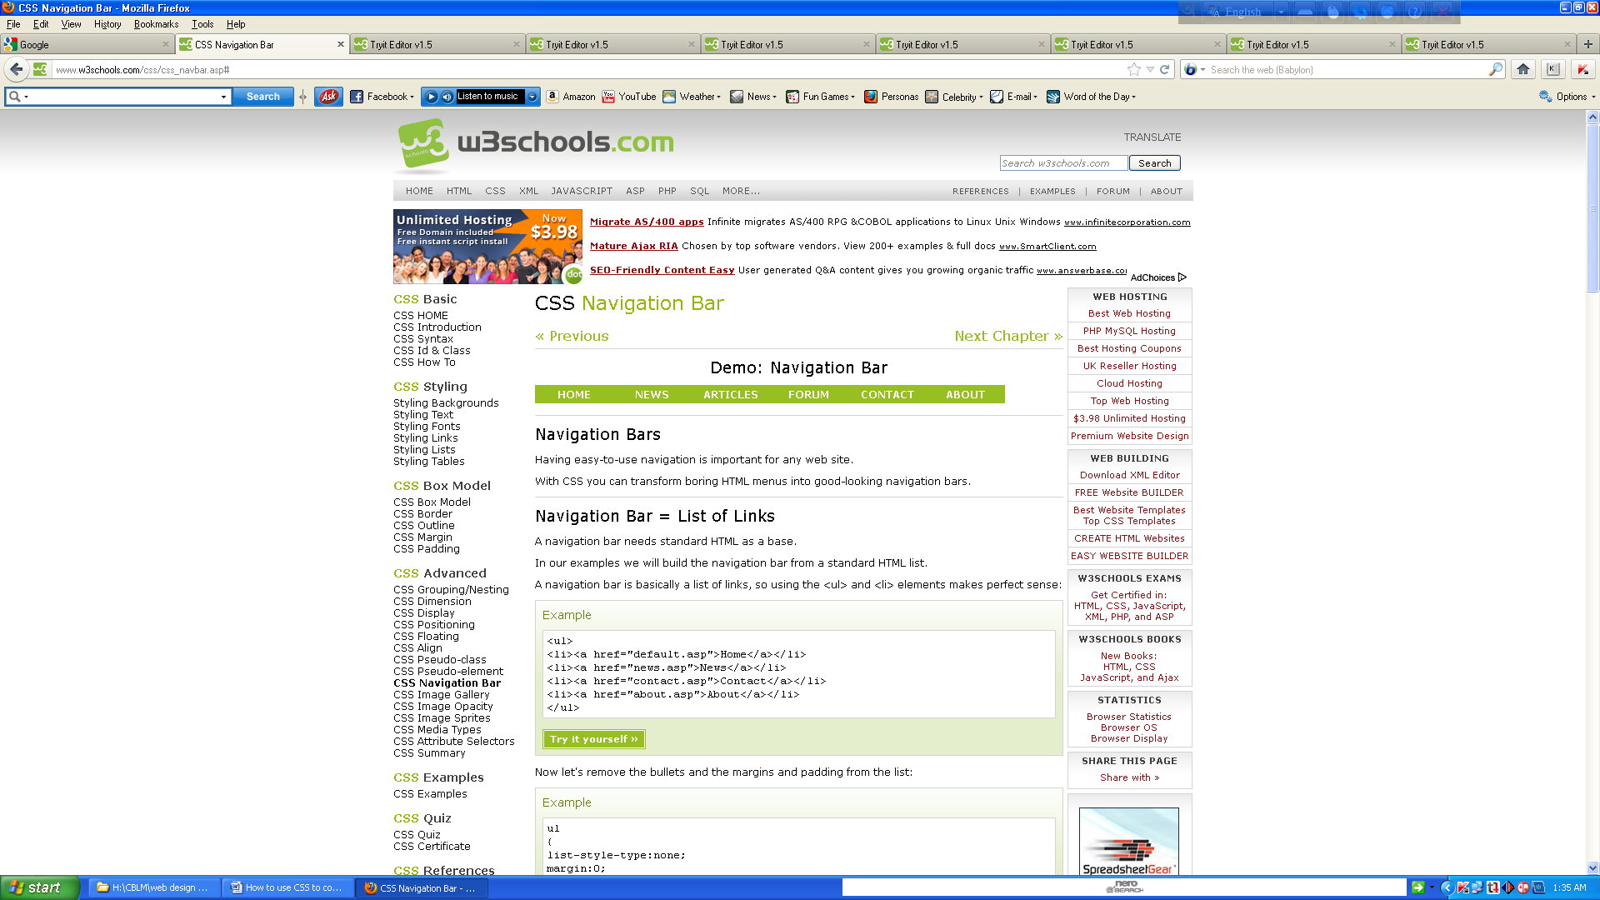

* [Home](http://www.w3schools.com/css/css_navbar.asp)
* [News](http://www.w3schools.com/css/css_navbar.asp)
* [Articles](http://www.w3schools.com/css/css_navbar.asp)
* [Forum](http://www.w3schools.com/css/css_navbar.asp)
* [Contact](http://www.w3schools.com/css/css_navbar.asp)
* [About](http://www.w3schools.com/css/css_navbar.asp)

## 

## Navigation Bar = List of Links

A navigation bar needs standard HTML as a base.

In our examples we will build the navigation bar from a standard HTML list.

A navigation bar is basically a list of links, so using the <ul> and <li> elements makes perfect sense:

## Example

<html><body><ul><li><a href="#home">Home</a></li><li><a href="#news">News</a></li>

<li><a href="#contact">Contact</a></li><li><a href="#about">About</a></li></ul>

<p>Note: We use href="#" for test links. In a real web site this would be URLs.</p>

</body></html>  
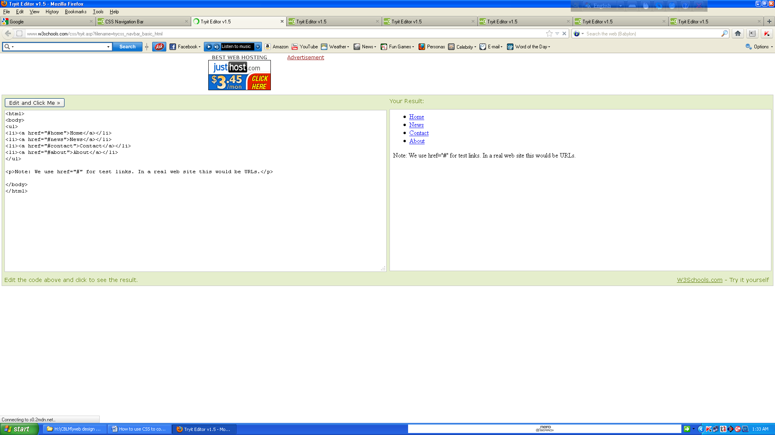

Now let's remove the bullets and the margins and padding from the list:

## 

## Example

<html><head><style>ul{list-style-type:none;margin:0;padding:0;}</style></head><body>

<ul><li><a href="#home">Home</a></li><li><a href="#news">News</a></li>

<li><a href="#contact">Contact</a></li><li><a href="#about">About</a></li>

</ul></body></html>

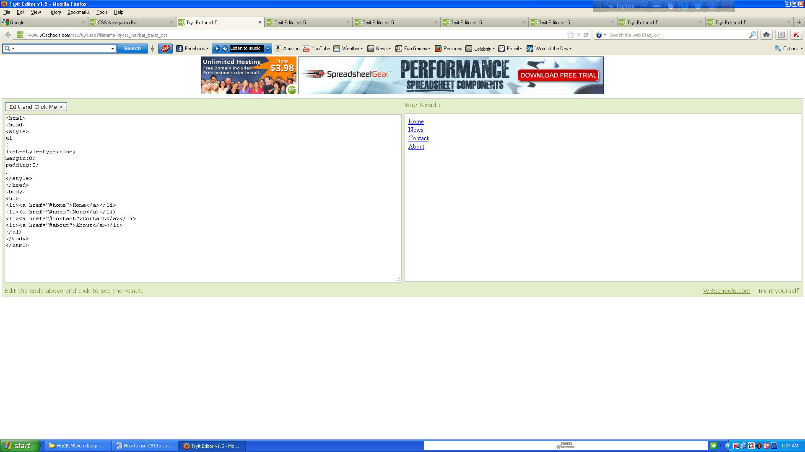  
**Example explained:**

* list-style-type:none - Removes the bullets. A navigation bar does not need list markers
* Setting margins and padding to 0 to remove browser default settings

The code in the example above is the standard code used in both vertical, and horizontal navigation bars.

## Vertical Navigation Bar

To build a vertical navigation bar we only need to style the <a> elements, in addition to the code above:

## Example

<html><head><style type="text/css">ul{list-style-type:none;margin:0;padding:0;}

a{display:block;width:60px;background-color:#dddddd;}</style></head>

<body><ul><li><a href="#home">Home</a></li><li><a href="#news">News</a></li>

<li><a href="#contact">Contact</a></li><li><a href="#about">About</a></li></ul>

<p>A background color is added to the links to show the link area.</p>

<p>Notice that the whole link area is clickable, not just the text.</p></body></html>

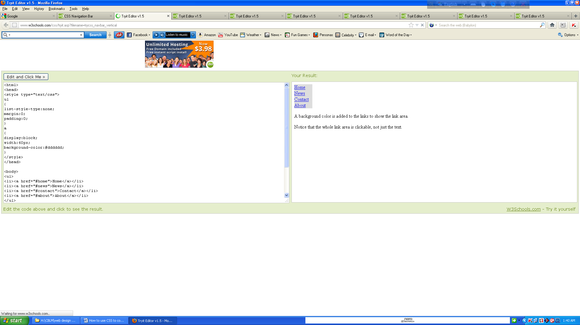

Example explained:

* display:block - Displaying the links as block elements makes the whole link area clickable (not just the text), and it allows us to specify the width
* width:60px - Block elements take up the full width available by default. We want to specify a 60 px width

**Note:** Always specify the width for <a> elements in a vertical navigation bar. If you omit the width, IE6 can produce unexpected results.

## Horizontal Navigation Bar

There are two ways to create a horizontal navigation bar. Using **inline** or **floating** list items.

Both methods work fine, but if you want the links to be the same size, you have to use the floating method.

## 

## Inline List Items

One way to build a horizontal navigation bar is to specify the <li> elements as inline, in addition to the "standard" code above:

## Example

<html><head><style type="text/css">ul{list-style-type:none;margin:0;padding:0;}

li{display:inline;}</style></head><body><ul><li><a href="#home">Home</a></li>

<li><a href="#news">News</a></li><li><a href="#contact">Contact</a></li>

<li><a href="#about">About</a></li></ul></body></html>

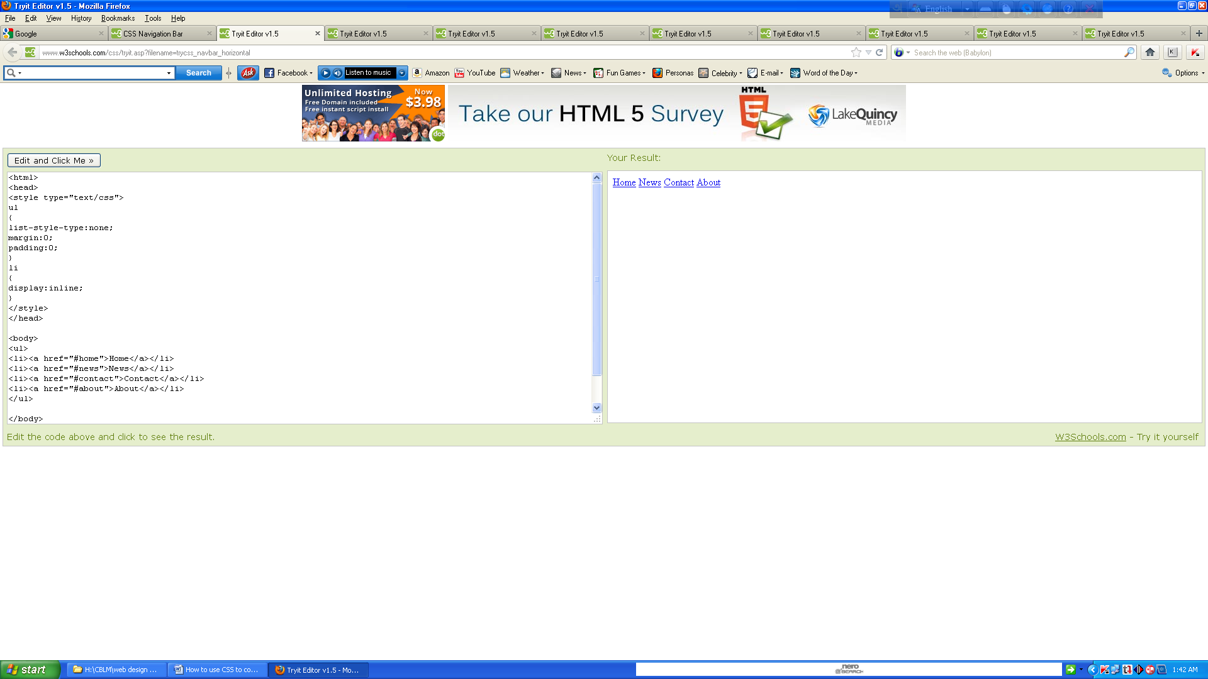

Example explained:

* display:inline; - By default, <li> elements are block elements. Here, we remove the line breaks before and after each list item, to display them on one line

## Floating List Items

In the example above the links have different widths.

For all the links to have an equal width, float the <li> elements and specify a width for the <a> elements:

## 

## Example

<!DOCTYPE html ><html><head><style type="text/css">ul{list-style-type:none;margin:0;padding:0;overflow:hidden;}li{float:left;}a{display:block;width:60px;background-color:#dddddd;}</style></head><body><ul><li><a href="#home">Home</a></li>

<li><a href="#news">News</a></li><li><a href="#contact">Contact</a></li><li><a href="#about">About</a></li></ul><p><b>Note:</b> If a !DOCTYPE is not specified, floating items can produce unexpected results.</p><p>A background color is added to the links to show the link area. The whole link area is clickable, not just the text.</p><p><b>Note:</b> overflow:hidden is added to the ul element to prevent li elements from going outside of the list.</p></body></html>

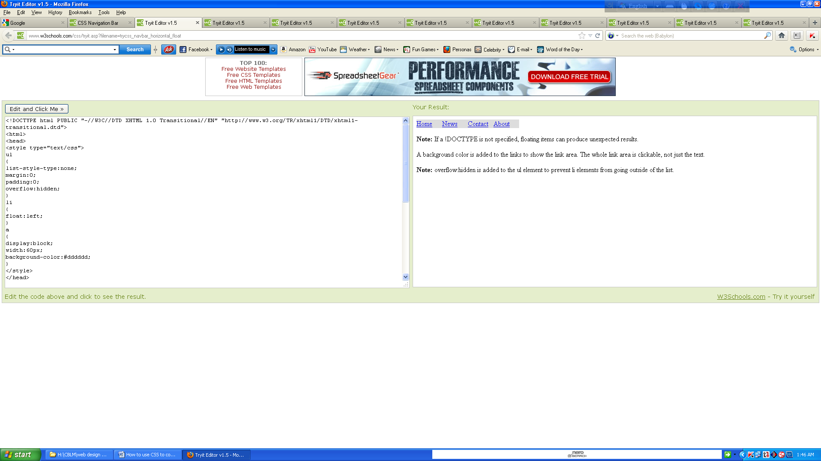

Example explained:

* float:left - use float to get block elements to slide next to each other
* display:block - Displaying the links as block elements makes the whole link area clickable (not just the text), and it allows us to specify the width
* width:60px - Since block elements take up the full width available, they cannot float next to each other. We specify the width of the links to 60px

**CSS can be used to create an image gallery.**

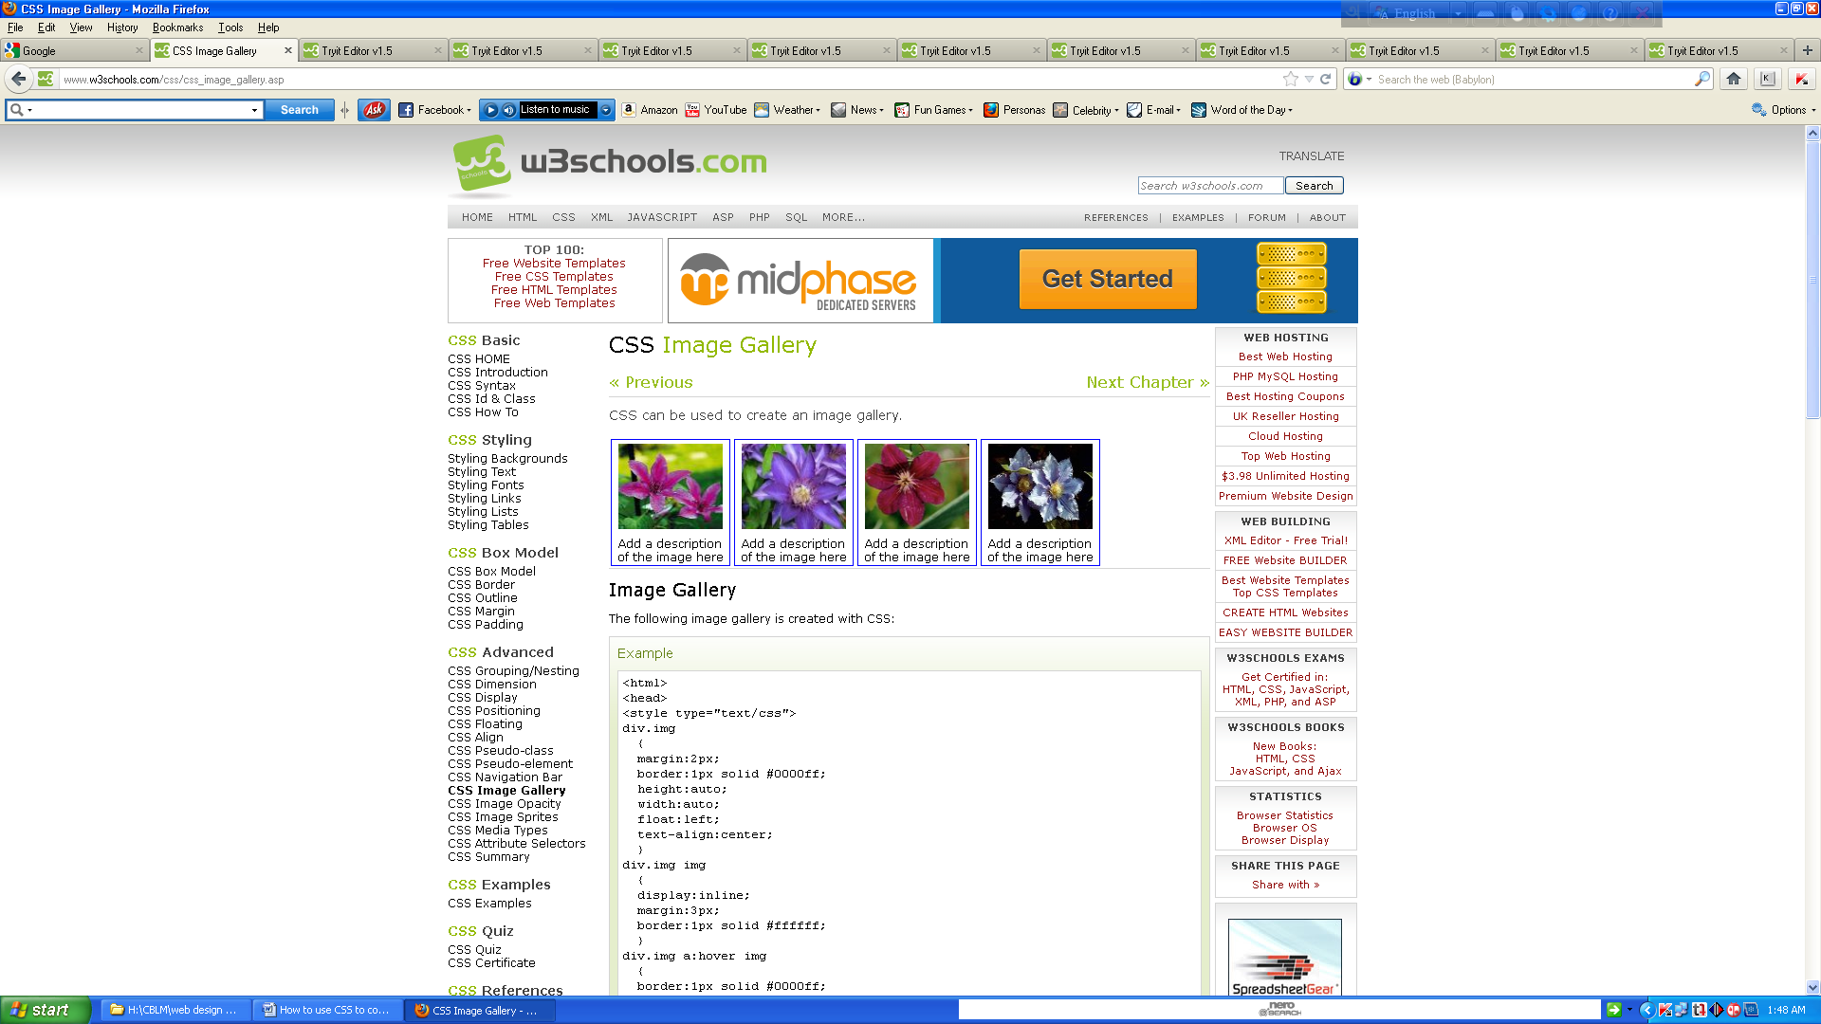

## Image Gallery

The following image gallery is created with CSS:

## Example

<html><head><style type="text/css">div.img  {  margin:2px;  border:1px solid #0000ff;  height:auto;  width:auto;  float:left;  text-align:center;  }  
div.img img  {  display:inline;  margin:3px;  border:1px solid #ffffff;  }  
div.img a:hover img  {  border:1px solid #0000ff;  }

div.desc  {  text-align:center;  font-weight:normal;  width:120px;  margin:2px;  }  
</style></head><body><div class="img">  <a target="_blank" href="klematis_big.htm">  
  <img src="klematis_small.jpg" alt="Klematis" width="110" height="90" />  </a>  
  <div class="desc">Add a description of the image here</div></div>  
<div class="img">  <a target="_blank" href="klematis2_big.htm">  <img src="klematis2_small.jpg" alt="Klematis" width="110" height="90" />  </a>  
  <div class="desc">Add a description of the image here</div></div><div class="img">  
  <a target="_blank" href="klematis3_big.htm">  <img src="klematis3_small.jpg" alt="Klematis" width="110" height="90" />  </a>  <div class="desc">Add a description of the image here</div>  
</div><div class="img">  <a target="_blank" href="klematis4_big.htm">  
  <img src="klematis4_small.jpg" alt="Klematis" width="110" height="90" />  </a>  
  <div class="desc">Add a description of the image here</div></div></body></html>

# CSS Image Opacity / Transparency

Creating transparent images with CSS is easy.

**Note:** The CSS opacity property is a part of the W3C CSS3 recommendation.

## Creating a Transparent Image

The CSS3 property for transparency is **opacity**.

First we will show you how to create a transparent image with CSS.

Regular image:



The same image with transparency:

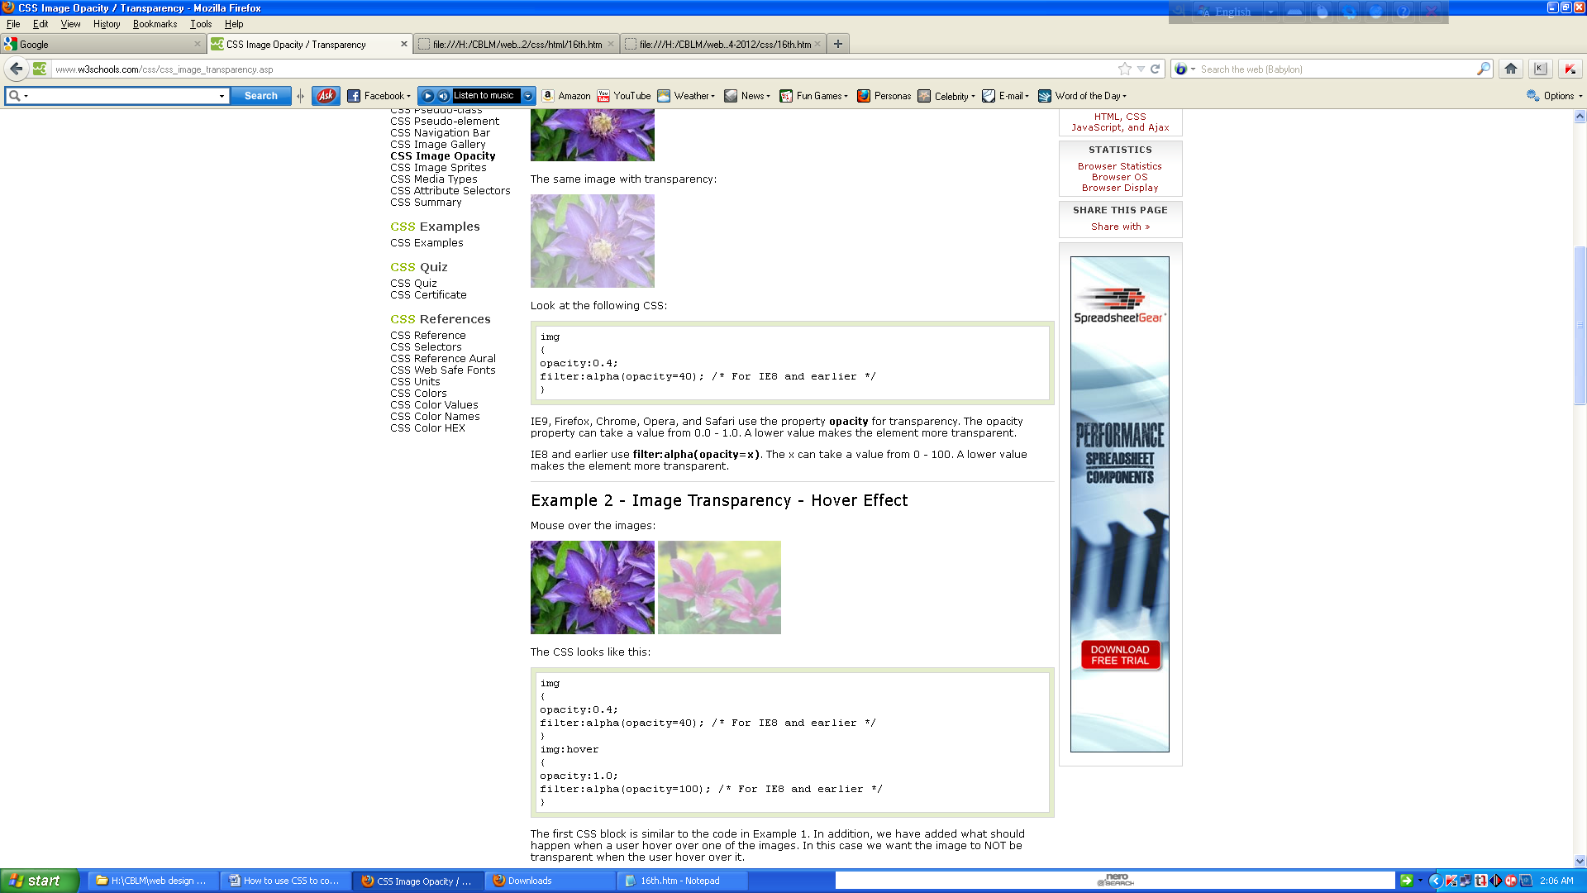

Look at the following CSS:

Img {opacity:0.4;filter:alpha(opacity=40); /* For IE8 and earlier */}

IE9, Firefox, Chrome, Opera, and Safari use the property **opacity** for transparency. The opacity property can take a value from 0.0 - 1.0. A lower value makes the element more transparent.

IE8 and earlier use **filter:alpha(opacity=x)**. The x can take a value from 0 - 100. A lower value makes the element more transparent.

## Image Transparency - Hover Effect

Mouse over the images:



The CSS looks like this:

img{opacity:0.4;filter:alpha(opacity=40); /* For IE8 and earlier */}  
img:hover{opacity:1.0;filter:alpha(opacity=100); /* For IE8 and earlier */}

The first CSS block is similar to the code in Example 1. In addition, we have added what should happen when a user hover over one of the images. In this case we want the image to NOT be transparent when the user hover over it.

The CSS for this is: **opacity=1**.

IE8 and earlier: **filter:alpha(opacity=100)**.

When the mouse pointer moves away from the image, the image will be transparent again.

## Text in Transparent Box

This is some text that is placed in the transparent box. This is some text that is placed in the transparent box. This is some text that is placed in the transparent box. This is some text that is placed in the transparent box. This is some text that is placed in the transparent box.

The source code looks like this:

<html><head><style type="text/css">  
div.background  {  width:500px;  height:250px;  background:url(klematis.jpg) repeat;  border:2px solid black;  }div.transbox  {  width:400px;  height:180px;  margin:30px 50px;  background-color:#ffffff;  border:1px solid black;  opacity:0.6;  filter:alpha(opacity=60); /* For IE8 and earlier */  }div.transbox p  {  margin:30px 40px;  font-weight:bold;  color:#000000;  }  
</style></head><body><div class="background"><div class="transbox"><p>This is some text that is placed in the transparent box.This is some text that is placed in the transparent box.  
This is some text that is placed in the transparent box.This is some text that is placed in the transparent box.This is some text that is placed in the transparent box.</p></div></div>  
</body></html>

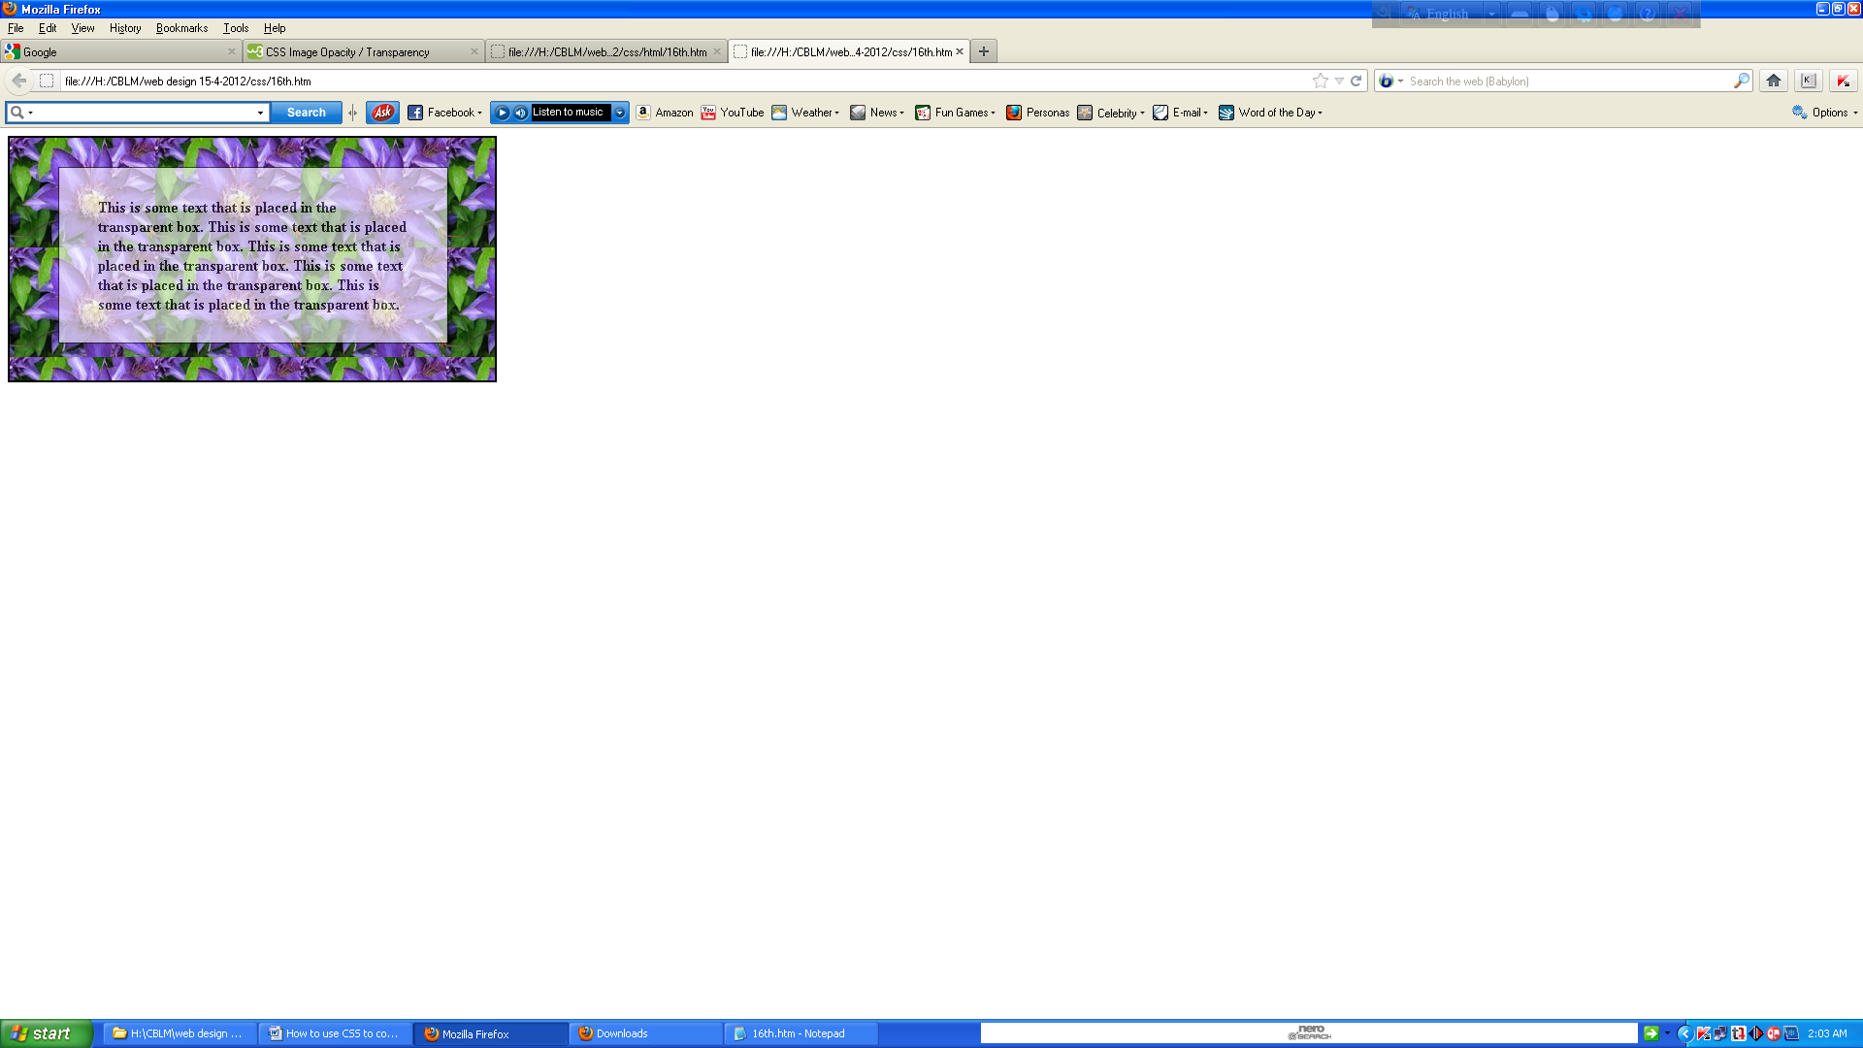

First, we create a div element (class="background") with a fixed height and width, a background image, and a border. Then we create a smaller div (class="transbox") inside the first div element. The "transbox" div have a fixed width, a background color, and a border - and it is transparent. Inside the transparent div, we add some text inside a p element.

### Validate the HTML

The first stage of checking a web-site is to make sure that you have valid HTML (or XHTML). This can be done with a validator such as the W3C validator, WDG validator and CSE validator. Your own browser may ignore certain errors, but there is a significant risk that markup errors will result in display problems in some browser or other.

There are sometimes reasons for including invalid HTML. For example some pages on my own site use the non-standard NOINDEX element, for the benefit of my site search engine. But you should only tolerate HTML validation errors if there is a clear need for the non-standard markup, and if you have tested the result in a variety of browsers.

### Validate the CSS

CSS can be validated with for example the W3C CSS validator. The considerations here are much the same as HTML validation. It may sometimes be necessary to use something non-standard to get Internet Explorer to work, but such rules can be placed in a separate CSS file and hidden in an Internet Explorer conditional comment, where they won’t bother other browsers or a validator.

## Web Page Validator

A validator is a software program that can check your web pages against the web standards.

When using a validator to check HTML, XHTML or CSS documents, the validator returns a list of errors found, according to your chosen standard.

Make sure you make it a habit to validate all your web pages before publishing.

## Validate your HTML files with W3C

Top of Form

Input the address of the page you want to validate in the box below:



Bottom of Form

## Validate your CSS files with W3C

Top of Form

Input the address of the css file that you want to validate in the box below:



Validate as: CSS3 CSS2.1 CSS2 CSS1

Bottom of Form

## [CSS Validator main window](http://www.htmlvalidator.com/) mentioned below:

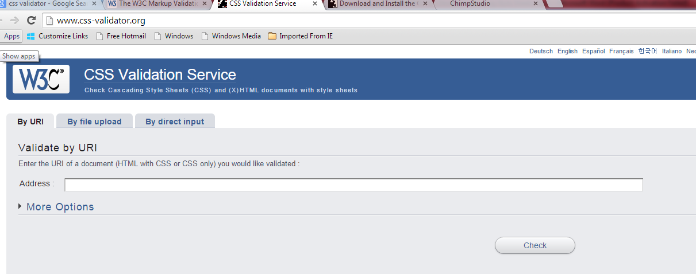

* HTML validators – they check your HTML code for errors

## CSS validators – they check Cascading Style Sheets (CSS) for errors

## 

|  |
| --- |
| **Self Check No. 1(Information Sheet 1: Define the purpose, accessibility and styles of CSS and create a webpage using CSS and HTML )** |

**1. What is CSS?**

## 2. Why CSS Comments?

# 3. What is the purpose of the HTML?

# 4. What is the purpose of the CSS?

**5. What is your comments regarding browsers support by the CSS?**

**6. What is the benefit of separate CSS file?**

**7. What is CSS file extension?**

**8. Who create CSS and why?**

**9. Write down CSS syntax**

**10. Before study CSS what you should already know?**

# 11. Mention 5 (five) ways to ensure your site is accessible to the visually impaired

**12. Identify the platform where the CSS will be used.**

**13. How many types of selectors in CSS?**

**14. Define “id” selector.**

**15. Define “Class” selector.**

**16. How many ways to insert CSS in the HTML document?**

**17. How to insert the external style sheet in the HTML document?**

**18. Write down the command lines for internal style sheet.**

**19. Which the style sheet has height priority?**

**20. Why does background properties are used?**

**21. What are the text formatting properties?**

## 22. Why text decoration does is used?

**23. What are text transfer properties?**

## 24. What is Text Indentation?

## 25. Show the difference between Serif and Sans-serif Fonts.

## 26. Why does font size is important?

# 27. How many styles of CSS links?

# 28. How many markers of CSS lists?

## 29. Why does use collapse borders?

## 30. Why does use table padding?

# 31. When CSS box model is used?

**32. Mention the different parts of box model**

**33. How to calculate the margin, border, padding and content with example?**

**34. Why do we use DOCTYPE?**

## 35. List the border-style values?

**36. What is CSS outline?**

**37. Why does create group selection?**

# 38. What is a display property?

**39. Mention the difference between block and inline.**

### 40. What is validate the HTML

**41. What are the reasons of HTML validation?**

### 42. What is CSS validation?

## 43. What is Web Page Validator?

**44. How to validate HTML and CSS with W3C?**

|  |
| --- |
| **Answer Key no. 1 (Information sheet 1: Define the purpose, accessibility and styles of CSS and create a webpage using CSS and HTML.)** |

**1. What is CSS?**

**Answer:**

1. CSS stands for Cascading Style Sheets
2. Styles define how to display HTML elements
3. Styles were added to HTML 4.0 to solve a problem
4. External Style Sheets can save a lot of work
5. External Style Sheets are stored in CSS files

## 2. Why CSS Comments?

**Answer:**

Comments are used to explain your code, and may help you when you edit the source code at a later date. Comments are ignored by browsers.

# 3. What is the purpose of the HTML?

**Answer:**

Basically, it is a way to set the basic blocks for other languages (like Javascript and CSS) to manipulate.

# 4. What is the purpose of the CSS?

**Answer:**

The basic purpose of CSS is to separate the content of a web document (written in any markup language) from its presentation (that is written using Cascading Style Sheets).

**5. What is your comments regarding browsers support by the CSS?**

**Answer:**

All browsers support CSS today.

**6. What is the benefit of separate CSS file?**

**Answer:**

Development of large web sites, where fonts and color information were added to every single page, became a long and expensive process.

To solve this problem, the World Wide Web Consortium (W3C) created CSS.

In HTML 4.0, all formatting could be removed from the HTML document, and stored in a separate CSS file.

**7. What is CSS file extension?**

**Answer:**

Styles are normally saved in external .css files.

**8. Who create CSS and why?**

**Answer:**

The World Wide Web Consortium (W3C) created CSS.In HTML 4.0; all formatting could be removed from the HTML document, and stored in a separate CSS file.

**9. Write down CSS syntax**

**Answer:**

A CSS rule has two main parts: a selector, and one or more declarations:



The selector is normally the HTML element you want to style.

Each declaration consists of a property and a value.

The property is the style attribute you want to change. Each property has a value.

**10. Before study CSS what you should already know?**

**Answer:**

Before you continue to study CSS you should have a basic understanding of the following:

1. HTML / XHTML

# 11. Mention 5 (five) ways to ensure your site is accessible to the visually impaired

**Answer:**

5 (Five) Ways to Ensure Your Site Is Accessible to the Visually Impaired as follows

## 1. Make Allowances for Enlarged Text

## 2. Contrast is Key

## 3. Be Mindful of Colors for Action Items

## 4. Let Desktop Users Browse Your Mobile Site

## 5. Use Keyboard Shortcuts to Aid Navigation

**12. Identify the platform where the CSS will be used.**

**Answer:**

CSS platform means where CSS will be run. The most common platforms are IE9+, Firefox, Safari, Chrome AND iPad / iPhone, Blacberry, Android etc.

**13. How many types of selectors in CSS?**

**Answer:**

Two types of selectors called "id" and "class".

**14. Define “id” selector.**

**Answer:**

The id selector is used to specify a style for a single, unique element.

The id selector uses the id attribute of the HTML element, and is defined with a "#".

The style rule below will be applied to the element with id="para1":

**15. Define “Class” selector.**

**Answer:**

The class selector is used to specify a style for a group of elements. Unlike the id selector, the class selector is most often used on several elements.

This allows you to set a particular style for many HTML elements with the same class.

The class selector uses the HTML class attribute, and is defined with a "."

**16. How many ways to insert CSS in the HTML document?**

**Answer:**

## Three Ways to Insert CSS

There are three ways of inserting a style sheet:

* External style sheet
* Internal style sheet
* Inline style

**17. How to insert the external style sheet in the HTML document?**

**Answer:**

An external style sheet is ideal when the style is applied to many pages. With an external style sheet, you can change the look of an entire website by changing one file. Each page must link to the style sheet using the <link> tag. The <link> tag goes inside the head section:

<head>  
<link rel="stylesheet" type="text/css" href="mystyle.css" />  
</head>

**18. Write down the command lines for internal style sheet.**

**Answer:**

<style type="text/css">  
hr {color:sienna;}  
p {margin-left:20px;}  
body {background-image:url("images/back40.gif");}  
</style>

**19. Which the style sheet has height priority?**

**Answer:**

An inline style (inside an HTML element) has the highest priority, which means that it will override a style defined inside the <head> tag, or in an external style sheet, or in a browser (a default value).

**20. Why does background properties are used?**

**Answer:**

CSS background properties are used to define the background effects of an element.

CSS properties used for background effects:

* background-color
* background-image
* background-repeat
* background-attachment
* background-position

**21. What are the text formatting properties?**

**Answer:**

Text formatting properties uses to the text-align, text-transform, and color properties. The paragraph is indented, aligned, and the space between characters is specified.

## 22. Why text decoration does is used?

## Answer:

The text-decoration property is used to set or remove decorations from text.

**23. What are text transfer properties?**

## Answer:

The text-transform property is used to specify uppercase and lowercase letters in a text.

It can be used to turn everything into uppercase or lowercase letters, or capitalize the first letter of each word.

## 24. What is Text Indentation?

## Answer:

The text-indentation property is used to specify the indentation of the first line of a text.

## 25. Show the difference between Serif and Sans-serif Fonts.

# Answer:

## Difference between Serif and Sans-serif Fonts showed below



On computer screens, sans-serif fonts are considered easier to read than serif fonts.

## 26. Why does font size is important?

**Answer:**

The font-size property sets the size of the text. Being able to manage the text size is important in web design. However, you should not use font size adjustments to make paragraphs look like headings, or headings look like paragraphs.

Always use the proper HTML tags, like <h1> - <h6> for headings and <p> for paragraphs.

The font-size value can be an absolute or relative size.

# 27. How many styles of CSS links?

**Answer:**

The four links states are:

* a:link - a normal, unvisited link
* a:visited - a link the user has visited
* a:hover - a link when the user mouses over it
* a:active - a link the moment it is clicked

# 28. How many markers of CSS lists?

# Answer:

The CSS list properties allow you three markers as follows:

* Set different list item markers for ordered lists
* Set different list item markers for unordered lists
* Set an image as the list item marker

## 29. Why does use collapse borders?

## Answer:

The border-collapse property sets whether the table borders are collapsed into a single border or separated.

## 30. Why does use table padding?

**Answer:**

To control the space between the border and content in a table, use the padding property on td and th elements.

# 31. When CSS box model is used?

## Answer:

All HTML elements can be considered as boxes. In CSS, the term "box model" is used when talking about design and layout.

The CSS box model is essentially a box that wraps around HTML elements, and it consists of: margins, borders, padding, and the actual content.

The box model allows us to place a border around elements and space elements in relation to other elements.

**32. Mention the different parts of box model**

**Answer:**

The different parts of box model:

* **Margin** - Clears an area around the border. The margin does not have a background color, it is completely transparent
* **Border** - A border that goes around the padding and content. The border is affected by the background color of the box
* **Padding** - Clears an area around the content. The padding is affected by the background color of the box
* **Content** - The content of the box, where text and images appear
* In order to set the width and height of an element correctly in all browsers, you need to know how the box model works.

**33. How to calculate the margin, border, padding and content with example?**

**Answer:**

The total width of an element should be calculated like this:

Total element width = width + left padding + right padding + left border + right border + left margin + right margin

**Example:**

The total width of the element in the example below is 300px:

Width: 250px;  
padding:10px;  
border:5px solid gray;  
margin:10px;

Let's do the math:  
250px (width)  
+ 20px (left and right padding)  
+ 10px (left and right border)  
+ 20px (left and right margin)  
= 300px

**34. Why do we use DOCTYPE?**

**Answer:**

To fix the display problem (i.e. width, border, margin and padding), just add a DOCTYPE to the HTML page:

## 35. List the border-style values?

**Answer:**

## Border-style values:

none: Defines no border

dotted: Defines a dotted border

dashed: Defines a dashed border

solid: Defines a solid border

double: Defines two borders. The width of the two borders are the same as the border-width value

groove: Defines a 3D grooved border. The effect depends on the border-color value

ridge: Defines a 3D ridged border. The effect depends on the border-color value

inset: Defines a 3D inset border. The effect depends on the border-color value

outset: Defines a 3D outset border. The effect depends on the border-color value

**36. What is CSS outline?**

## Answer:

An outline is a line that is drawn around elements (outside the borders) to make the element "stand out”. The outline properties specify the style, color, and width of an outline.

However, the outline property is different from the border property.

The outline is not a part of an element's dimensions; the element's total width and height is not affected by the width of the outline.

**37. Why does create group selection?**

**Answer:**

In style sheets there are often elements with the same style. To minimize the code, you can group selectors. Separate each selector with a comma. In the example below we have grouped the selectors:

h1, h2, p {color: green ;}

# 38. What is a display property?

# Answer:

The display property specifies if/how an element is displayed, and the visibility property specifies if an element should be visible or hidden.

**39. Mention the difference between block and inline.**

**Answer:**

A block element is an element that takes up the full width available, and has a line break before and after it.

Examples of block elements:

* <h1>
* <p>
* <div>

An inline element only takes up as much width as necessary, and does not force line breaks.

Examples of inline elements:

* <span>
* <a>

### 40. What is validate the HTML

### Answer:

The HTML validates means checking a web-site is to make sure that you have valid HTML (or XHTML). This can be done with a validator such as the W3C validator or WDG validator. Your own browser may ignore certain errors, but there is a significant risk that markup errors will result in display problems in some browser or other.

**41. What are the reasons of HTML validation?**

**Answer:**

There are sometimes reasons for including invalid HTML. For example some pages on my own site use the non-standard NOINDEX element, for the benefit of my site search engine. But you should only tolerate HTML validation errors if there is a clear need for the non-standard markup, and if you have tested the result in a variety of browsers.

### 42. What is CSS validation?

**Answer:**

The considerations here are much the same as HTML validation. It may sometimes be necessary to use something non-standard to get Internet Explorer to work, but such rules can be placed in a separate CSS file and hidden in an Internet Explorer conditional comment, where they won’t bother other browsers or a validator.

## 43. What is Web Page Validator?

**Answer:**

A validator is a software program that can check your web pages against the web standards.

When using a validator to check HTML, XHTML or CSS documents, the validator returns a list of errors found, according to your chosen standard. Make sure you make it a habit to validate all your web pages before publishing.

**44. How to validate HTML and CSS with W3C?**

**Answer:**

## Validate your HTML files with W3C

Top of Form

Input the address of the page you want to validate in the box below:



Bottom of Form

## Validate your CSS files with W3C

Top of Form

Input the address of the css file that you want to validate in the box below:



Validate as: CSS3 CSS2.1 CSS2 CSS1

Bottom of Form

|  |
| --- |
| **Job 1: Define the purpose, accessibility and styles of CSS and create a webpage using CSS and HTML.** |

## Activity 1: A Simple internal CSS code embeds to the HTML.

Codes are mentioned below

<html> <head><style type="text/css">.center{ text-align:center; }</style></head><body>

<h1 class="center">Center-aligned heading</h1><p class="center">Center-aligned paragraph.</p> </body></html>

Output of the above codes

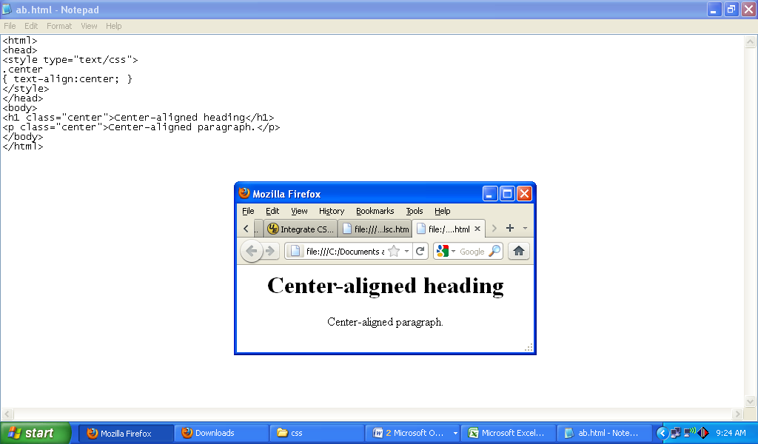

**Activity 2: Create an External CSS file and linked that file to a HTML file.**

Write the CSS code in the notepad and then save the file like **a.css** as a .CSS file

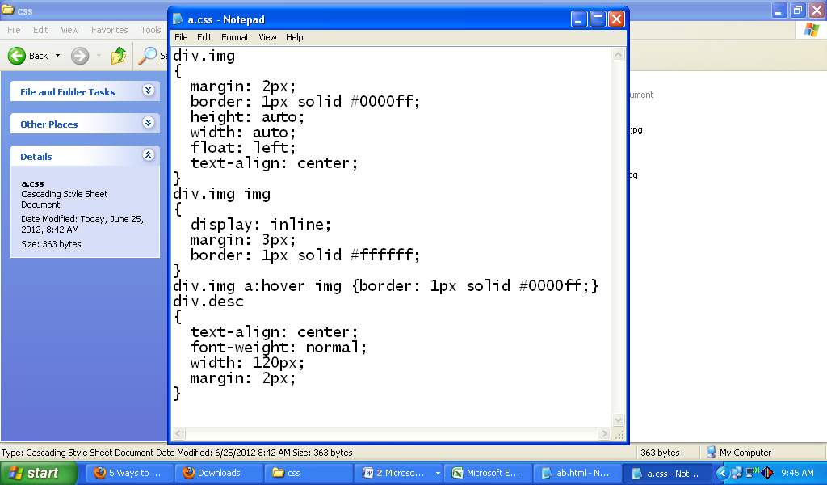

CSS file linked to the HTML file using the following codes

……………………………………………………………………..

<link rel="stylesheet" type="text/css" href="[a.css](view-source:file:///C:/Documents%20and%20Settings/User/Desktop/cb/css/a.css)" />

………………………………………………………………………..

**Remaining HTML code file**

……………………………………………………………

<div class="img"> <a target="_blank" href="[klematis_big.htm](view-source:file:///C:/Documents%20and%20Settings/User/Desktop/cb/css/klematis_big.htm)"><img src="[klematis_small.jpg](view-source:file:///C:/Documents%20and%20Settings/User/Desktop/cb/css/klematis_small.jpg)" alt="Klematis" width="110" height="90" /></a> <div class="desc">Add a description of the image here</div></div><div class="img"> <a target="_blank" href="[klematis2_big.htm](view-source:file:///C:/Documents%20and%20Settings/User/Desktop/cb/css/klematis2_big.htm)"><img src="[klematis2_small.jpg](view-source:file:///C:/Documents%20and%20Settings/User/Desktop/cb/css/klematis2_small.jpg)" alt="Klematis" width="110" height="90" /></a> <div class="desc">Add a description of the image here</div></div><div class="img"> <a target="_blank" href="[klematis3_big.htm](view-source:file:///C:/Documents%20and%20Settings/User/Desktop/cb/css/klematis3_big.htm)"><img src="[klematis3_small.jpg](view-source:file:///C:/Documents%20and%20Settings/User/Desktop/cb/css/klematis3_small.jpg)" alt="Klematis" width="110" height="90" /></a>

<div class="desc">Add a description of the image here</div></div><div class="img"> <a target="_blank" href="[klematis4_big.htm](view-source:file:///C:/Documents%20and%20Settings/User/Desktop/cb/css/klematis4_big.htm)"><img src="[klematis4_small.jpg](view-source:file:///C:/Documents%20and%20Settings/User/Desktop/cb/css/klematis4_small.jpg)" alt="Klematis" width="110" height="90" /></a> <div class="desc">Add a description of the image here</div></div></body>

………………………………………………………………………………………………………………

**Out put of the file**

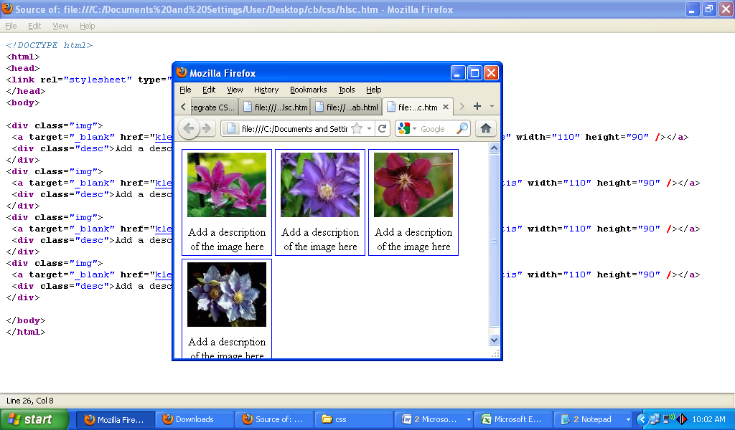

|  |
| --- |
| **Activity 3: Create a Webpage using HTML and CSS to show the appearance without and with CSS.** |

**The HTML codes for the website**

**<!DOCTYPE html>**<html ><head><meta http-equiv="content-type" content="text/html; charset=utf-8" /><title>FCI Group</title></head><body><div id="wrapper">

<div id="header-wrapper"><div id="header"><div id="logo"><h1><a href="[#](view-source:file:///K:/CBLM/CSS/HLSC+CSS+JavaScript%20Template%282%29/css+html/index.html)">FCI Group</a></h1>

<p>Design by FCI Group</a></p></div></div></div><!-- end #header --><div id="menu"><ul>

<li class="current_page_item"><a href="[#](view-source:file:///K:/CBLM/CSS/HLSC+CSS+JavaScript%20Template%282%29/css+html/index.html)">Home</a></li><li><a href="[#](view-source:file:///K:/CBLM/CSS/HLSC+CSS+JavaScript%20Template%282%29/css+html/index.html)">Blog</a></li>

<li><a href="[#](view-source:file:///K:/CBLM/CSS/HLSC+CSS+JavaScript%20Template%282%29/css+html/index.html)">Photos</a></li><li><a href="[#](view-source:file:///K:/CBLM/CSS/HLSC+CSS+JavaScript%20Template%282%29/css+html/index.html)">About</a></li><li><a href="[#](view-source:file:///K:/CBLM/CSS/HLSC+CSS+JavaScript%20Template%282%29/css+html/index.html)">Links</a></li>

<li><a href="[#](view-source:file:///K:/CBLM/CSS/HLSC+CSS+JavaScript%20Template%282%29/css+html/index.html)">Contact</a></li></ul></div><!-- end #menu --><div id="page"><div id="page-bgtop">

<div id="page-bgbtm"><div id="content"><div class="post"><h2 class="title"><a href="[#](view-source:file:///K:/CBLM/CSS/HLSC+CSS+JavaScript%20Template%282%29/css+html/index.html)">Welcome to FCI Group</a></h2><div class="entry"><p><img src="images/pics01.jpg" width="600" height="200" alt="" />The picture in this template is from FotoGrph. This free template is released under a <a href="[#](view-source:file:///K:/CBLM/CSS/HLSC+CSS+JavaScript%20Template%282%29/css+html/index.html)">Creative Commons Attributions 3.0</a> license, so you’re pretty much free to do whatever you want with it (even use it commercially) provided you keep the links in the footer intact. Aside from that, have fun with it :)</p></div></div><div class="post"><h2 class="title"><a href="[#](view-source:file:///K:/CBLM/CSS/HLSC+CSS+JavaScript%20Template%282%29/css+html/index.html)">Lorem ipsum sed aliquam</a></h2><div class="entry"><p><img src="images/pics02.jpg" width="600" height="200" alt="" />Sed lacus. Donec lectus. Nullam pretium nibh ut turpis. Nam bibendum. In nulla tortor, elementum vel, tempor at, varius non, purus. Mauris vitae nisl nec metus placerat consectetuer. Donec ipsum. Proin imperdiet est. Phasellus <a href="[#](view-source:file:///K:/CBLM/CSS/HLSC+CSS+JavaScript%20Template%282%29/css+html/index.html)">dapibus semper urna</a>. Pellentesque ornare, consectetuer nisl felis ac diam. Sed lacus. Donec lectus. Nullam pretium nibh ut turpis. Nam bibendum. Mauris vitae nisl nec metus placerat consectetuer. </p></div></div><div class="post"><h2 class="title"><a href="[#](view-source:file:///K:/CBLM/CSS/HLSC+CSS+JavaScript%20Template%282%29/css+html/index.html)">Phasellus pellentesque turpis </a></h2><div class="entry"><p><img src="[images/pics01.jpg](view-source:file:///K:/CBLM/CSS/HLSC+CSS+JavaScript%20Template%282%29/css+html/images/pics01.jpg)" width="600" height="200" alt="" />Sed lacus. Donec lectus. Nullam pretium nibh ut turpis. Nam bibendum. In nulla tortor, elementum vel, tempor at, varius non, purus. Mauris vitae nisl nec metus placerat consectetuer. Donec ipsum. Proin imperdiet est. Pellentesque ornare, orci in consectetuer hendrerit, urna elit eleifend nunc. Donec ipsum. Proin imperdiet est. Pellentesque ornare, orci in consectetuer hendrerit, urna elit eleifend nunc.</p></div></div><div style="clear: both;">&nbsp;</div></div><!-- end #content --><div id="sidebar"><ul><li><h2>Aliquam tempus</h2>

<p>Mauris vitae nisl nec metus placerat perdiet est. Phasellus dapibus semper consectetuer hendrerit.</p></li><li><h2>Categories</h2><ul><li><a href="[#](view-source:file:///K:/CBLM/CSS/HLSC+CSS+JavaScript%20Template%282%29/css+html/index.html)">Aliquam libero</a></li>

<li><a href="[#](view-source:file:///K:/CBLM/CSS/HLSC+CSS+JavaScript%20Template%282%29/css+html/index.html)">Consectetuer adipiscing elit</a></li><li><a href="[#](view-source:file:///K:/CBLM/CSS/HLSC+CSS+JavaScript%20Template%282%29/css+html/index.html)">Metus aliquam pellentesque</a></li><li><a href="[#](view-source:file:///K:/CBLM/CSS/HLSC+CSS+JavaScript%20Template%282%29/css+html/index.html)">Suspendisse iaculis mauris</a></li><li><a href="[#](view-source:file:///K:/CBLM/CSS/HLSC+CSS+JavaScript%20Template%282%29/css+html/index.html)">Urnanet non molestie semper</a></li><li><a href="[#](view-source:file:///K:/CBLM/CSS/HLSC+CSS+JavaScript%20Template%282%29/css+html/index.html)">Proin gravida orci porttitor</a></li>

</ul></li><li><h2>Blogroll</h2><ul><li><a href="[#](view-source:file:///K:/CBLM/CSS/HLSC+CSS+JavaScript%20Template%282%29/css+html/index.html)">Aliquam libero</a></li><li><a href="[#](view-source:file:///K:/CBLM/CSS/HLSC+CSS+JavaScript%20Template%282%29/css+html/index.html)">Consectetuer adipiscing elit</a></li><li><a href="[#](view-source:file:///K:/CBLM/CSS/HLSC+CSS+JavaScript%20Template%282%29/css+html/index.html)">Metus aliquam pellentesque</a></li>

<li><a href="[#](view-source:file:///K:/CBLM/CSS/HLSC+CSS+JavaScript%20Template%282%29/css+html/index.html)">Suspendisse iaculis mauris</a></li><li><a href="[#](view-source:file:///K:/CBLM/CSS/HLSC+CSS+JavaScript%20Template%282%29/css+html/index.html)">Urnanet non molestie semper</a></li><li><a href="[#](view-source:file:///K:/CBLM/CSS/HLSC+CSS+JavaScript%20Template%282%29/css+html/index.html)">Proin gravida orci porttitor</a></li></ul> </li><li><h2>Archives</h2><ul><li><a href="[#](view-source:file:///K:/CBLM/CSS/HLSC+CSS+JavaScript%20Template%282%29/css+html/index.html)">Aliquam libero</a></li>

<li><a href="[#](view-source:file:///K:/CBLM/CSS/HLSC+CSS+JavaScript%20Template%282%29/css+html/index.html)">Consectetuer adipiscing elit</a></li><li><a href="[#](view-source:file:///K:/CBLM/CSS/HLSC+CSS+JavaScript%20Template%282%29/css+html/index.html)">Metus aliquam pellentesque</a></li><li><a href="[#](view-source:file:///K:/CBLM/CSS/HLSC+CSS+JavaScript%20Template%282%29/css+html/index.html)">Suspendisse iaculis mauris</a></li>

<li><a href="[#](view-source:file:///K:/CBLM/CSS/HLSC+CSS+JavaScript%20Template%282%29/css+html/index.html)">Urnanet non molestie semper</a></li><li><a href="[#](view-source:file:///K:/CBLM/CSS/HLSC+CSS+JavaScript%20Template%282%29/css+html/index.html)">Proin gravida orci porttitor</a></li></ul></li></ul></div><!-- end #sidebar --><div style="clear: both;">&nbsp;</div></div>

</div></div><!-- end #page --></div><div id="footer"><p>Copyright (c) 2012 fcigroup.com. All rights reserved. Design by <a href="[#](view-source:file:///K:/CBLM/CSS/HLSC+CSS+JavaScript%20Template%282%29/css+html/index.html)">FCI Group</a>.</p></div><!-- end #footer --></body>

The following appearance of webpage without CSS link

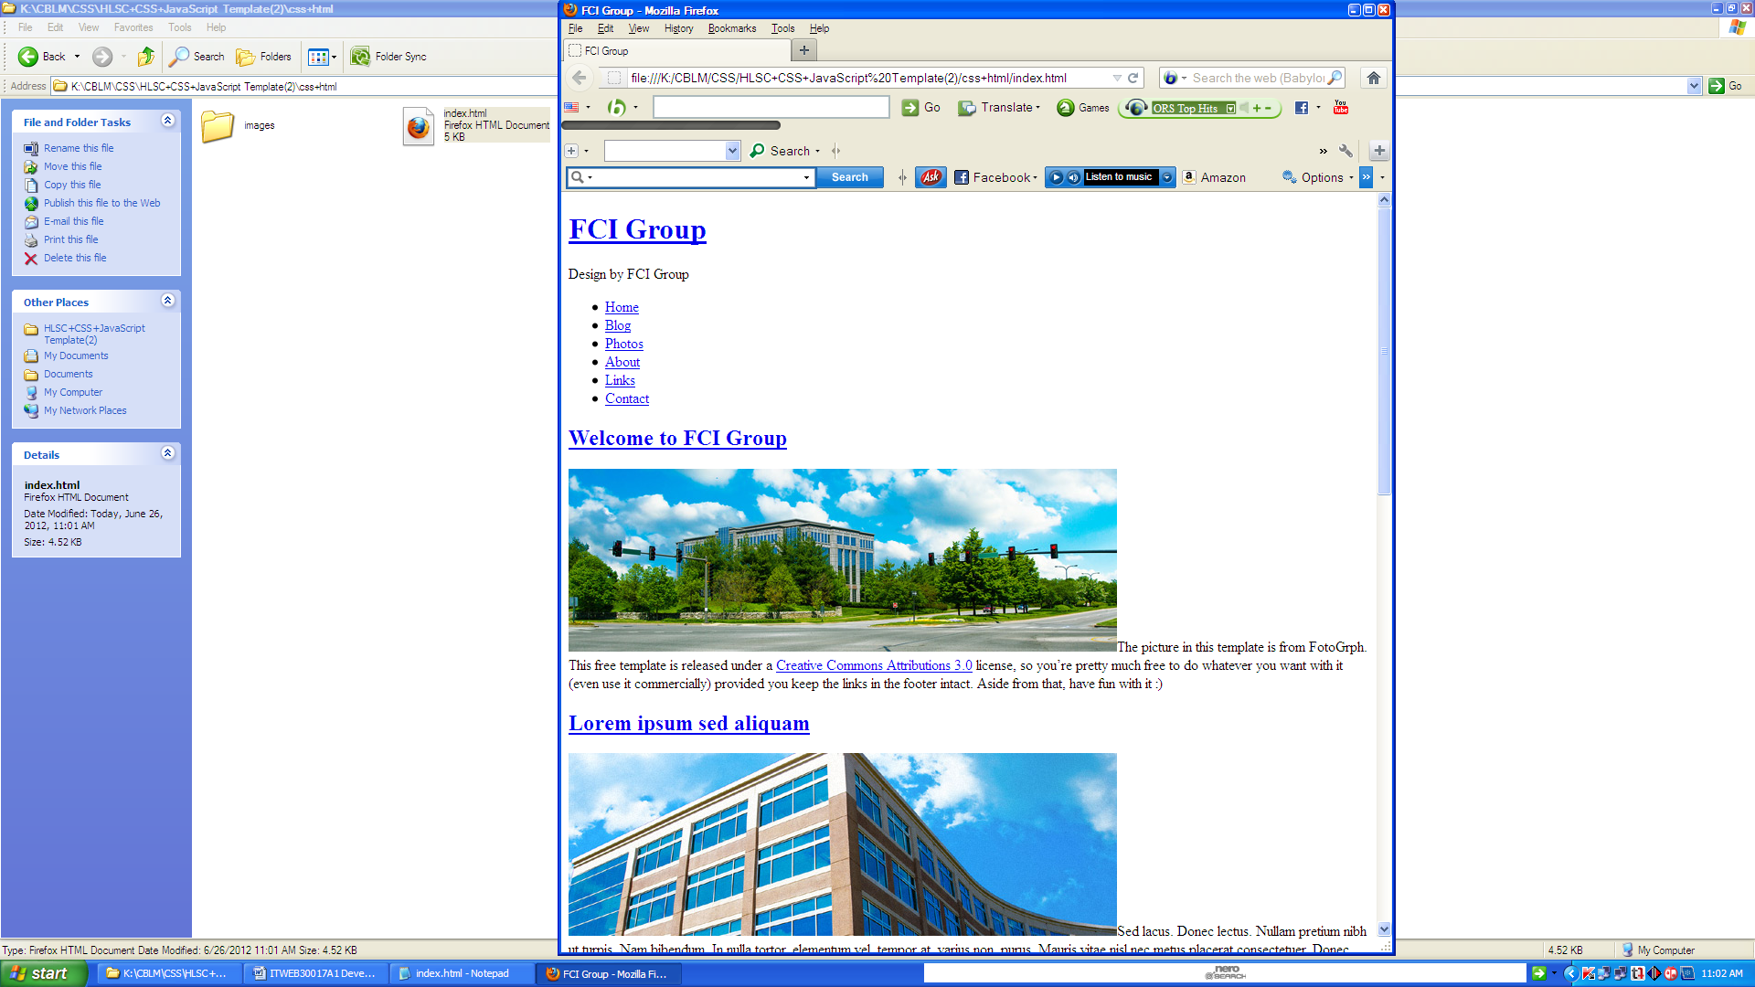

**CSS link with HTML**

**…………………………………………………………………………………**

<head>

<link href="[style.css](view-source:file:///K:/CBLM/CSS/HLSC+CSS+JavaScript%20Template%282%29/css+html/style.css)" rel="stylesheet" type="text/css" media="screen" / >

</head>

**……………………………………………………………………………………**

**The following CSS codes are linked with the HTML document**

body { margin: 0;padding: 0;background: #6659A6 url(images/wrapper-img-bg.jpg) no-repeat left top;font-family: Arial, Helvetica, sans-serif;font-size: 14px;color: #181B20;}

h1, h2, h3 {margin: 0;padding: 0;font-family: 'Oxygen', sans-serif;font-weight: normal;

color: #2E9F13;}h1 {font-size: 2em;}h2 {font-size: 2.4em;}h3 {font-size: 1.6em;}p, ul, ol {margin-top: 0;line-height: 180%;}ul, ol {}a {text-decoration: none;color: #B61C8C;}a:hover {text-decoration: underline;}img.border {border: 6px solid #EEE7DF;}img.alignleft {float: left;margin-right: 25px;}

img.alignright {float: right;}img.aligncenter {margin: 0px auto;}#wrapper {margin: 0 auto;padding: 0;background: url(images/img03.gif) no-repeat center top;}/* Header */#header-wrapper {height: 240px;}

#header {width: 960px;height: 240px;margin: 0 auto;}/* Logo */#logo {width: 980px;height: 100px;margin: 0px auto;padding: 80px 0px 0px 0px;color: #FFFFFF;}#logo h1, #logo p {display: block;margin: 0;padding: 0;}#logo h1 {margin: 0px;letter-spacing: -1px;text-align: center;//text-transform: lowercase;

font-size: 54px;font-weight: bold;color: #FFFFFF;}#logo h1 a {color: #FFFFFF;}#logo p {text-align: center;text-transform: uppercase;font-family: 'Arvo', serif;font-size: 20px;}#logo a {border: none;background: none;text-decoration: none;color: #FFFFFF;}/* Search */#search {float: right;width: 280px;height: 100px;padding: 0;}#search form {height: 41px;margin: 0;padding: 60px 0 0 30px;}

#search fieldset {margin: 0;padding: 0;border: none;}#search-text {width: 195px;padding: 6px 10px;border: none;background: #FFFFFF;text-transform: lowercase;font: normal 11px Arial, Helvetica, sans-serif;color: #7F7F81;}#search-submit {display: none;}/* Menu */#menu {width: 940px;height: 56px;margin: 0px auto;padding: 20px 20px 0px 20px;background: #212F77;}#menu ul {margin: 0;padding: 0px 0px 0px 0px;list-style: none;line-height: normal;}#menu li {float: left;}

#menu a {display: block;float: left;height: 56px;margin: 0px;padding: 0px 30px 0px 30px;line-height: 56px;letter-spacing: -1px;text-decoration: none;text-transform: uppercase;font-family: 'Arvo', serif;font-size: 14px;font-weight: normal;color: #FFFFFF;}#menu .current_page_item a {background: #FFFFFF;color: #B61C8C;}#menu a:hover {text-decoration: none;color: #C62647;}

/* Page */#page {width: 980px;margin: 0 auto;padding: 0;background-color: #FFFFFF;}

#page-bgtop {}#page-bgbtm {margin: 0px;padding: 40px 30px 0px 30px;}

/* Content */

#content {float: right;width: 600px;padding: 0px 0px 0px 0px;}.post {clear: both;padding-bottom: 10px;}

.post .title {padding-top: 10px;letter-spacing: -2px;}.post .title a {color: #1A1A1A;border: none;}

.post .meta {padding-bottom: 10px;text-align: left;font-family: Arial, Helvetica, sans-serif;

font-size: 11px;font-style: italic;}.post .meta a {}

.post .entry {text-align: justify;margin-bottom: 25px;padding: 10px 0px 0px 0px;}

.links {display: block;width: 96px;padding: 2px 0px 2px 0px;background: #A53602;text-align: center;text-transform: uppercase;font-size: 10px;color: #FFFFFF;}/* Sidebar */#sidebar {float: left;width: 240px;padding: 0px 0px 0px 0px;}#sidebar ul {margin: 0;padding: 0;list-style: none;}#sidebar li {margin: 0;padding: 0;}#sidebar li ul {margin: 0px 0px;padding-bottom: 30px;}#sidebar li li {line-height: 35px;background: url(images/img07.jpg) no-repeat left 14px;}#sidebar li li span {display: block;margin-top: -20px;padding: 0;font-size: 11px;font-style: italic;}#sidebar h2 {height: 38px;margin-bottom: 20px;padding: 12px 0 0 0;border-bottom: 1px solid #B6BFD0;letter-spacing: -1px;font-size: 24px;color: #1A1A1A;}#sidebar p {margin: 0 0px;padding: 0px 20px 20px 20px;text-align: justify;}

#sidebar a {border: none;}#sidebar a:hover {text-decoration: underline;}/* Calendar */#calendar { }

#calendar_wrap {padding: 20px;}#calendar table {width: 100%;}#calendar tbody td {text-align: center;}

#calendar #next {text-align: right;}/* Footer */#footer {width: 960px;height: 55px;margin: 0px auto 40px auto;border-top: 1px solid #B6BFD0;font-family: Arial, Helvetica, sans-serif;}#footer p {margin: 0;padding-top: 18px;line-height: normal;text-align: center;color: #212F77;}#footer a {color: #212F77;}

The following appearance is different from above webpage cause of CSS including .This different is proved that CSS enhanced the page appearance

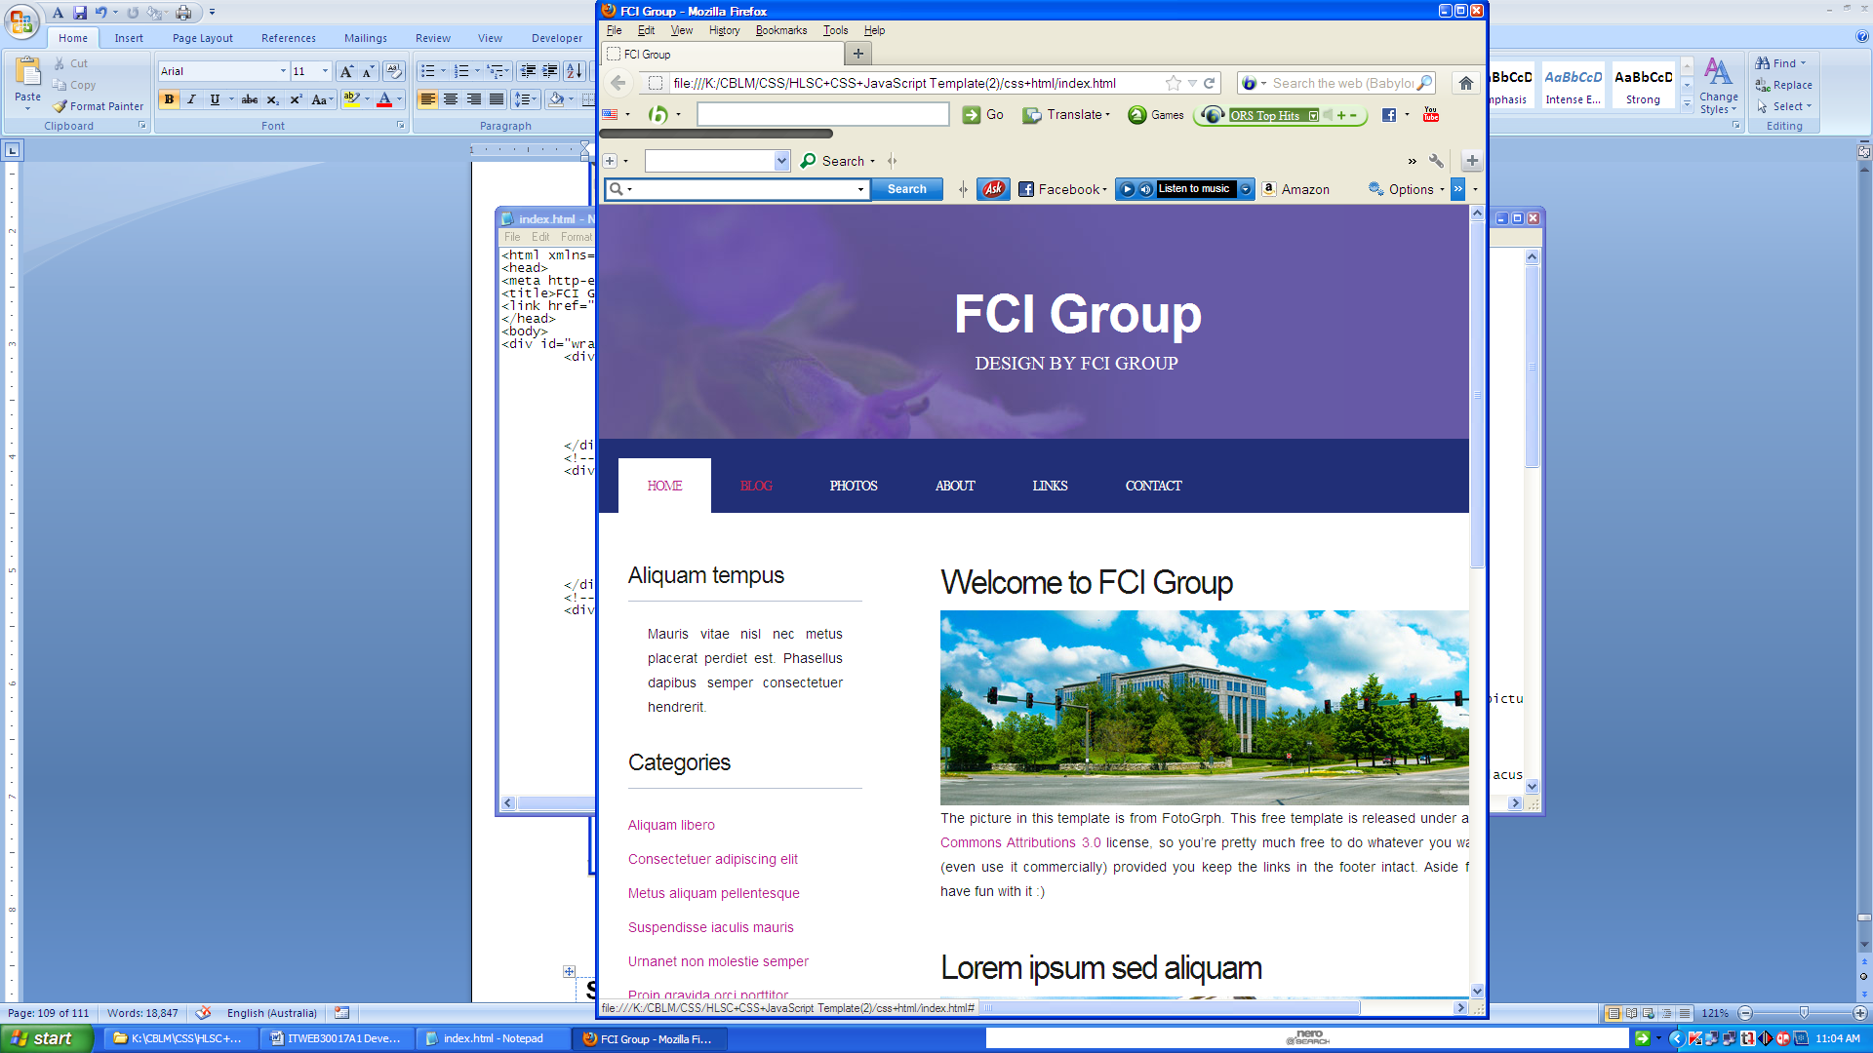

|  |
| --- |
| **Activity 4: Edit the HTML and CSS code to create another new webpage.** |

**CSS codes for new webpage**

* {margin:0;padding:0}

body {font-family:arial;font-size:16px;line-height:22px;color:#666;background:url(images/bg.jpg) repeat fixed #ddd}.fix {overflow:hidden}.main {width:960px;margin:25px auto;display:block;background:#fff}.header {}.slider {width:960px;background:url(images/banner.jpg) no-repeat;margin-bottom:25px}

.slider_text {color: #FFFFFF;line-height: 35px;margin-left: 221px;margin-top: 63px;}

.slider_text h1 {color: #0B5FB9;font-size: 46px;line-height: 45px;}.slider_text h2 {}

.slider_text p {}.maincontent {}.sidebar {width:250px;margin-right:30px;background:#EDEDED;float:left;padding:20px;margin-left:10px}

.sidebar h2 {background: none repeat scroll 0 0 #000000; color: #FFFFFF; font-weight: normal; margin-bottom: 20px; margin-left: -20px; margin-top: -20px; padding: 10px 25px; width: 245px;}

.sidebar ul {margin:0;padding:0;list-style:none}.sidebar ul li{padding:5px;border-bottom:1px solid #ddd}.sidebar ul li a{text-decoration:none;color:#666}.sidebar ul li a:hover{color:#000}

.content {width:600px;padding-right:30px}.content h2{margin-bottom:15px;font-weight:normal;font-family: 'QuicksandLight', sans-serif;}.content p {margin-bottom:15px}

.footer {padding:10px;background:#BBBBBB}

**HTML codes are as follows**

<!DOCTYPE html>

<html> <head><title>This is Title</title><link rel="stylesheet" type="text/css" href="style.css"/>

</head><body><div class="fix main"><div class="fix header"><img src="images/logo.jpg" alt=""/> </div><div class="fix slider"> <div class="slider-wrapper theme-light"><div class="nivoSlider" id="slider"><img src="images/nemo.jpg" alt="This site developed by Mohammad Atiqul Islam" title="This site developed by Mohammad Atiqul Islam"/><img src="images/toystory.jpg" alt=""/><img src="images/up.jpg" alt="" title="#htmlcaption"/>

<img src="images/walle.jpg" alt=""/></div><div class="nivo-html-caption" id="htmlcaption">

<p>This is html caption. This is <a href="http://fcibd.net">link</a></p></div></div></div> <div class="fix maincontent"><div class="fix sidebar"><h2>Site Navigation</h2><ul><li><a href="">Home</a></li><li><a href="">About</a></li><li><a href="">Contact</a></li> <li><a href="">Others</a></li><li><a href="">Media</a></li></ul> </div><div class="fix content">

<h2>This is content Title</h2><p style="font-family:'NymphetteRegular'">hihihihihihihihihihihi</p><p>Lorem ipsum dolor sit amet, consectetuer adipiscing elit, sed diam nonummy nibh euismod tincidunt ut laoreet dolore magna aliquam erat volutpat. Ut wisi enim ad minim veniam, quis nostrud exerci tation ullamcorper suscipit lobortis nisl ut aliquip ex ea commodo consequat. </p> <p>Duis autem vel eum iriure dolor in hendrerit in vulputate velit esse molestie consequat, vel illum dolore eu feugiat nulla facilisis at vero eros et accumsan et iusto odio dignissim qui blandit praesent luptatum zzril delenit augue duis dolore te feugait nulla facilisi. </p><p>Nam liber tempor cum soluta nobis eleifend option congue nihil imperdiet doming id quod mazim placerat facer possim assum. Typi non habent claritatem insitam; est usus legentis in iis qui facit eorum claritatem. Investigationes demonstraverunt lectores legere me lius quod ii legunt saepius. Claritas est etiam processus dynamicus, qui sequitur mutationem consuetudium lectorum. Mirum est notare quam littera gothica, quam nunc putamus parum claram, anteposuerit litterarum formas humanitatis per seacula quarta decima et quinta decima. Eodem modo typi, qui nunc nobis videntur parum clari, fiant sollemnes in futurum.</p></div></div><div class="fix footer"><p>&copy; ANZMSOFT, All Rights Reserved</p></div></div></body></html>

**Appearance of the new page**

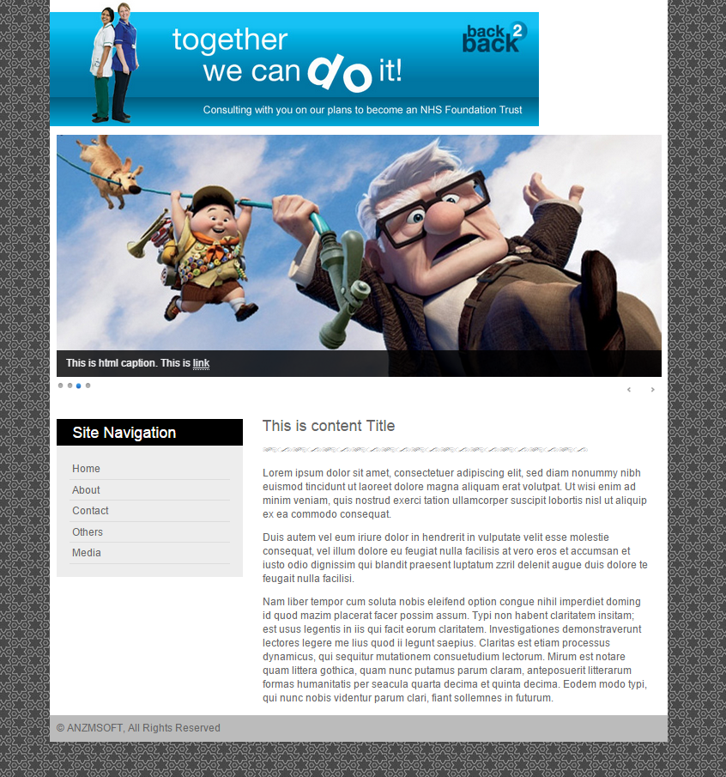

|  |
| --- |
| Activity 5- Validate the CSS and HTML code using CSE validator . |

Goto the <http://www.css-validator.org/> website

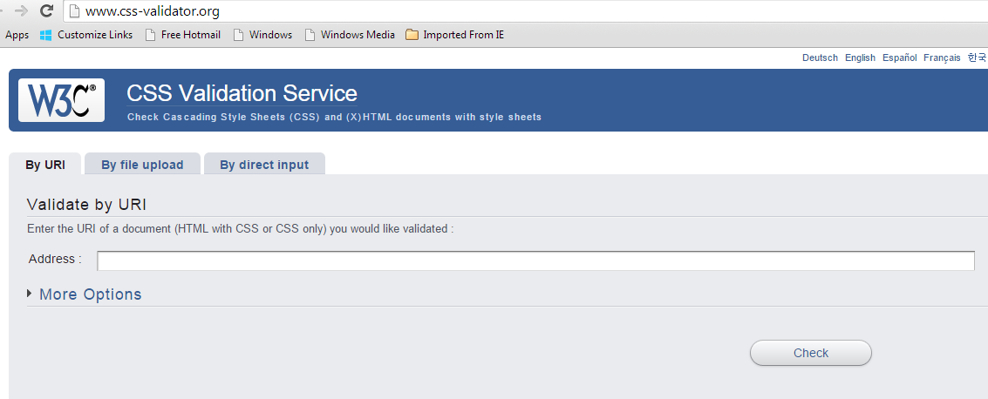

Paste your code to check error. Click check button for validation

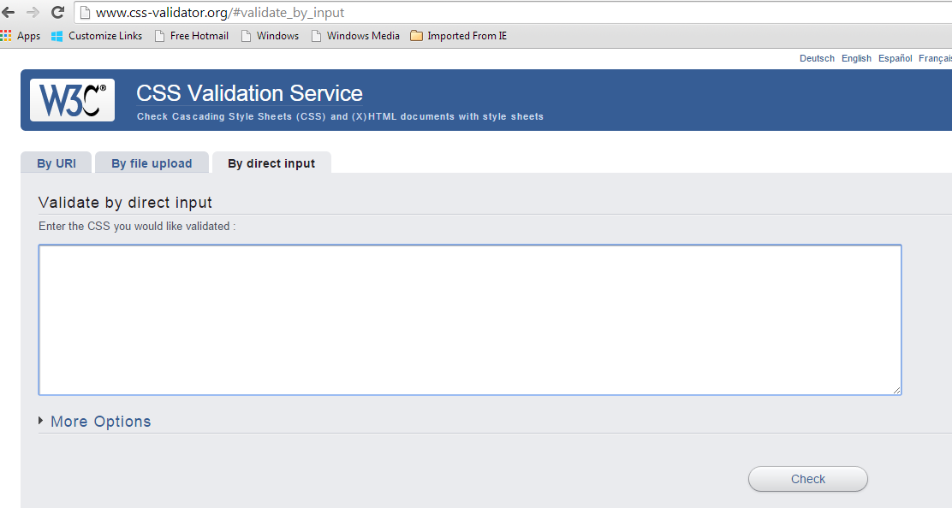

Below is your self assessment rating for module XXXXXXXXX

|  |  |  |
| --- | --- | --- |
| **Assessment performance Criteria** | **Yes** | **No** |
| *1. Learning outcome 1* | 🖵 | 🖵 |
| *2. Learning outcome 2* | 🖵 | 🖵 |
| *3. Learning outcome 3* | 🖵 | 🖵 |
| *4. Learning outcome 4* | 🖵 | 🖵 |
| *5. Learning outcome 5* | 🖵 | 🖵 |

I now feel ready to undertake my formal competency assessment.

Signed:

Date: